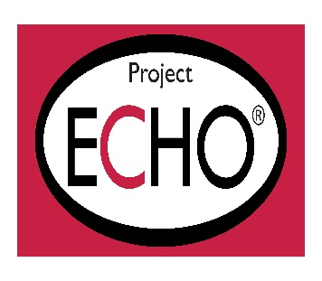

In support of improving patient care, Project ECHO® is jointly accredited by the Accreditation Council for Continuing Medical Education (ACCME), the Accreditation Council for Pharmacy Education (ACPE), and the American Nurses Credentialing Center (ANCC), to provide continuing education for the healthcare team.

**AMA Designation Statement**

Project ECHO® designates this live activity for a maximum of 1.0 *AMA PRA Category 1 CreditTM*. Physicians should claim only the credit commensurate with the extent of their participation in the activity.

**ANCC Designation Statement**

Project ECHO® designates this live activity for a maximum of 1.0 ANCC contact hour.  Nursing contact hours will be awarded for successful completion of program components based upon documented attendance and completion of evaluation.

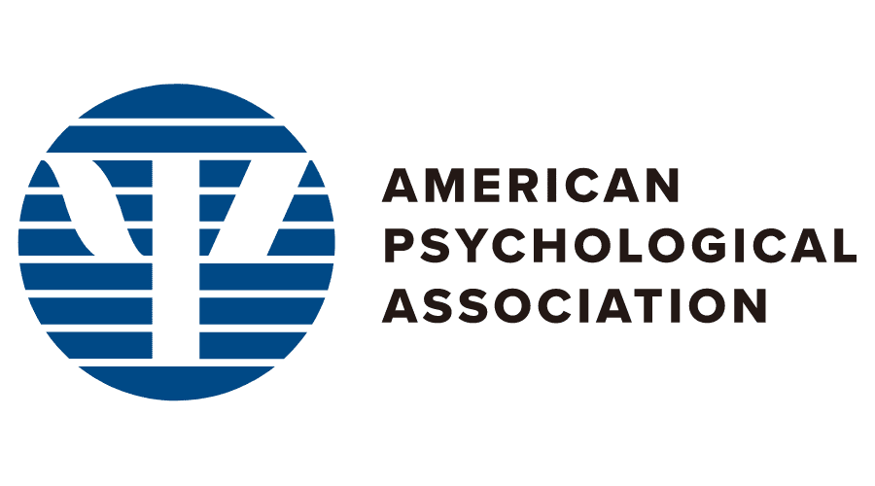

**Psychologist Accreditation**

Continuing Education (CE) credits for psychologists are provided through the co-sponsorship of the American Psychological Association (APA) Office of Continuing Education in Psychology (CEP). The APA CEP Office maintains responsibility for the content of the programs.

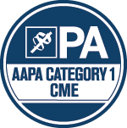

**AAPA Credit Designation Statement – Live**

Project ECHO has been authorized by the American Academy of PAs (AAPA) to award AAPA Category 1 CME credit for activities planned in accordance with AAPA CME Criteria. This activity is designated for 1.0 AAPA Category 1 CME credit. PAs should only claim credit commensurate with the extent of their participation.