3.3.3.1. Total number of books and chapters in edited volumes/books published and papers in national/ international conference proceedings year wise during last five years

Year | 2015-16 | 2016-17 | 2017-18 | 2018-19 | 2019-20
Number | 0 | 0 | 02 | 0 | 0
Data Requirement for last five years: (As per Data Template)
- Name of the teacher: Title of the paper
- Title of the book published: Name of the author/s : Title of the proceedings of the conference
- Name of the publisher: National/International
- National/international : ISBN/ISSN number of the proceedings
- Year of publication:

Formula:
$\frac{02}{27.6}$= 0.072

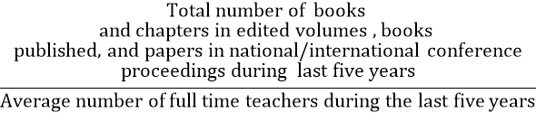

File Description: (Upload)
- Any additional information
List books and chapters edited volumes/ books published (Data Template)

