dk;kZy; izkpk;Z
ch-lh-,l- 'kkldh; LukrdksRrj egkfo|ky;] /kerjh ¼N-x-½
Website – www.bcspgcdmt.com
E-mail – pgcollege.dhamtari@gmail.com
AISHE CODE C-21763
NAAC GRADE-‘B’
nwjHkk"k&7722&237933
QSDl& 07722&237933

4.1.3 Percentage of classrooms and seminar halls with ICT- enabled facilities such as smart class, LMS, etc.

Seminar Hall (New Building-First Floor)
Geo-tagged Photographs of Seminar Hall

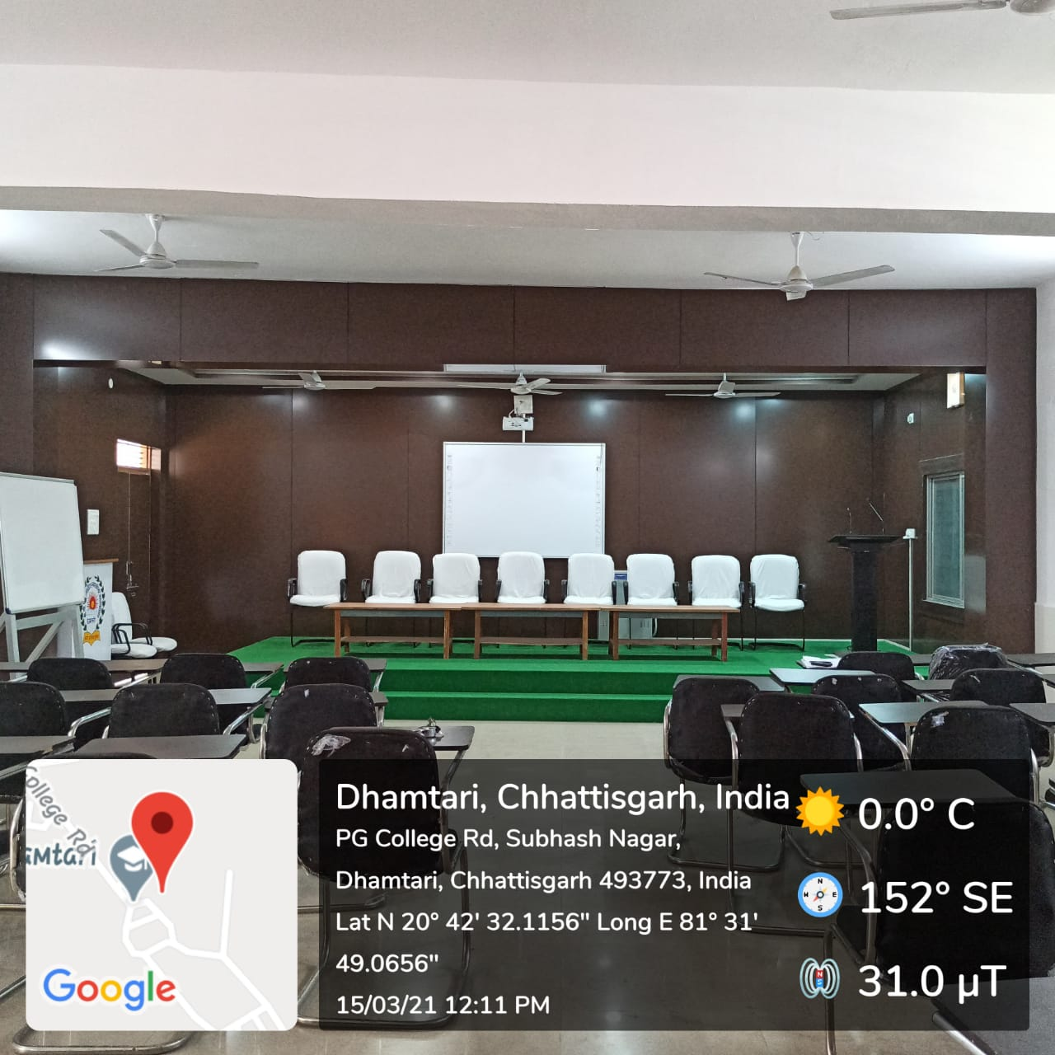

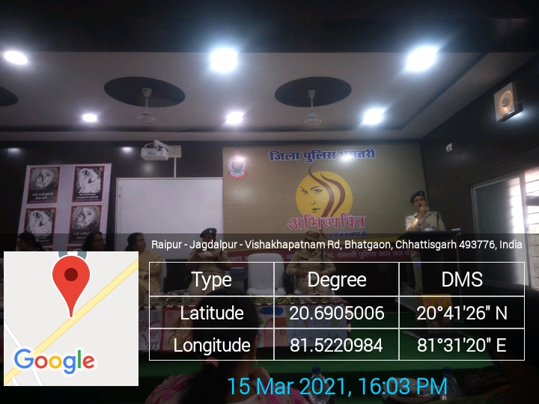

Seminar Hall (Old Building-Ground Floor)

Geo-tagged Photographs of Seminar Hall

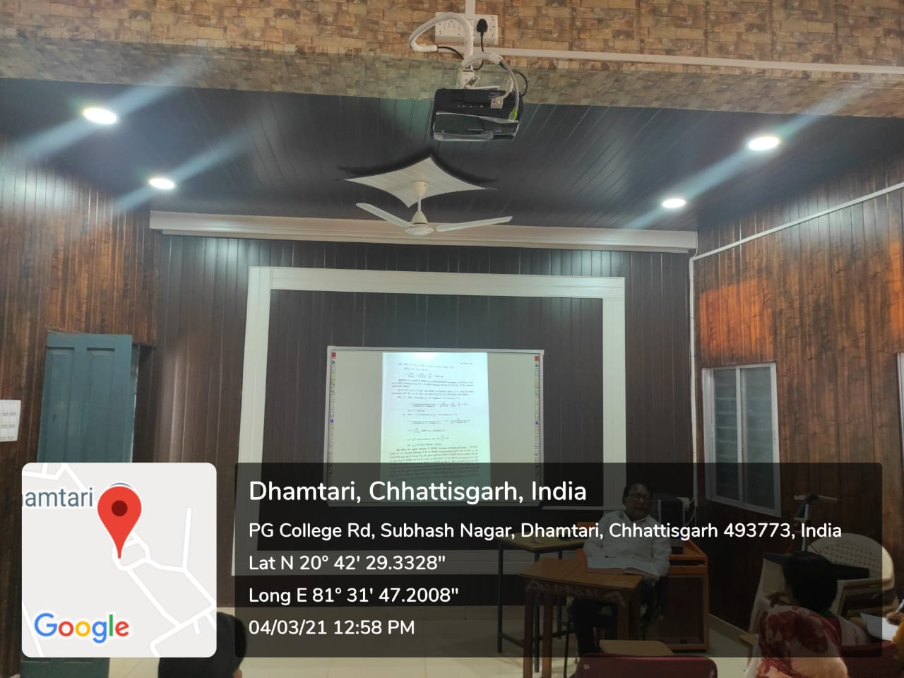

Psychology Lab cum class room
(Class room with LCD facility)

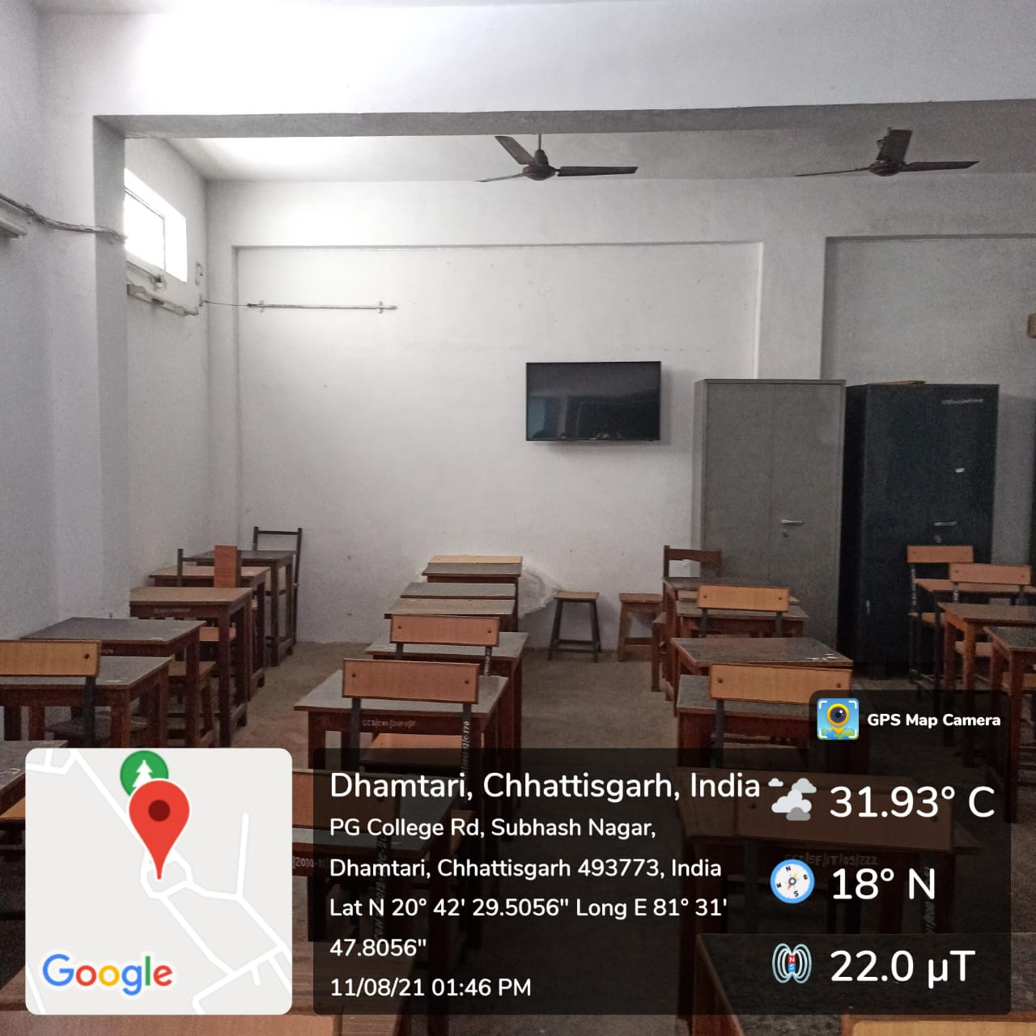

dk;kZy; izkpk;Z
ch-lh-,l- 'kkldh; LukrdksRrj egkfo|ky;] /kerjh ¼N-x-½
Website – www.bcspgcdmt.com
E-mail – pgcollege.dhamtari@gmail.com
AISHE CODE C-21763
NAAC GRADE-‘B’
nwjHkk"k&7722&237933
QSDl& 07722&237933

4.1.3 Percentage of classrooms and seminar halls with ICT- enabled facilities such as smart class, LMS, etc.

Wi-fi devices

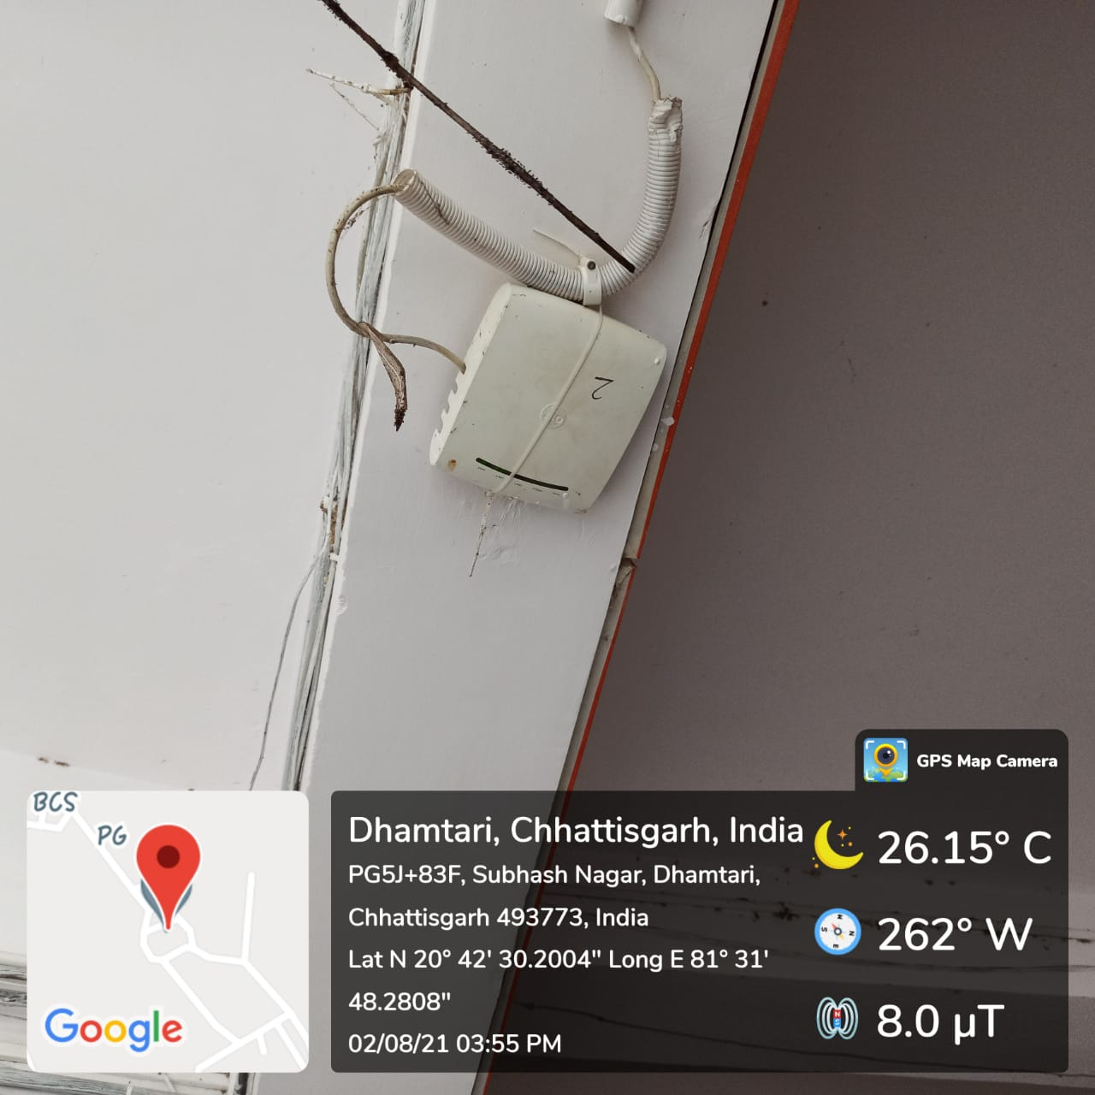
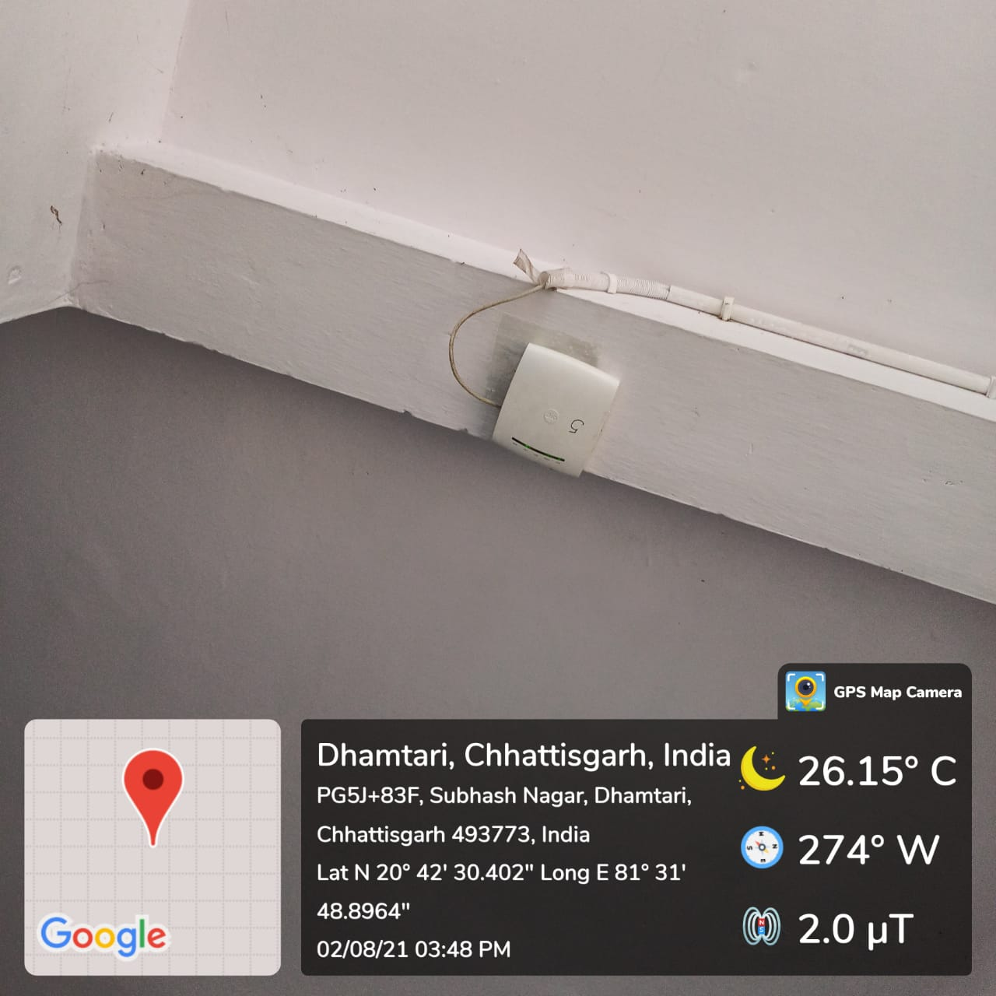
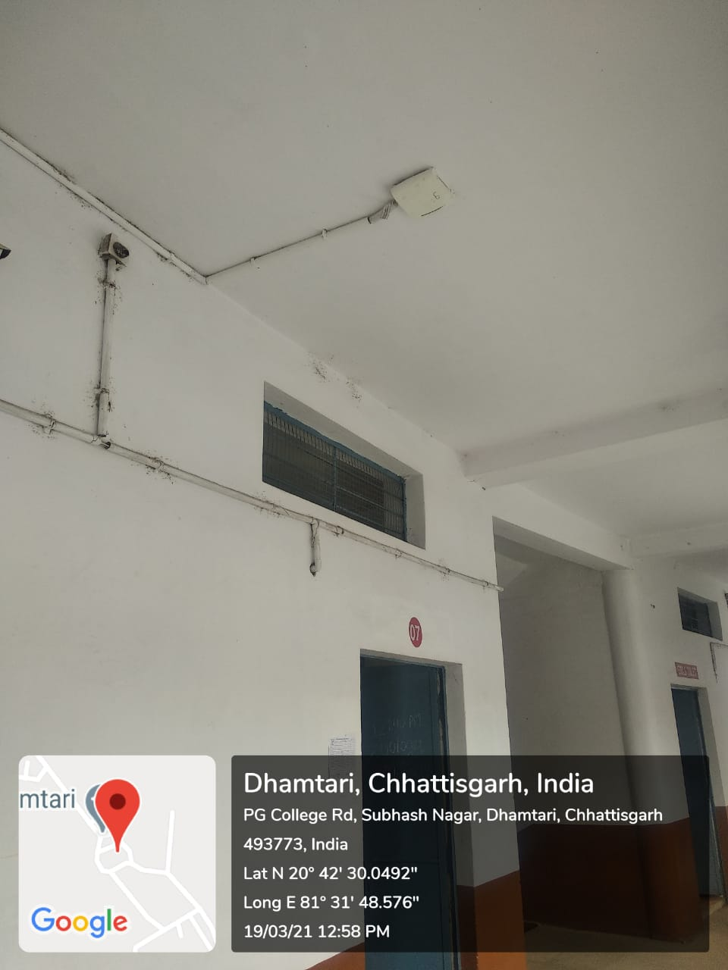

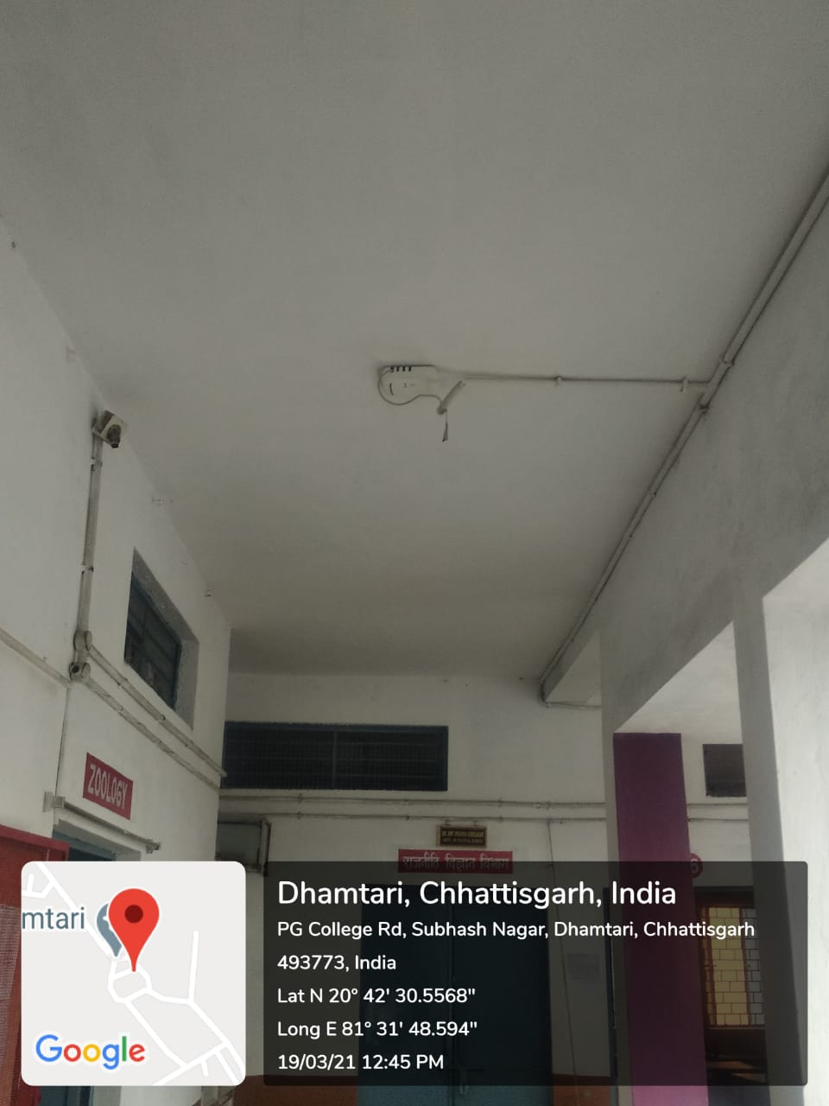
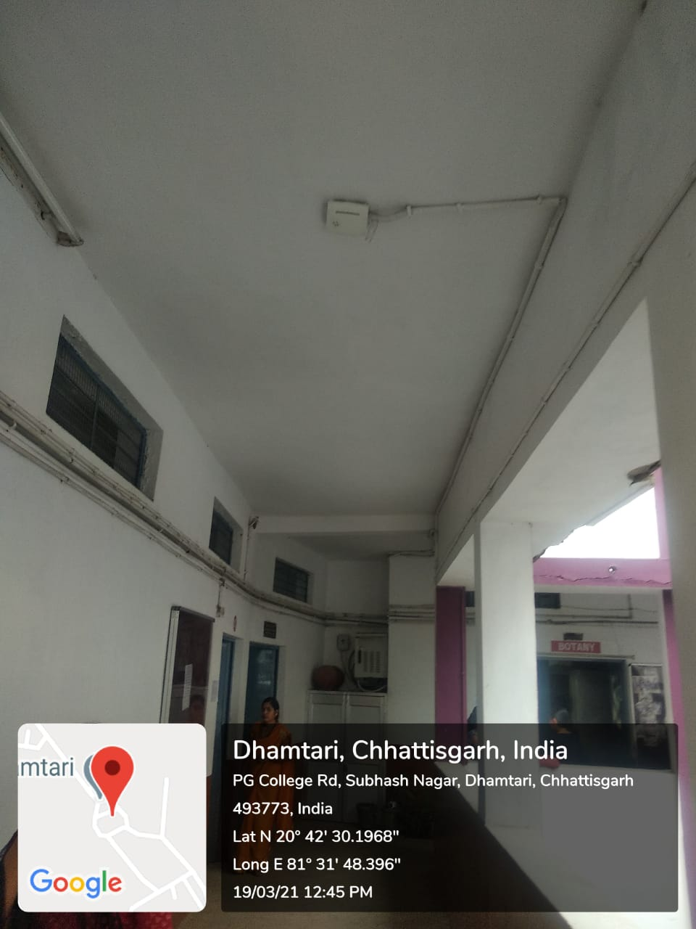
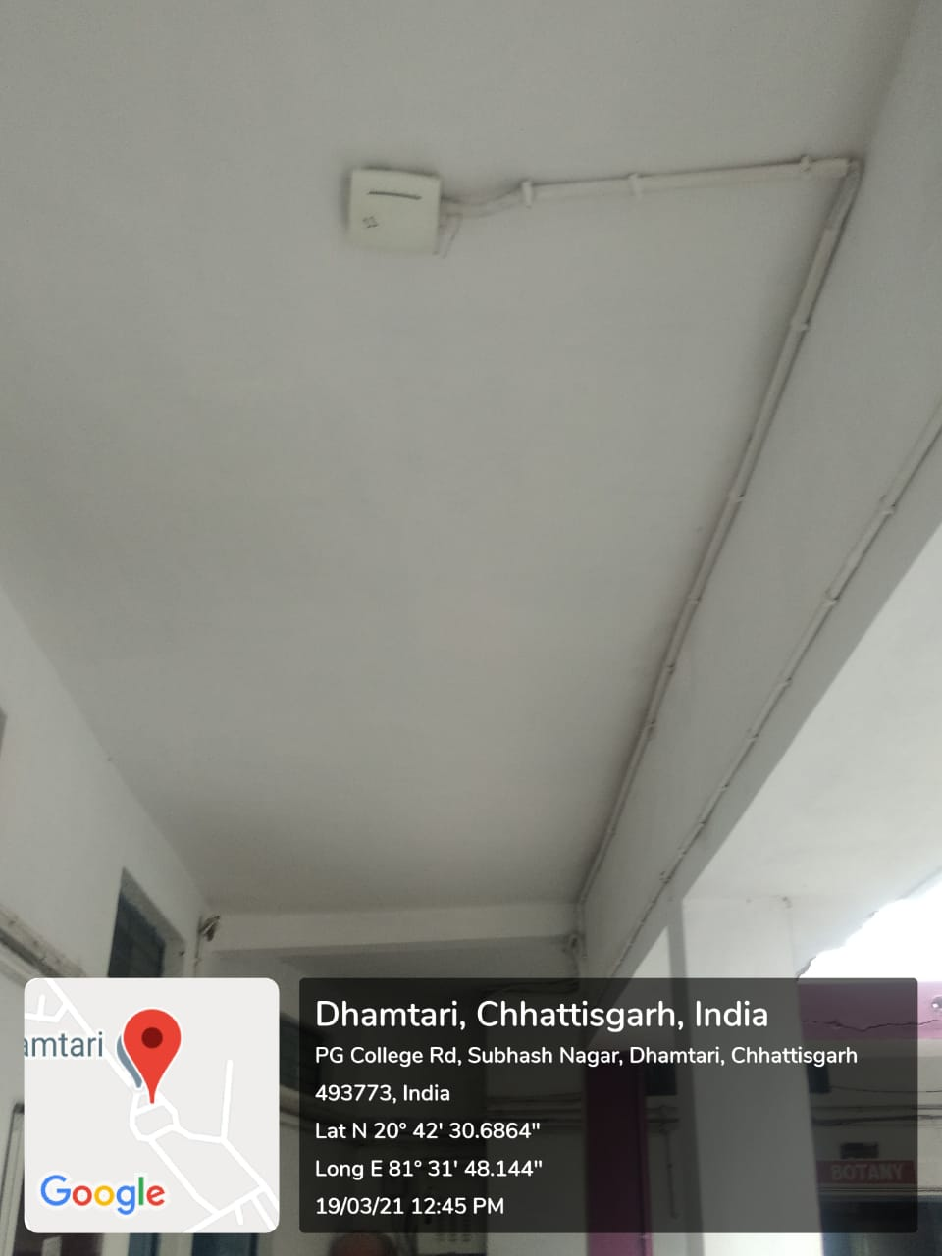

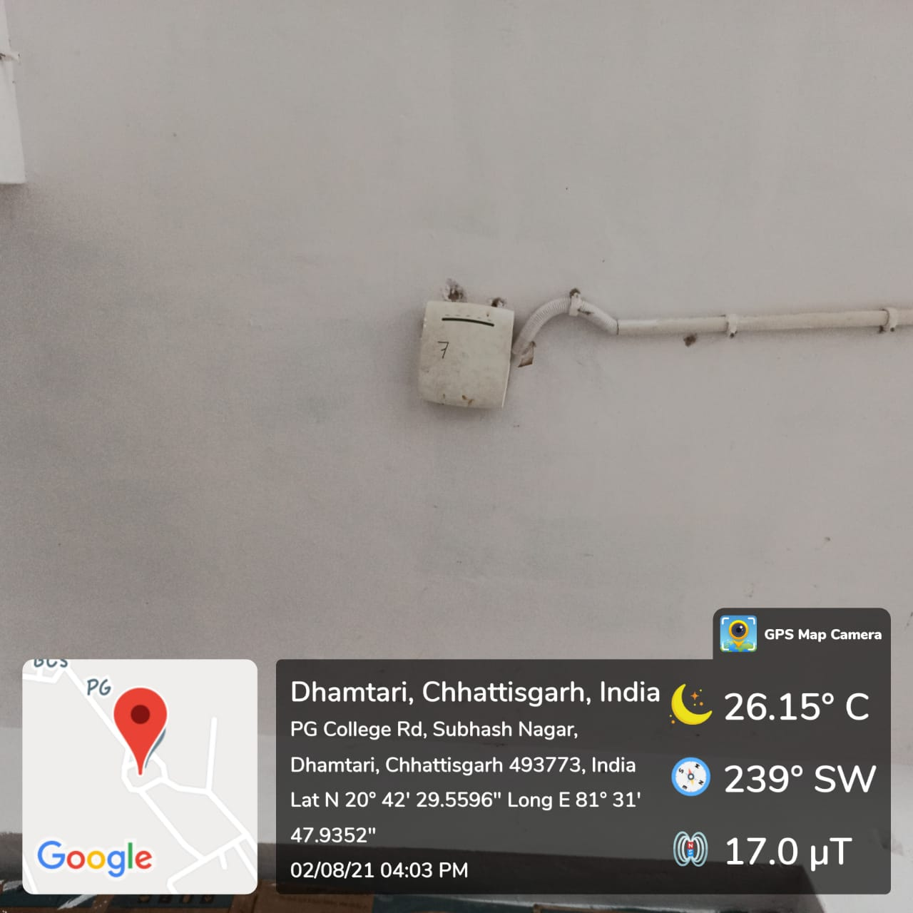

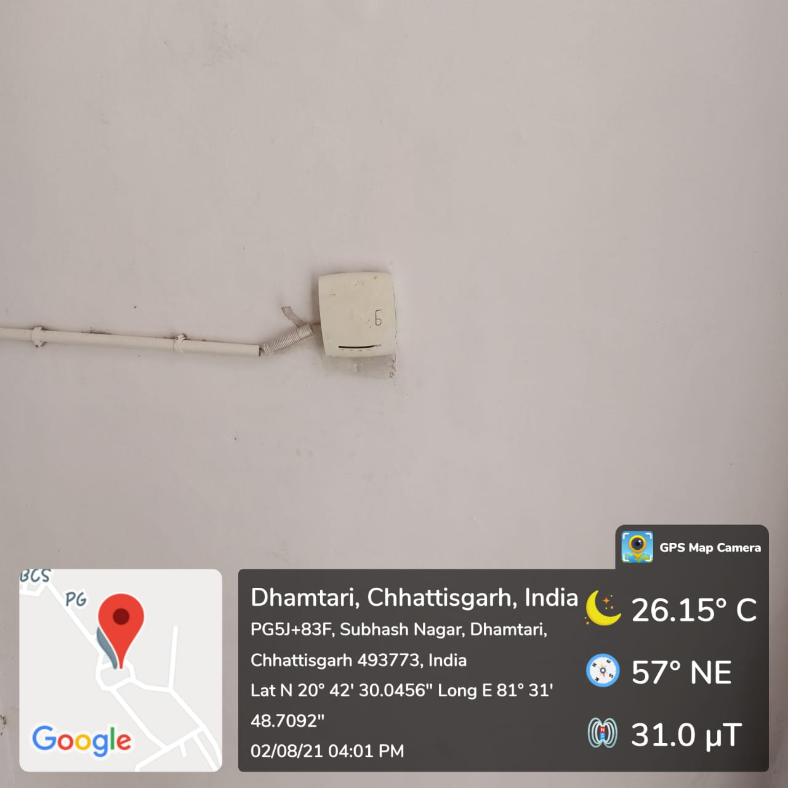

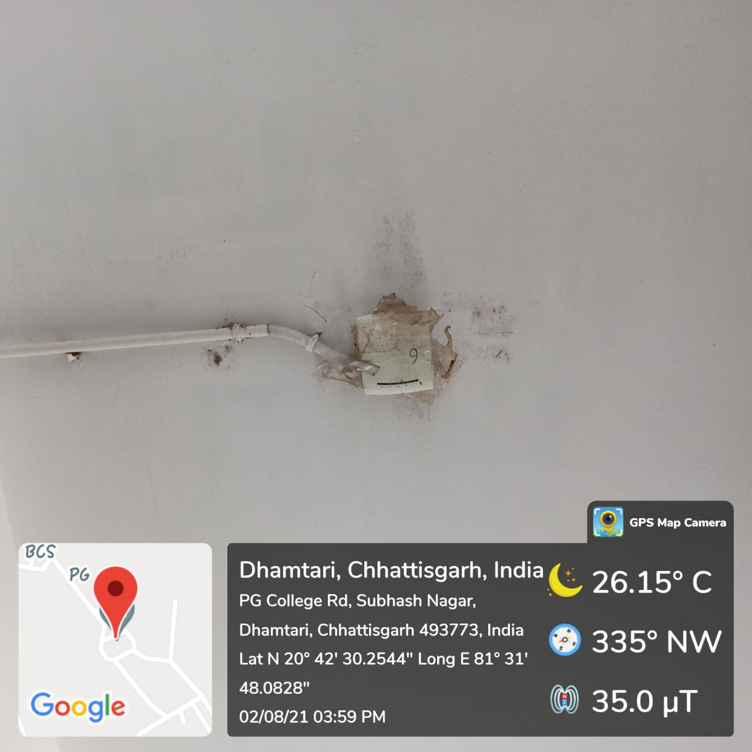
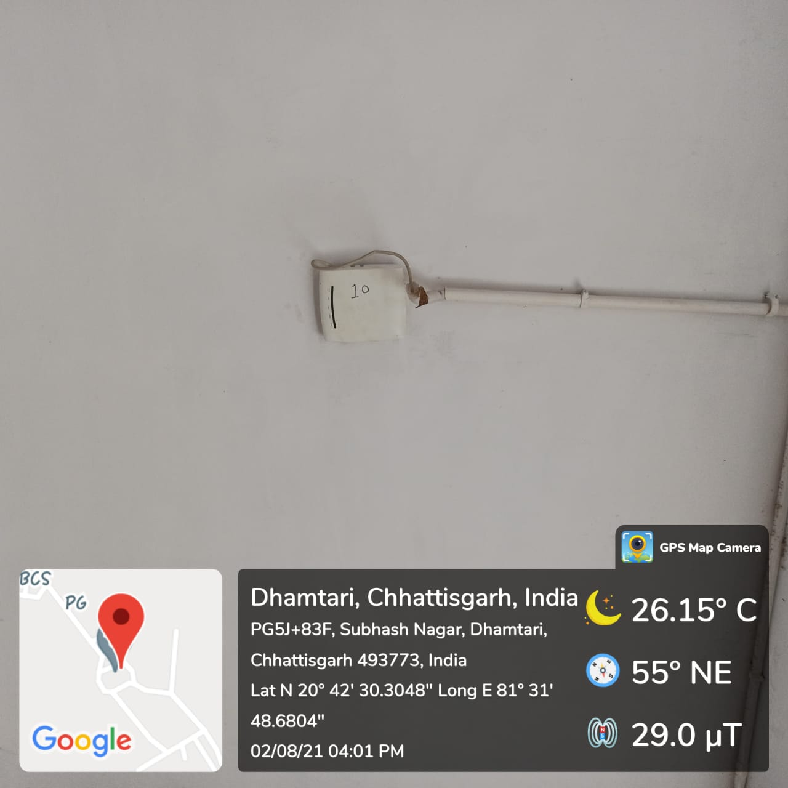
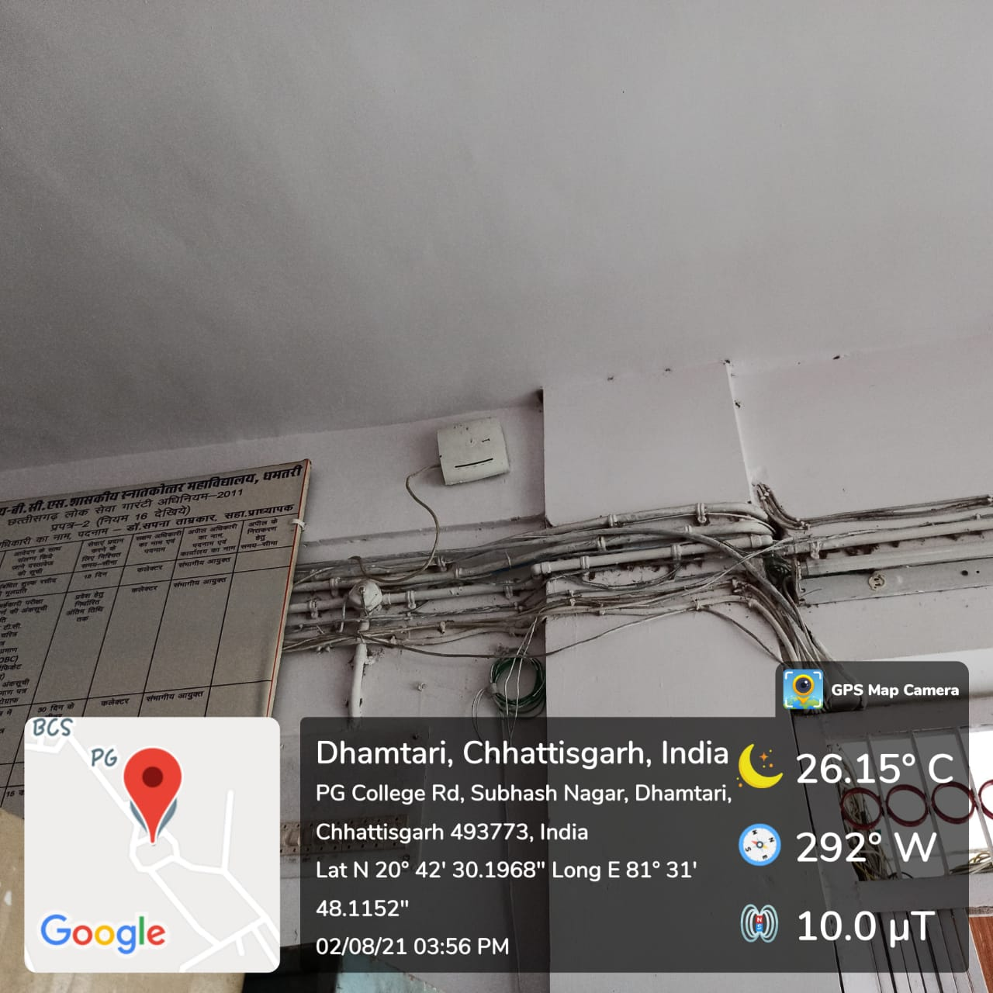

Xerox machine installed in Office

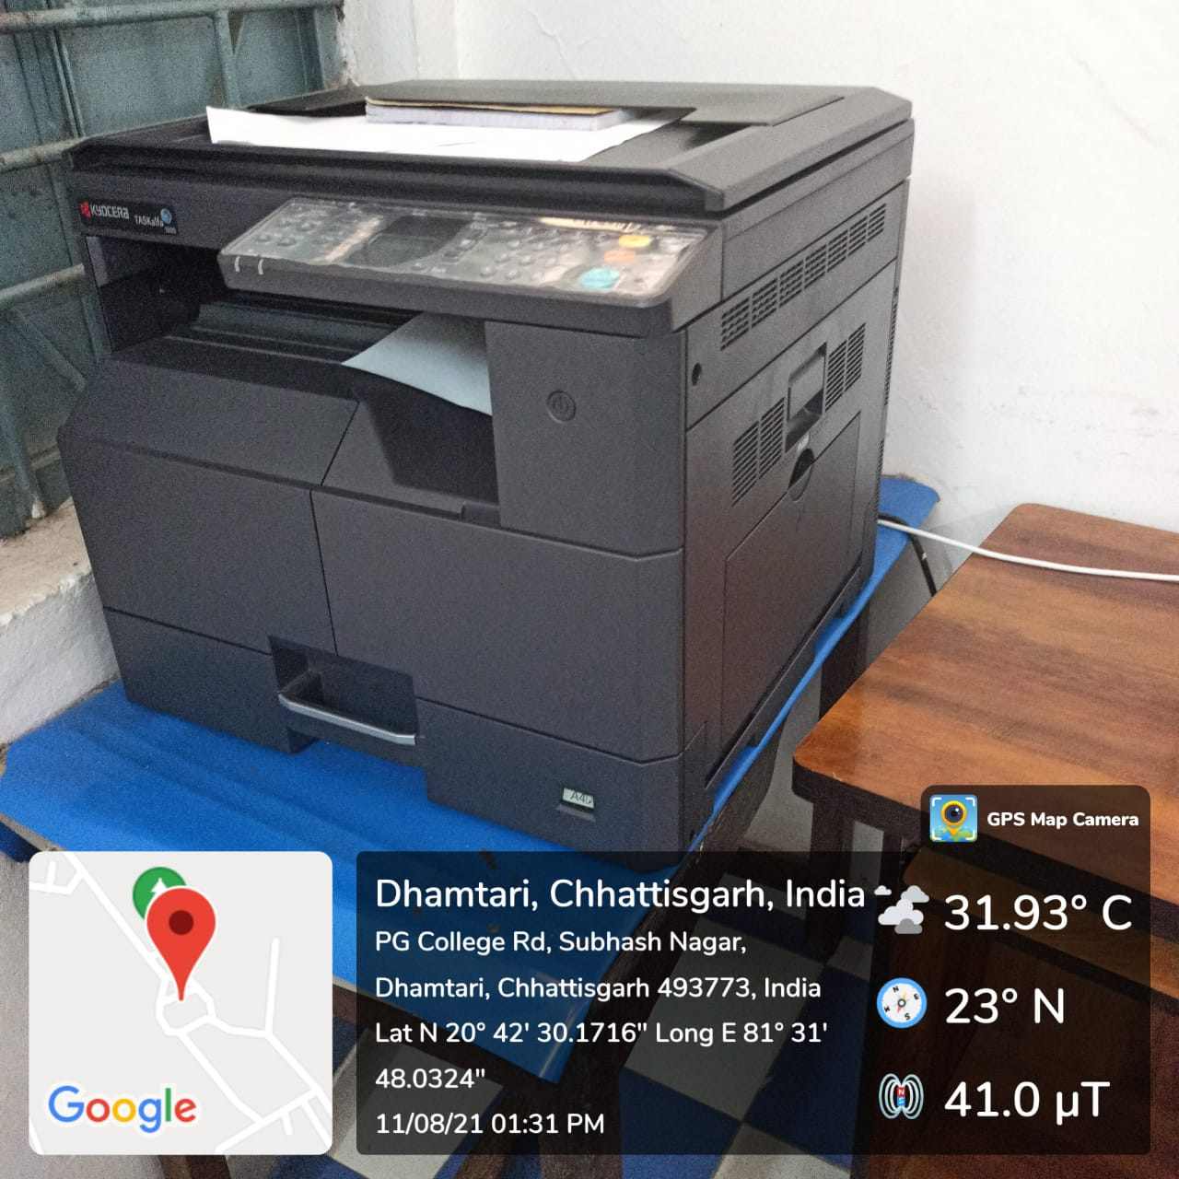

Xerox machine installed in Economics Department(Economics Research Centre)

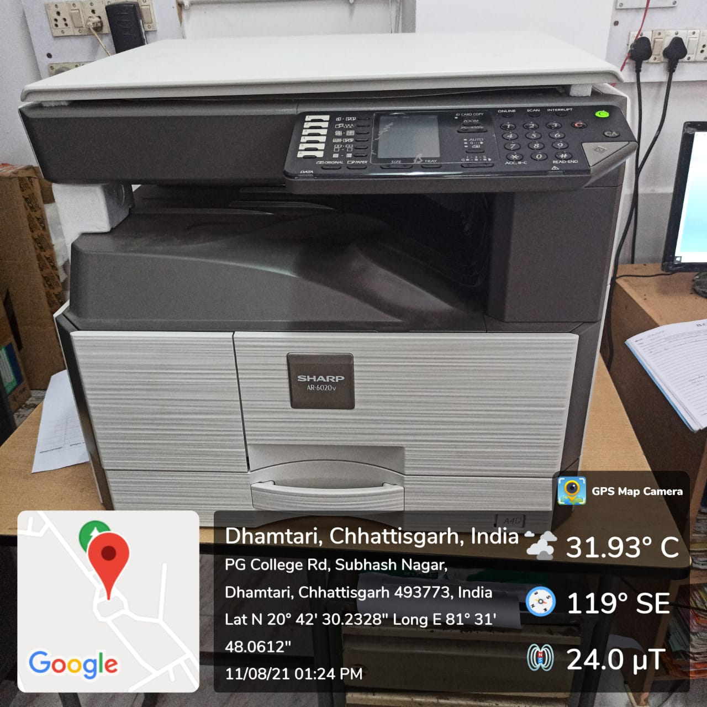

Xerox machine installed in Hindi Department(Hindi Research Centre)

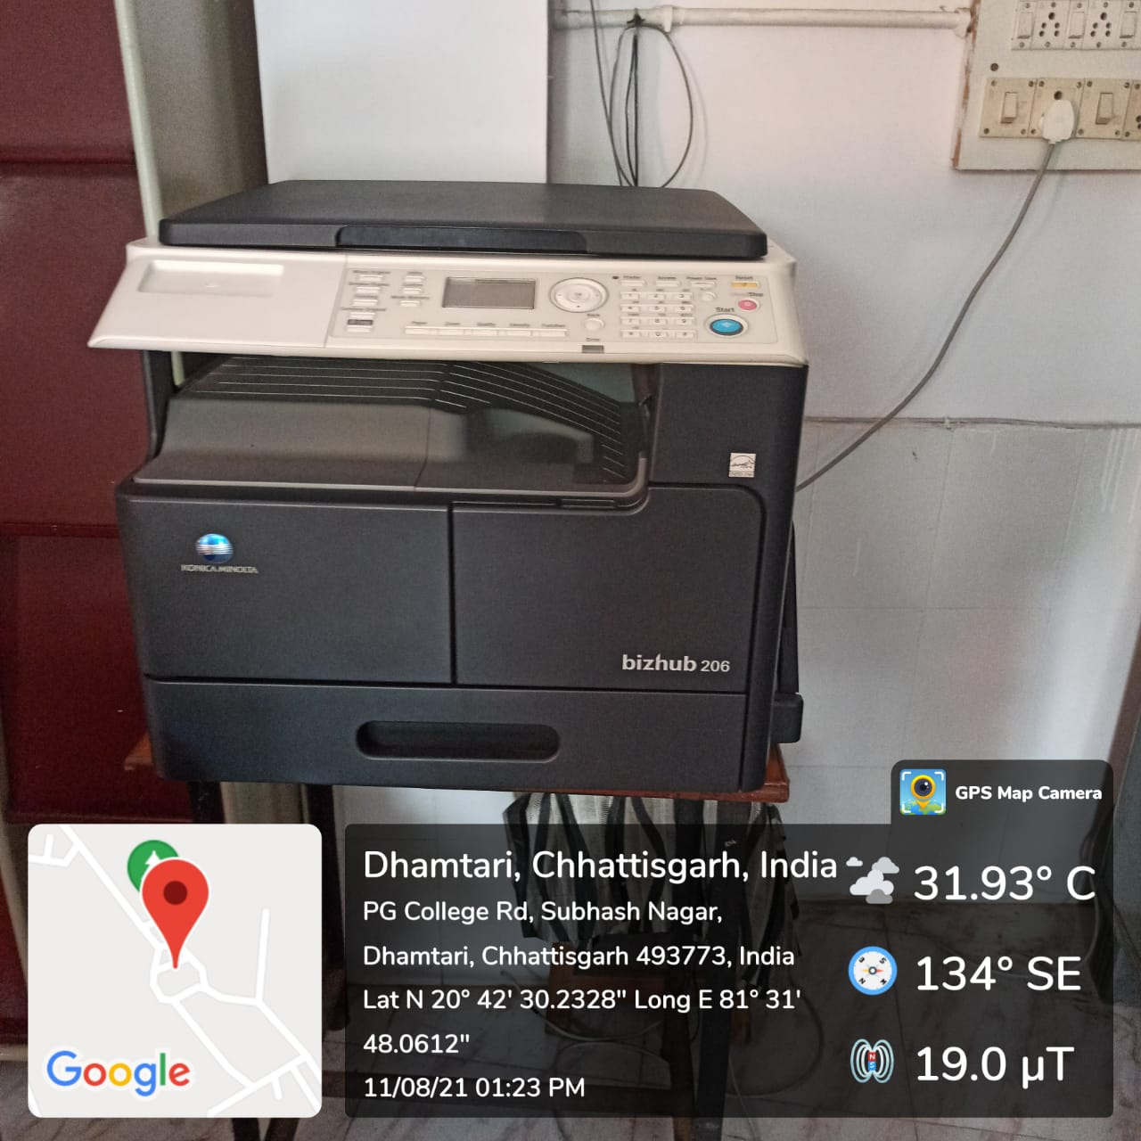

Xerox machine installed in Examination Control Room

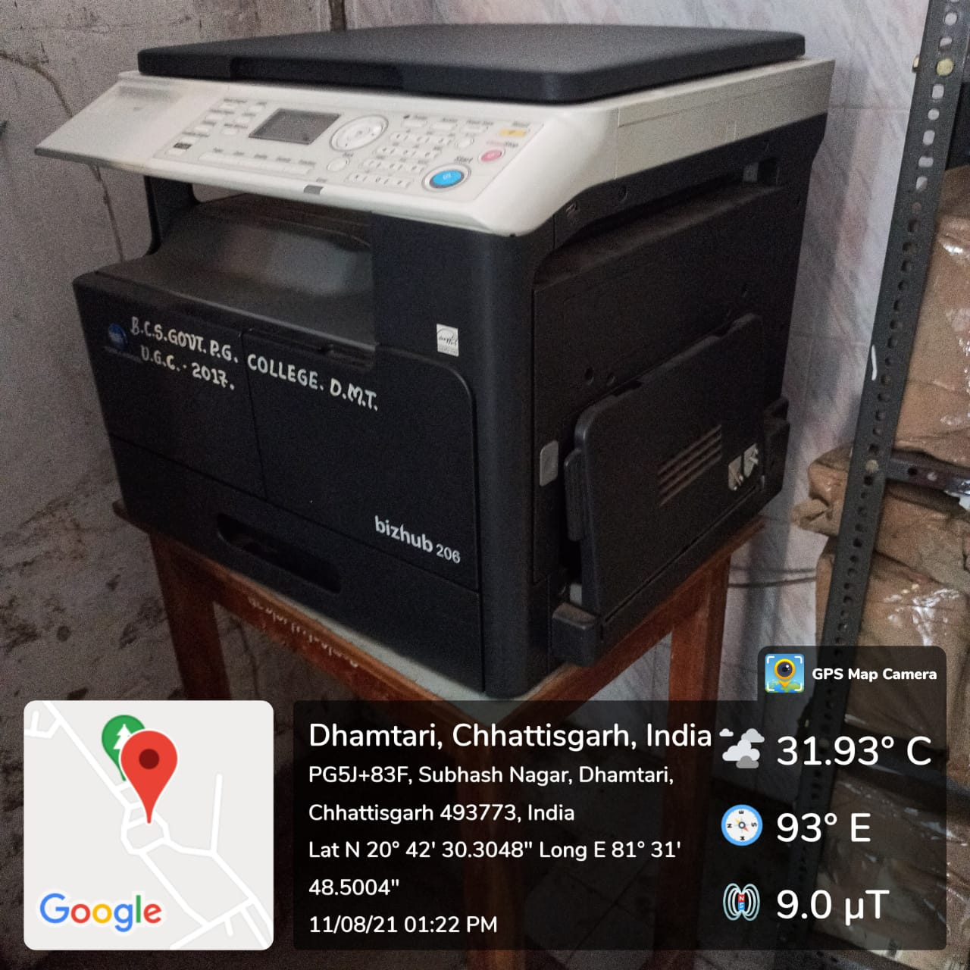

Xerox machine installed in Central Library

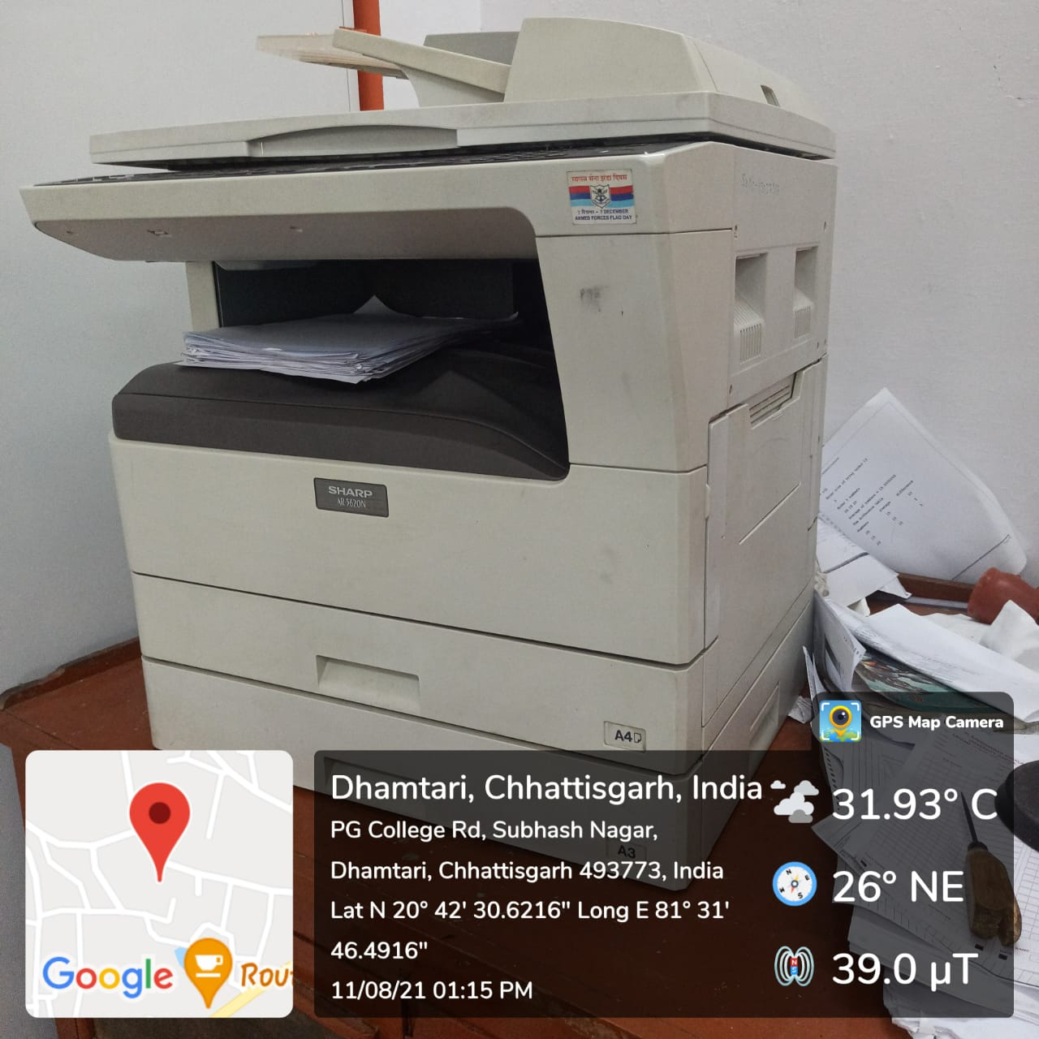

Printer installed in Geography department

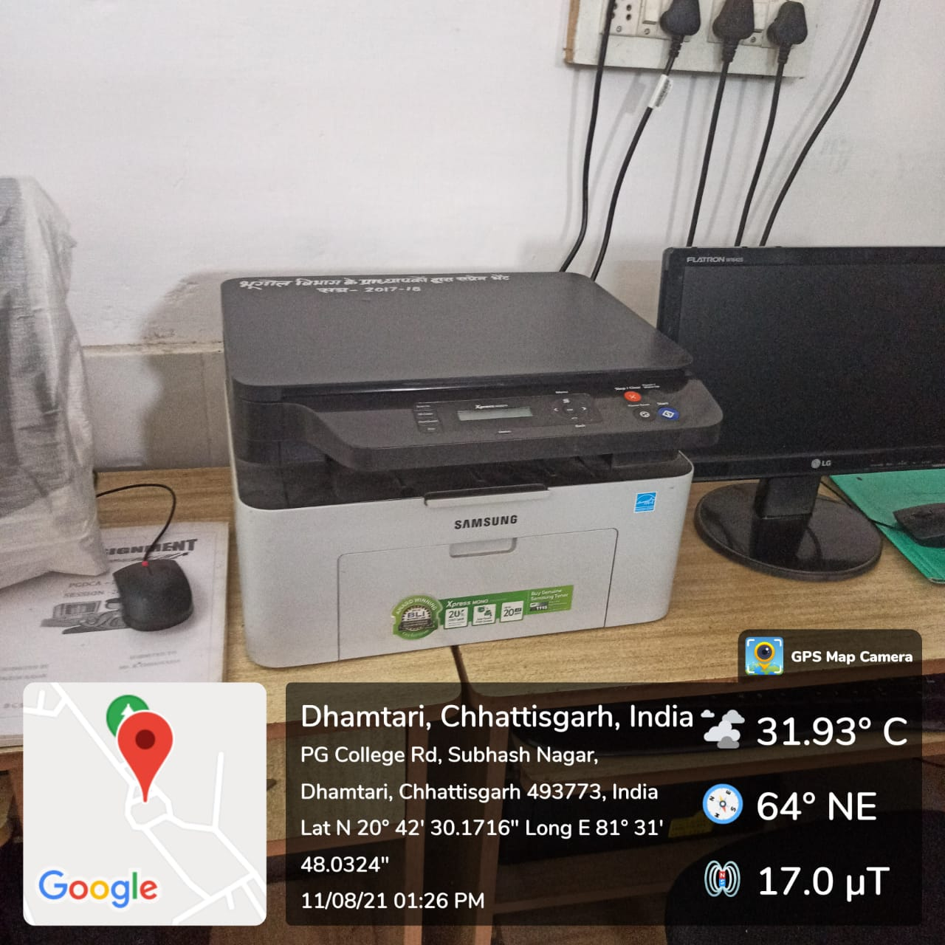

Printer installed in Economics department

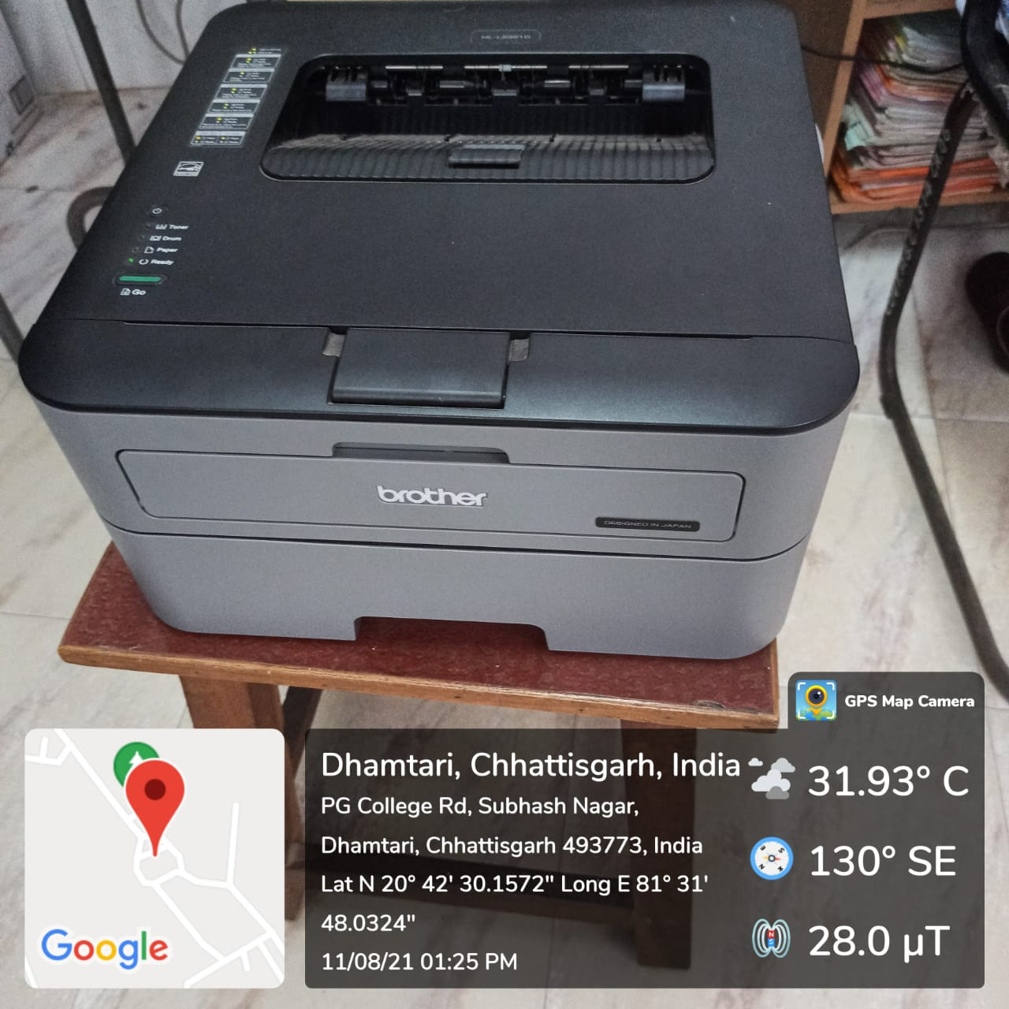

Printer installed in IT department

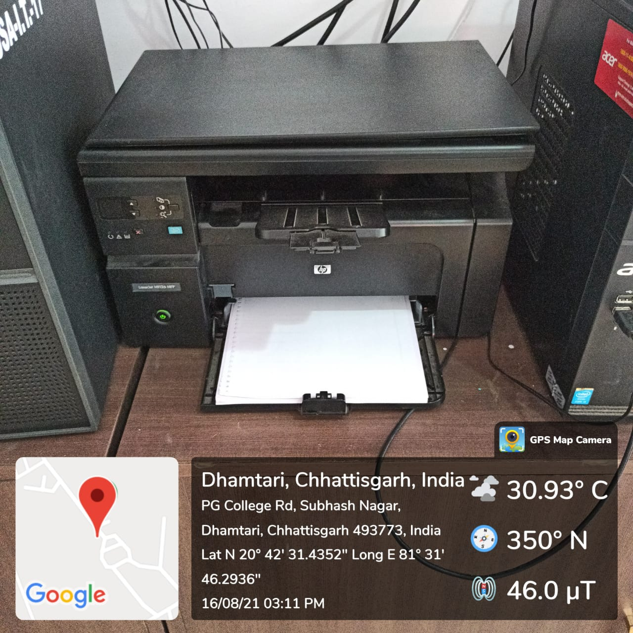

Printer installed in IT department

