BEST PRACTICE – 2020-21
- Title of Practice – Honouring Health Workers and Awareness programmes in community during Covid-19 pandemic.
Public awareness is a powerful medium to stop the spread of corona. Hence the NSS units of our college conducted awareness programmes. College family started honoring the Health Workers for their sacrifice and dedication during pandemic along with the women they had been honouring in the previous years.
Objectives of the Practice
- To motivate Health Workers by honoring them.
- To apprise the frontline health worker about our concern for them.
- To make people aware of the Pandemic.
- Shows sensitivity of students regarding Covid-19.

Context
To honour the selfless service of the Health Workers on the occasion of International Women’s Day on which occasion we had been honouring women workers of different sectors. Hence we honoured the health workers in the District Hospital, Dhamtari.
To inculcate human values among our students we motivated them to organize awareness porgrammes to stop the infection of Covid-19 in rural and urban sector. Hence they made the people in the nearby areas aware of the impact of corona in the society by urging the need of using mask, sanitiser and social distancing.

The Practice
The women staff member of the college organized a programme on 08-03-2021, international Women’s Day, to honour the women in the District Hospital. Because of the Covid-19 Pandemic we decided to honour the Health Workers along with women to motivate them to serve the corona patients with enthusiasm. Among them were Doctors, Nurses, Technician, Drivers and other class four employees like ward-boys of the District Hospital, Dhamtari. For the last five years we have been honouring the working women in different sectors but from this year we have started honoring the Health workers realizing their indispensable role during corona-Pandemic.
Awareness programme being one of the useful ways to make the people know regarding the fatal impact of Covid-19, our NSS units started the awareness campaign in the locality. During the rallies and awareness campaign they asked the people to use mask, sanitiser and social distancing when they go out of their house for some unavoidable work. On 18-11-2020 NSS and Red- Cross volunteers organized the campaign in Mujgahan, Ratnabhandha, Sorid and Potiyadih Villages.
Evidence of Success
- We found a sense of gratefulness in the face of the Health workers being honoured by us. They all thanked the college family for their concern as a noble gesture.
- This sort of programme encouraged the Health Workers to serve the corona patients with a new zeal and enthusiasm.
- After the awareness programmes the people were seen using masks and sanitisers when they are in market places and any other public places. people also started motivating their family members regarding the same.
Problem Encountered and Resources Required
- We could only also honour the Health Workers in District Hospital, Dhamtari. Due to lack of resources we couldn’t do the same in private clinics.
- People were very careless during the Pandemic hence students could organize limited number of awareness campaign became of risk of being infected with corona.

Celebration of International Women’s Day:
Honoring the Corona Warriors in District Hospital Dhamtari
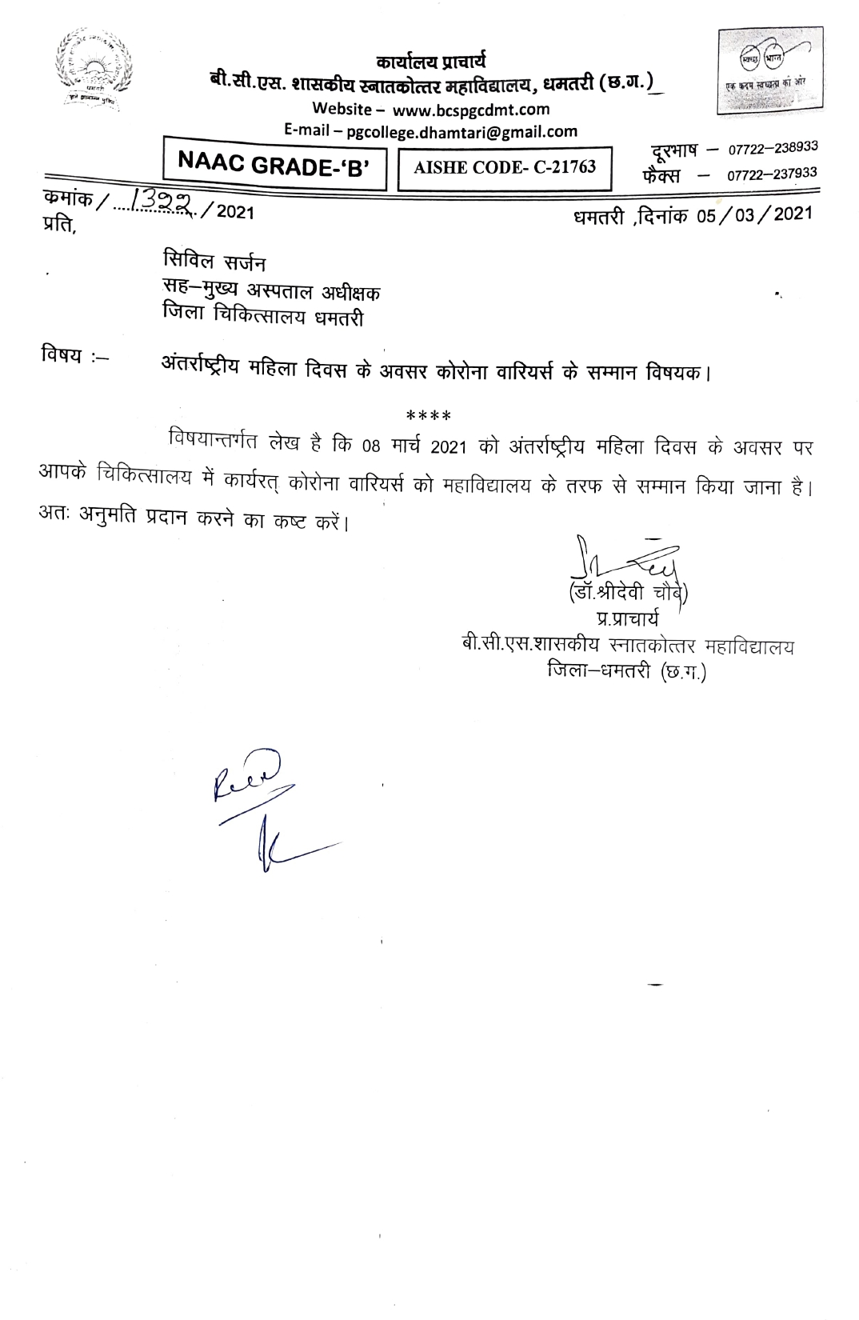

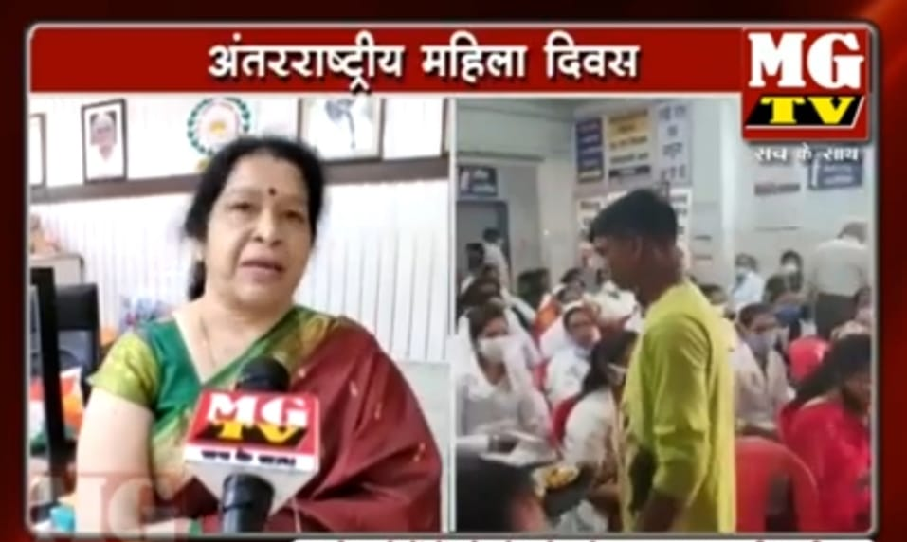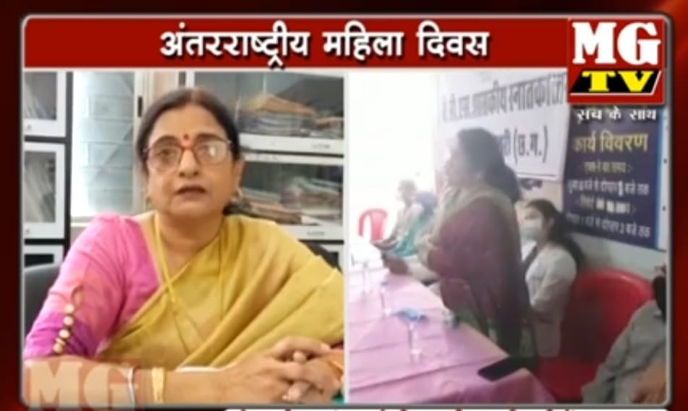
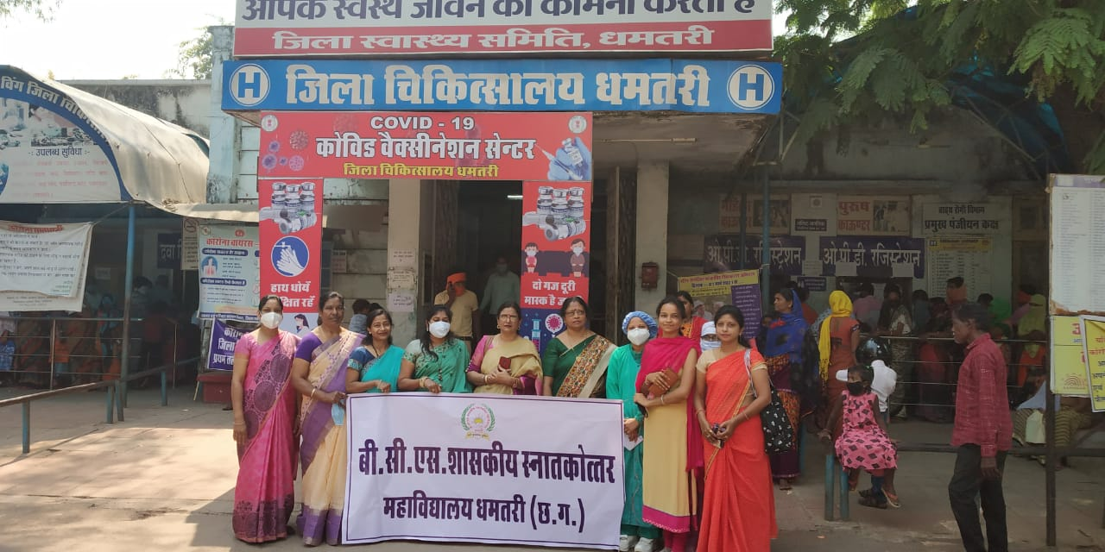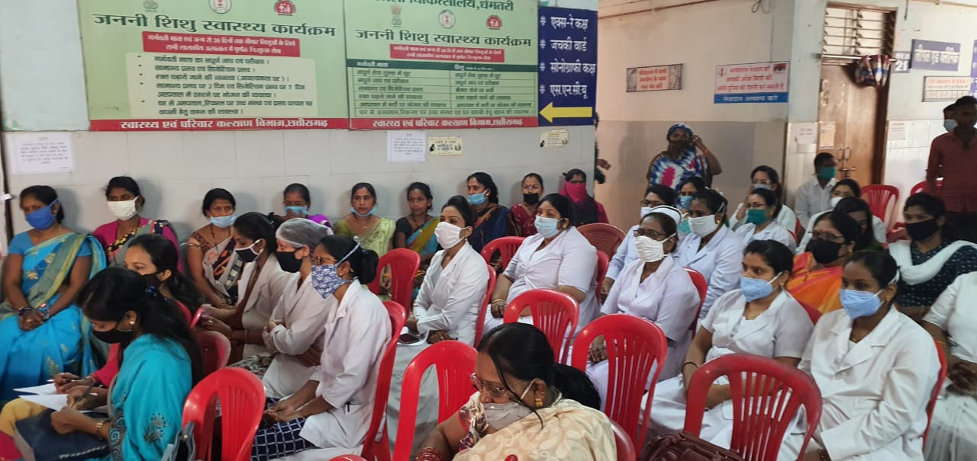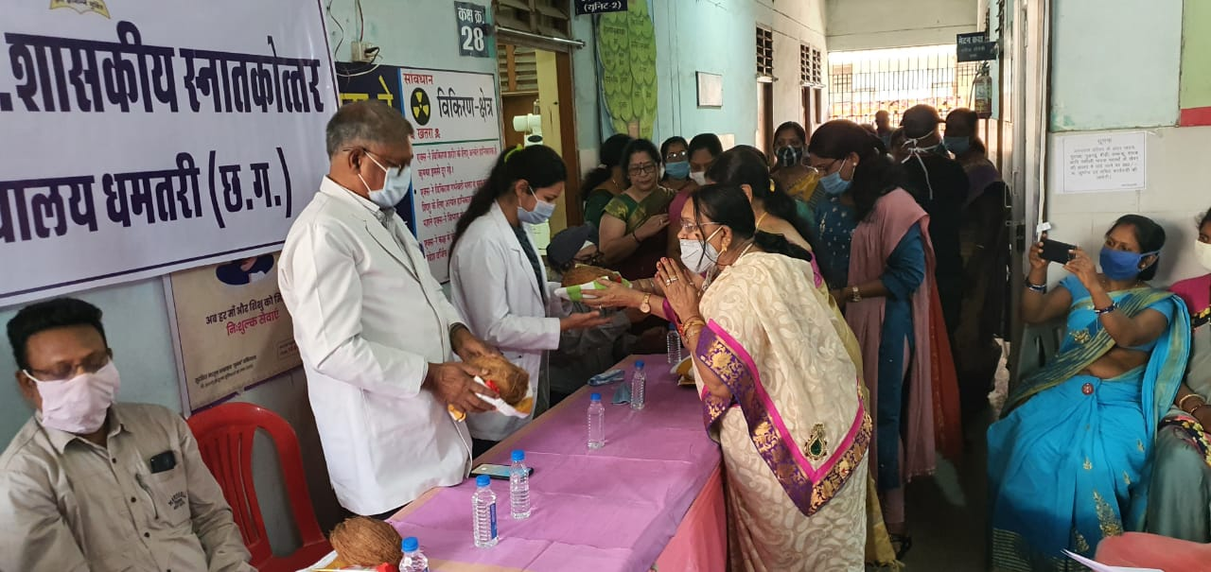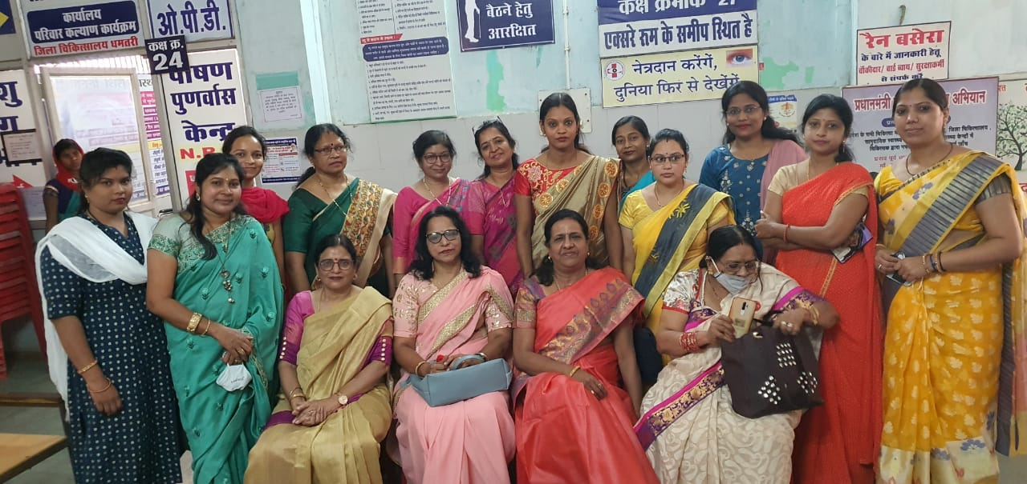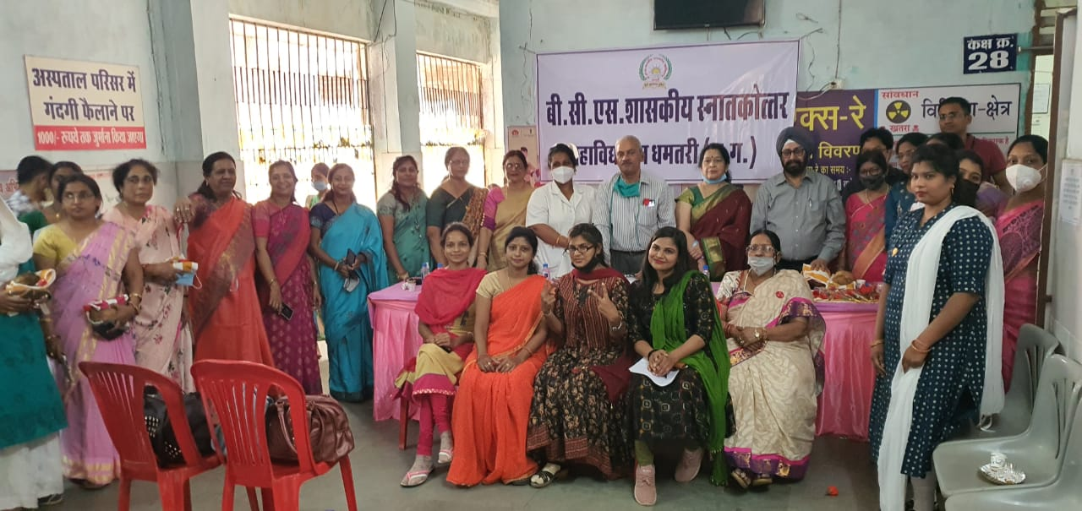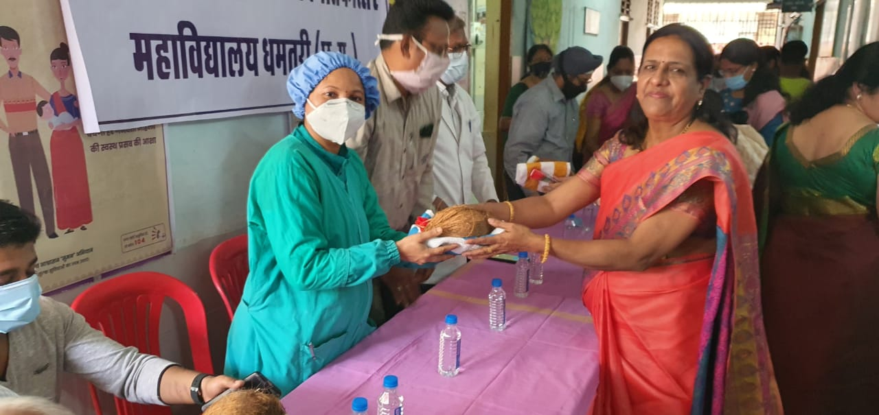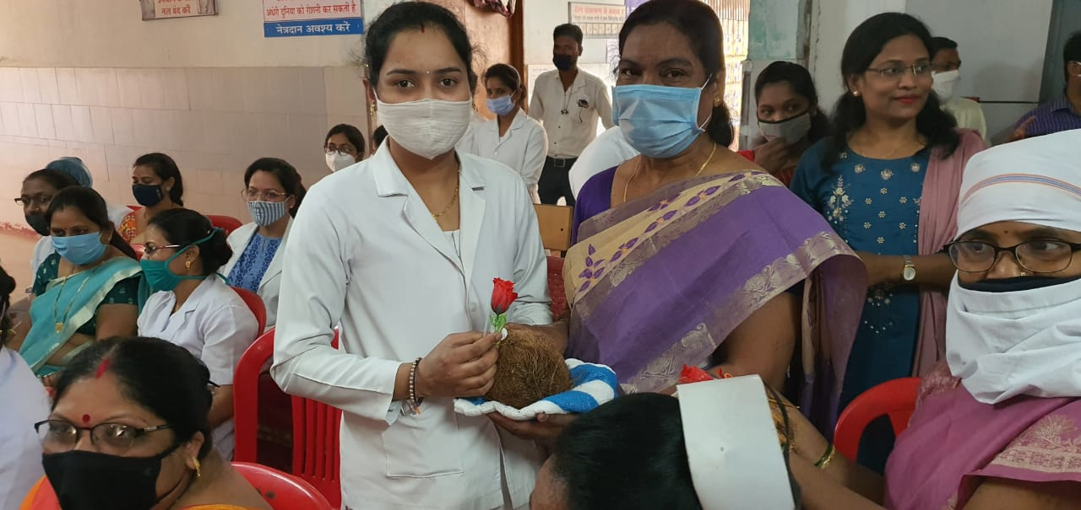
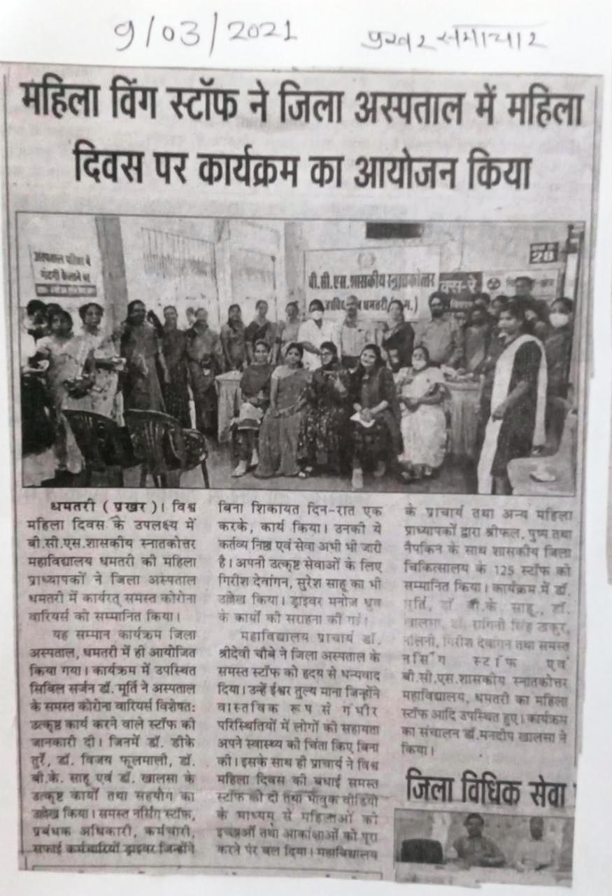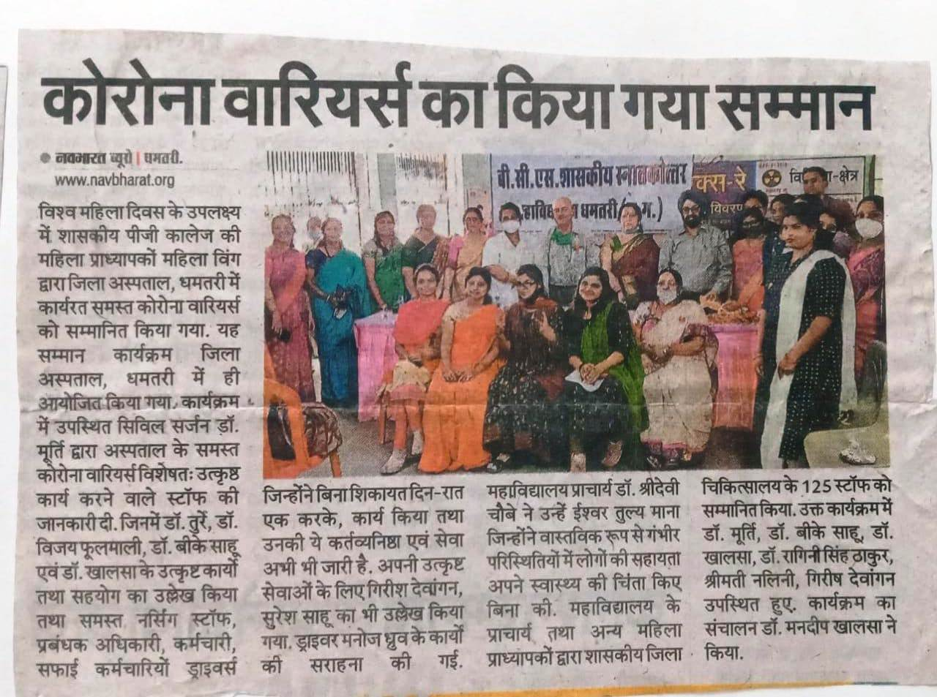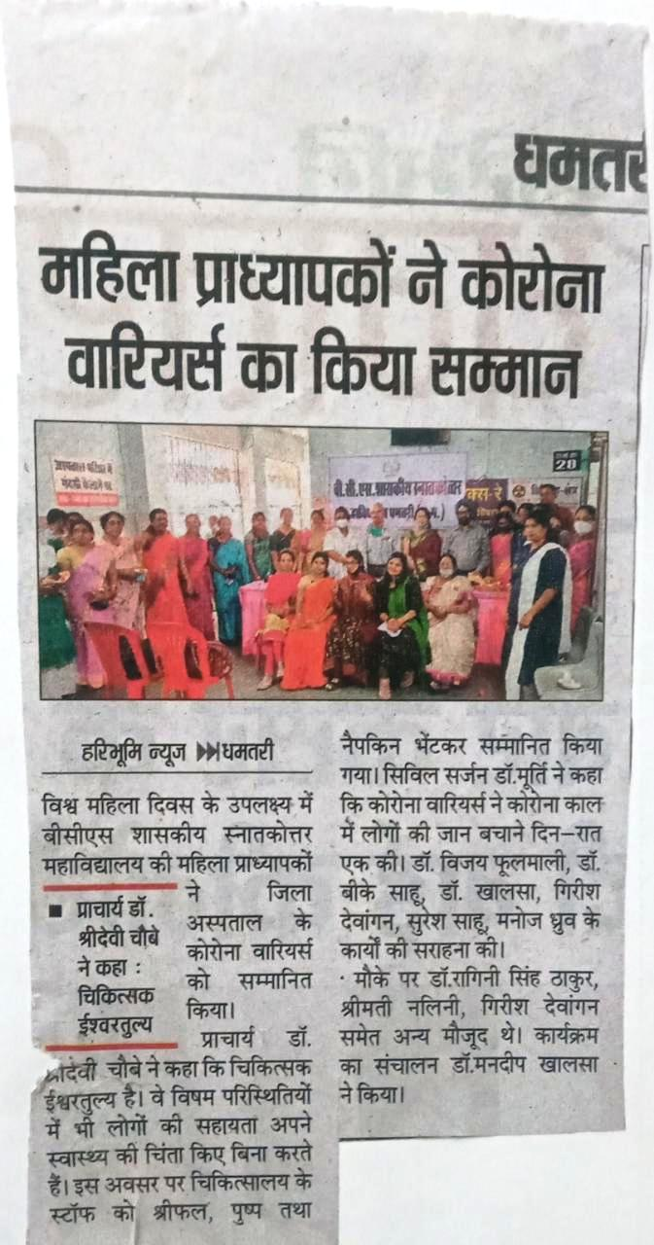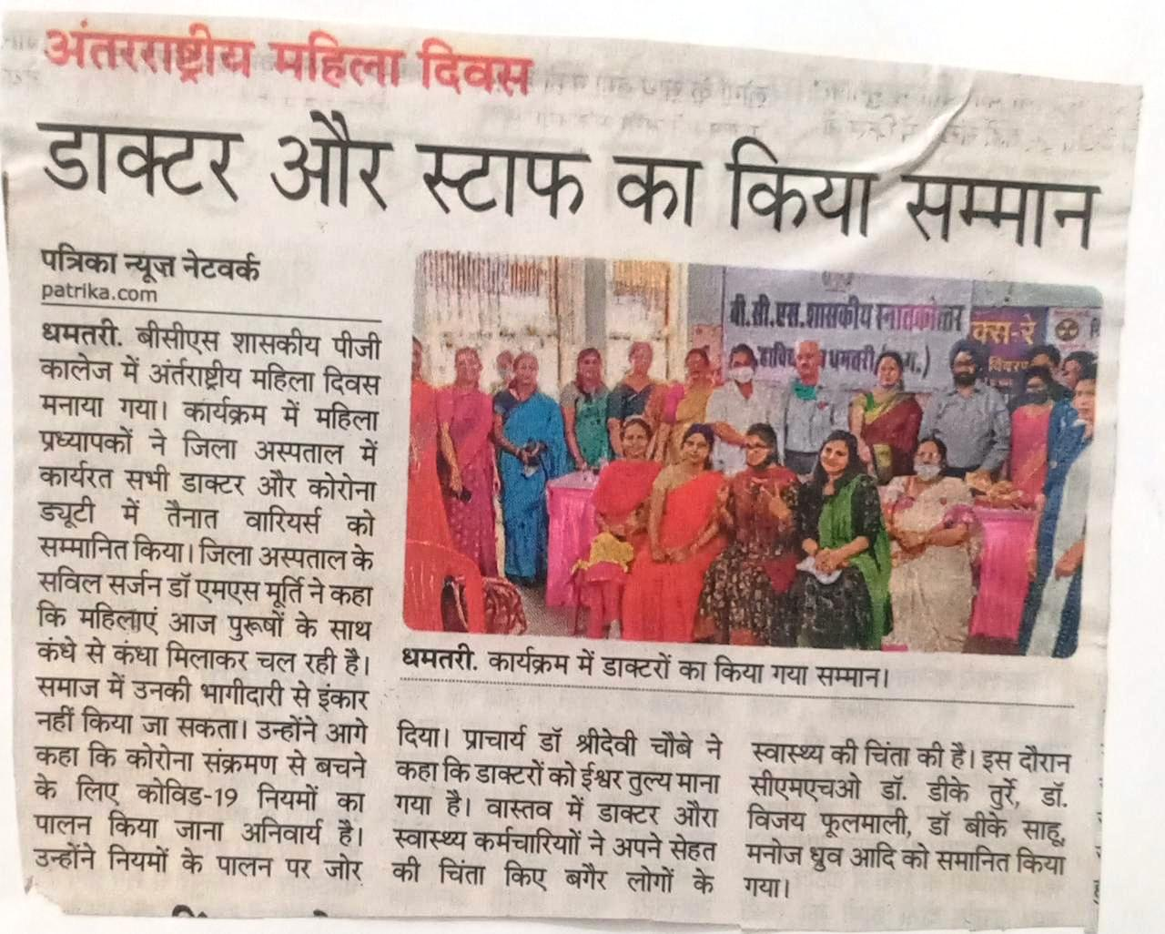

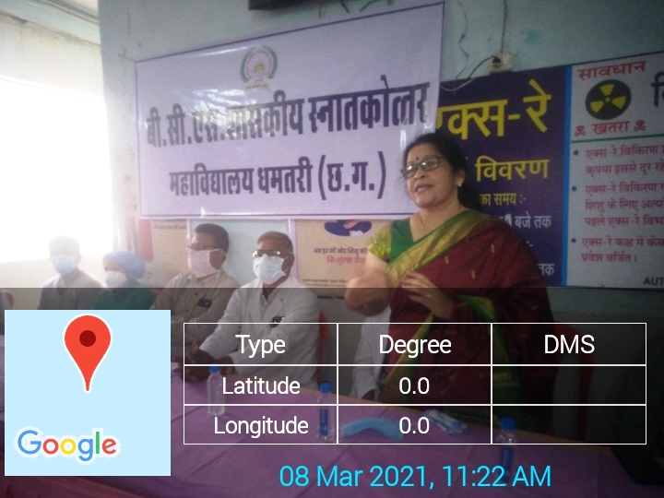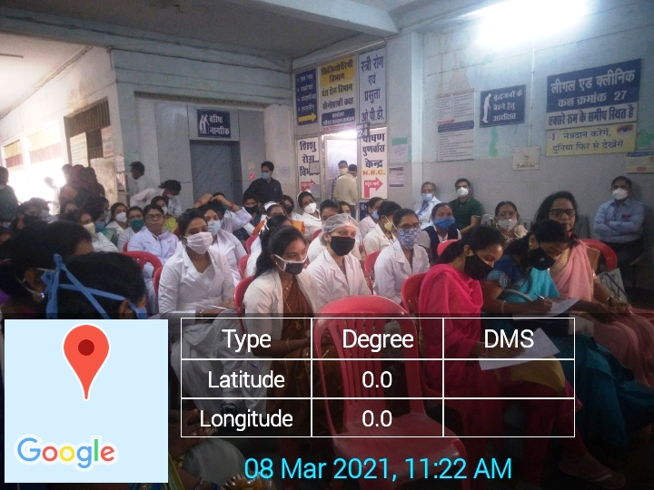

Covid-19 Awareness Campaign by NSS Unit and Red-Cross Society
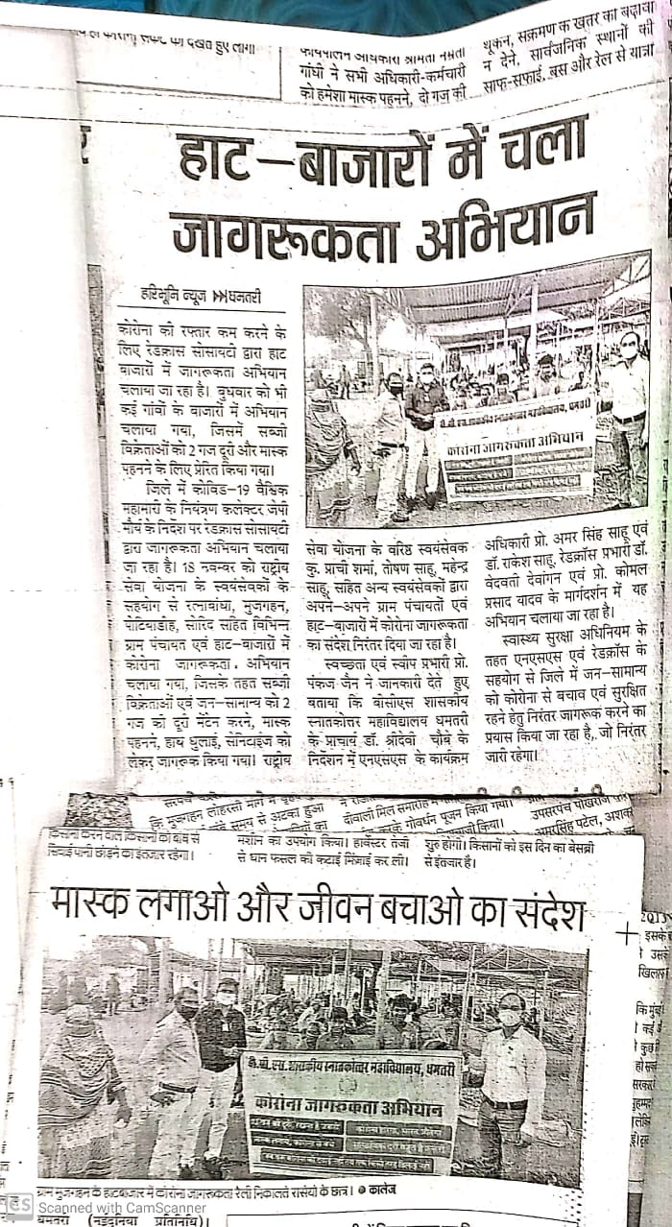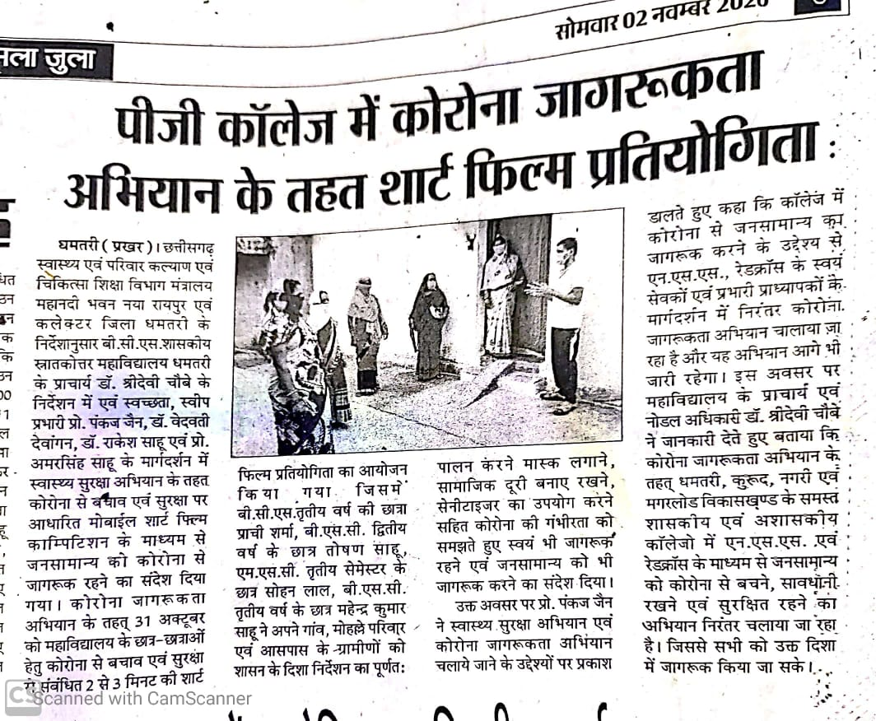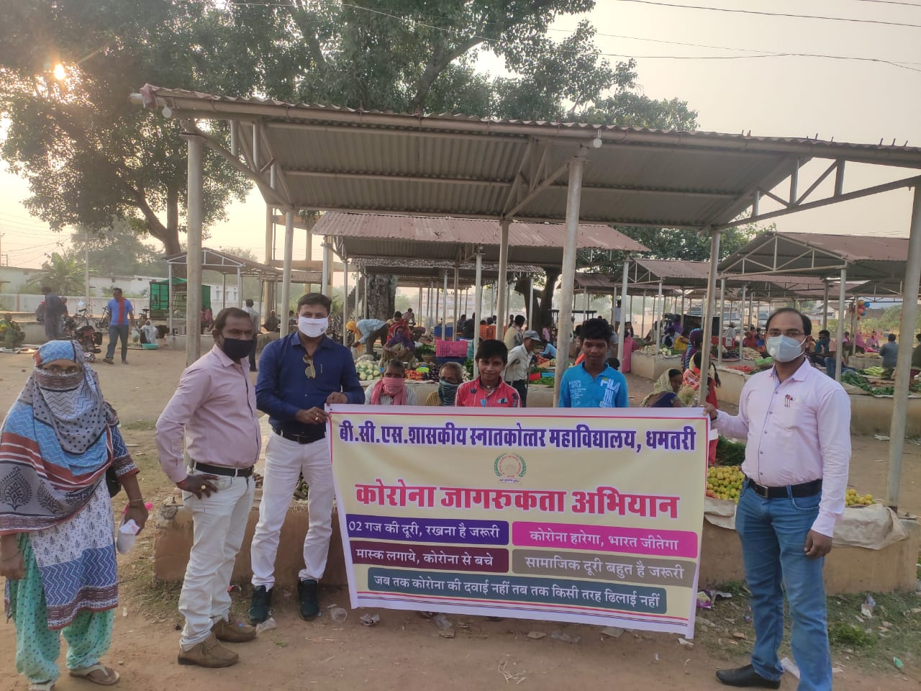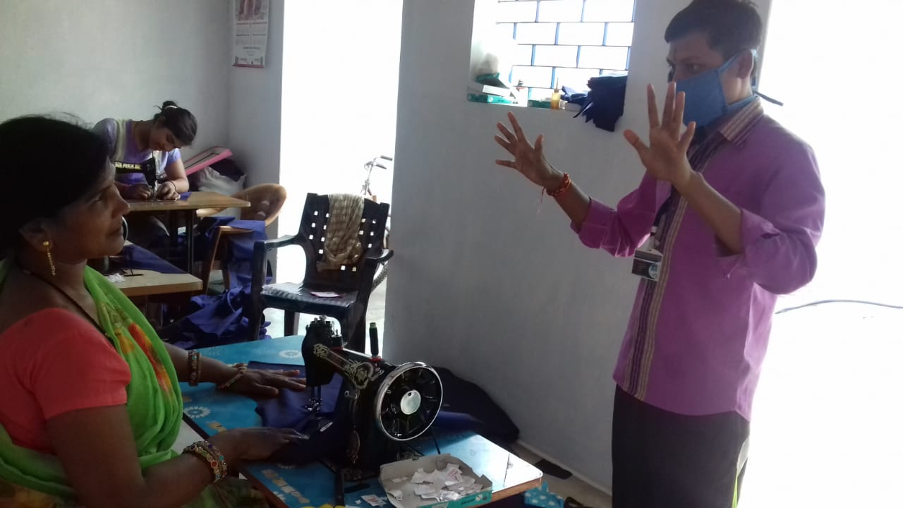

BEST PRACTICE – 2020-21
- Title of Practice – Financial Assistance by welfare club of the college.
Objectives of the Practice
- Helping the needy students, staff members and others to fight against health crises.
Context
During the time of medical urgency the welfare club helps out the needy family for the arrangement of medical expenses.

The Practice
Each and every year if someone of our college family, students or any other faces medical hazard for some critical illness. Welfare committee of the college comes forward to extend financial help for ailing member of the family so that monetary stress does not hinder proper treatment of the disease.

Evidence of Success
- In the month of May 2021 when daughter of Mr. Kisan Lal Yadav was suffering from critical disease related to mental health and was in need of large sum of money for the treatment. At that juncture welfare committee of the college arranged an amount of 47 thousand 400 rupees for the help of the patient. She was admitted in the clinic of psychiatrist Dr. Prakashnarayan Shukla, Raipur.
- In the month of April 2021 Mr. Arun Prakash kurrey son of Mr. Bhart Kurrey. He was suffering from mental depression and was admitted in Kolan Hospital Dhanwantri, Raipur and estimated cost was around 1.5 lakh. To help Bharat Kurrey the welfare committee of the college came forward with financial aid of rupees 26 thousand fifty five rupees. This act reflects sympathetic attitude of the staff member of the college to help persons in need through the welfare committee.
- Durga Thakur, diabetic patient with problem of amputation of leg was in need of financial help for proper treatment and artificial leg. The name was referred to us by Dr. Sarita Doshi, social worker, for possible help for ailing Durga Thakur. Welfare club of the college took the initiative to help Durga Thakur for his health crisis and collected an amount of rupees 13600 for the help.

Problem Encountered and Resources Required
- Because of short notice we could collect an amount of 13600 for the financial aid of Durga Thakur.
- Because of less number of permanent faculty members we are not in a position to arrange a sizeable amount for these crises.

Financial Assistance to Students, Staff Members and Other for Health Crises
Financial Assistance to Subordinate Staff
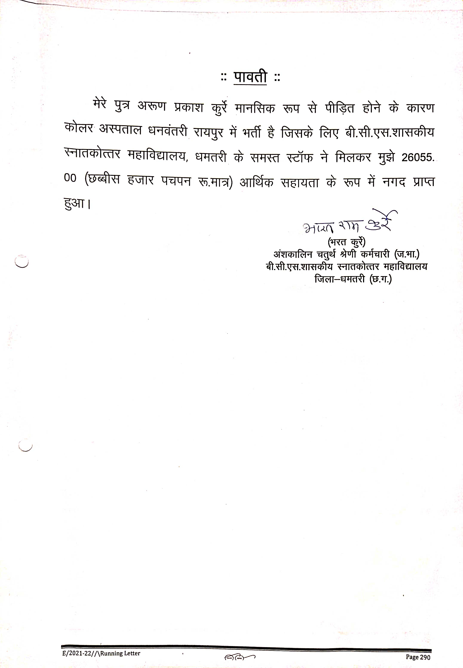
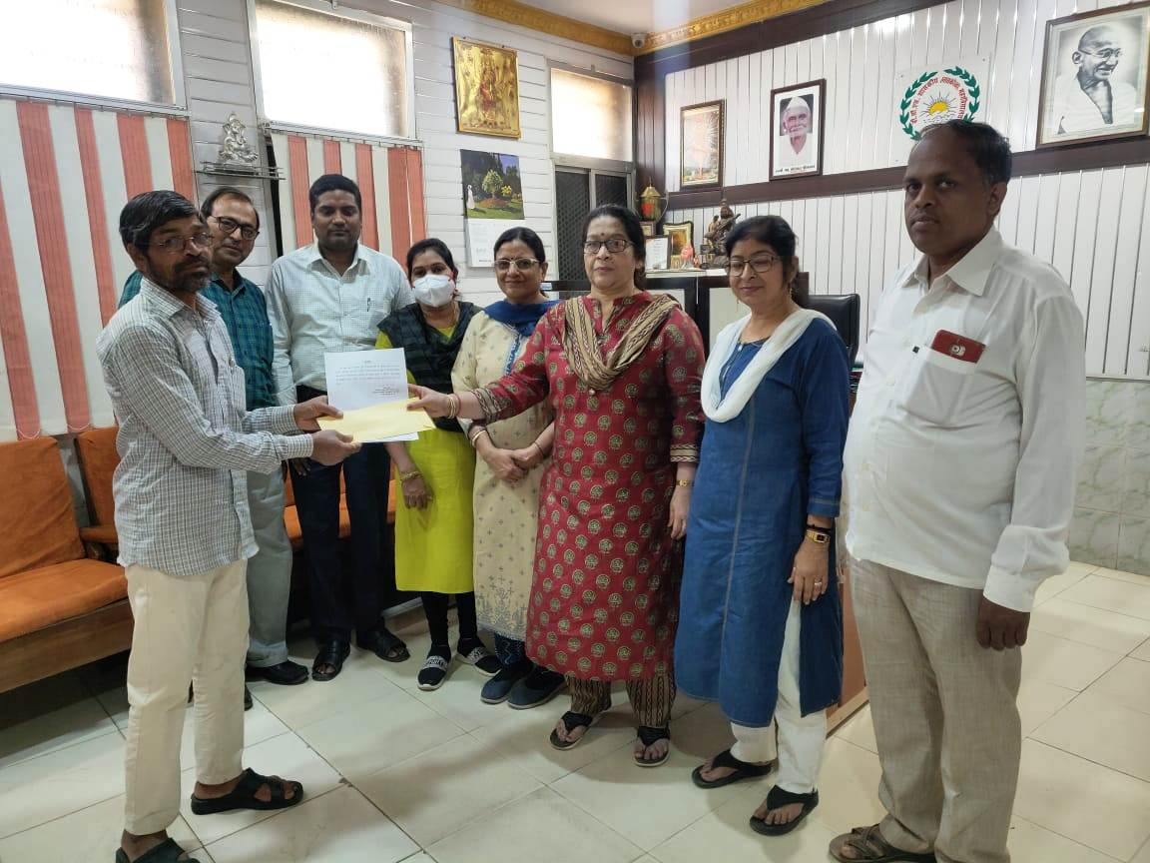

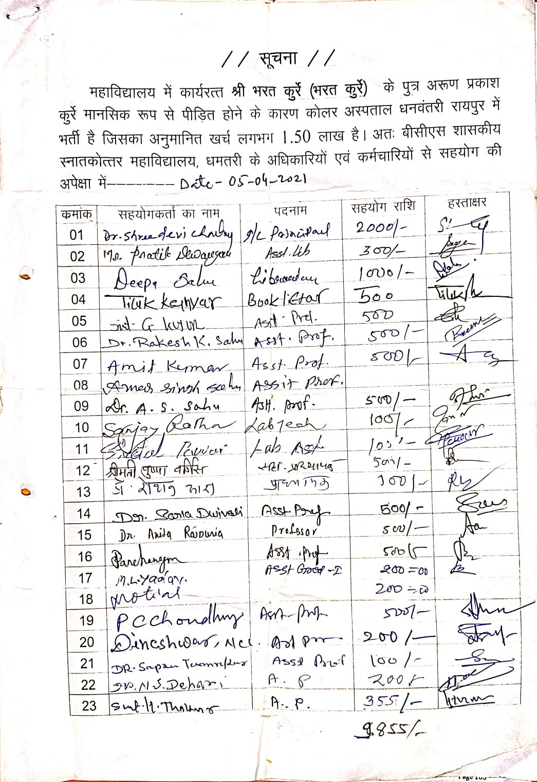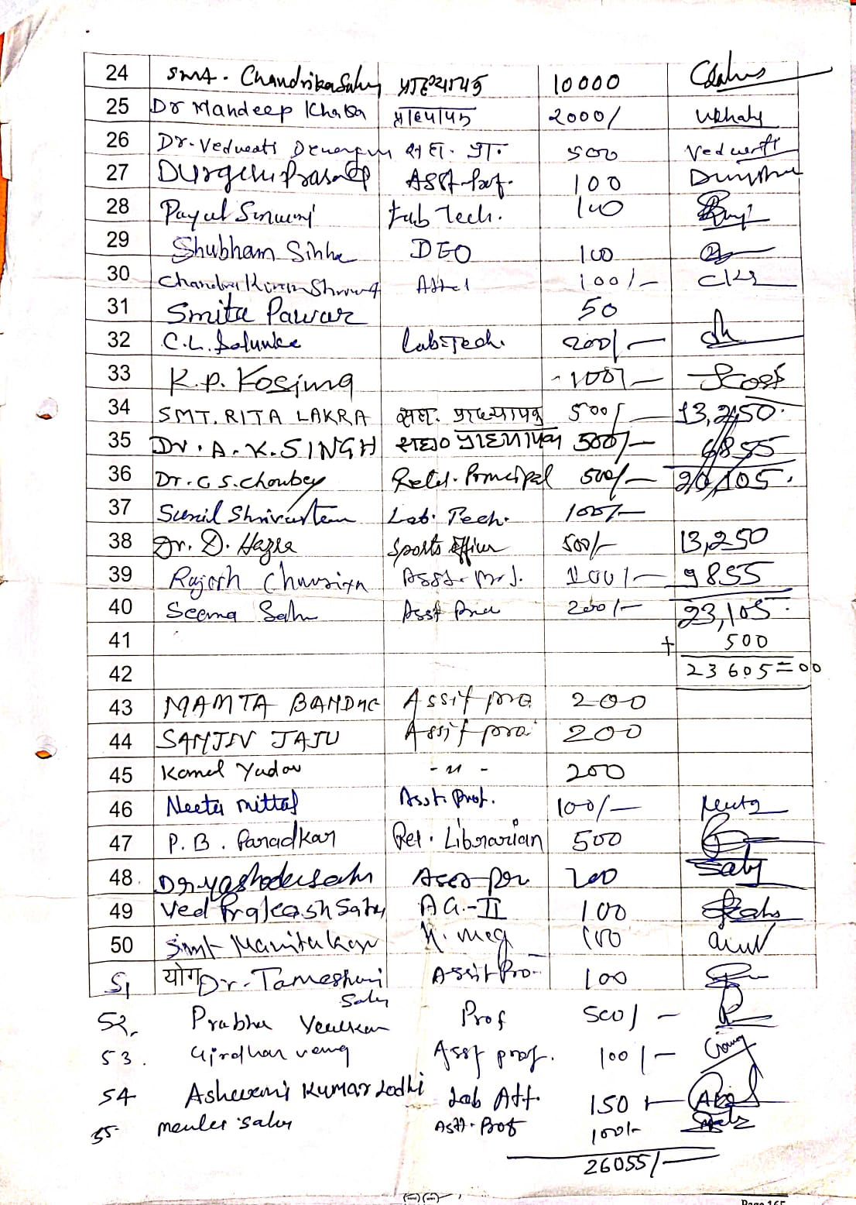

Financial Assistance to Subordinate Staff
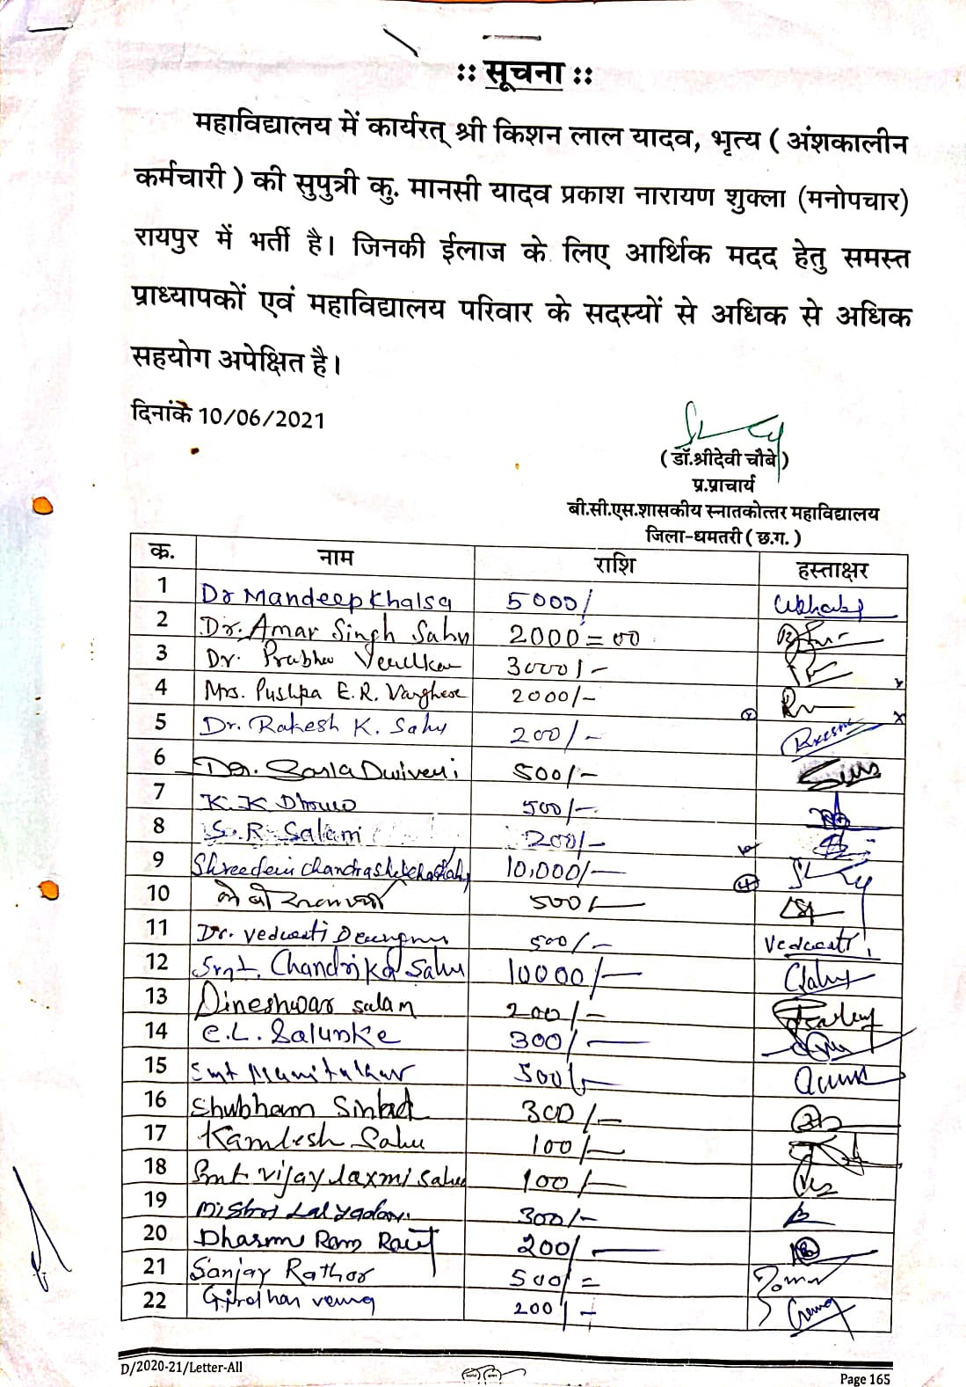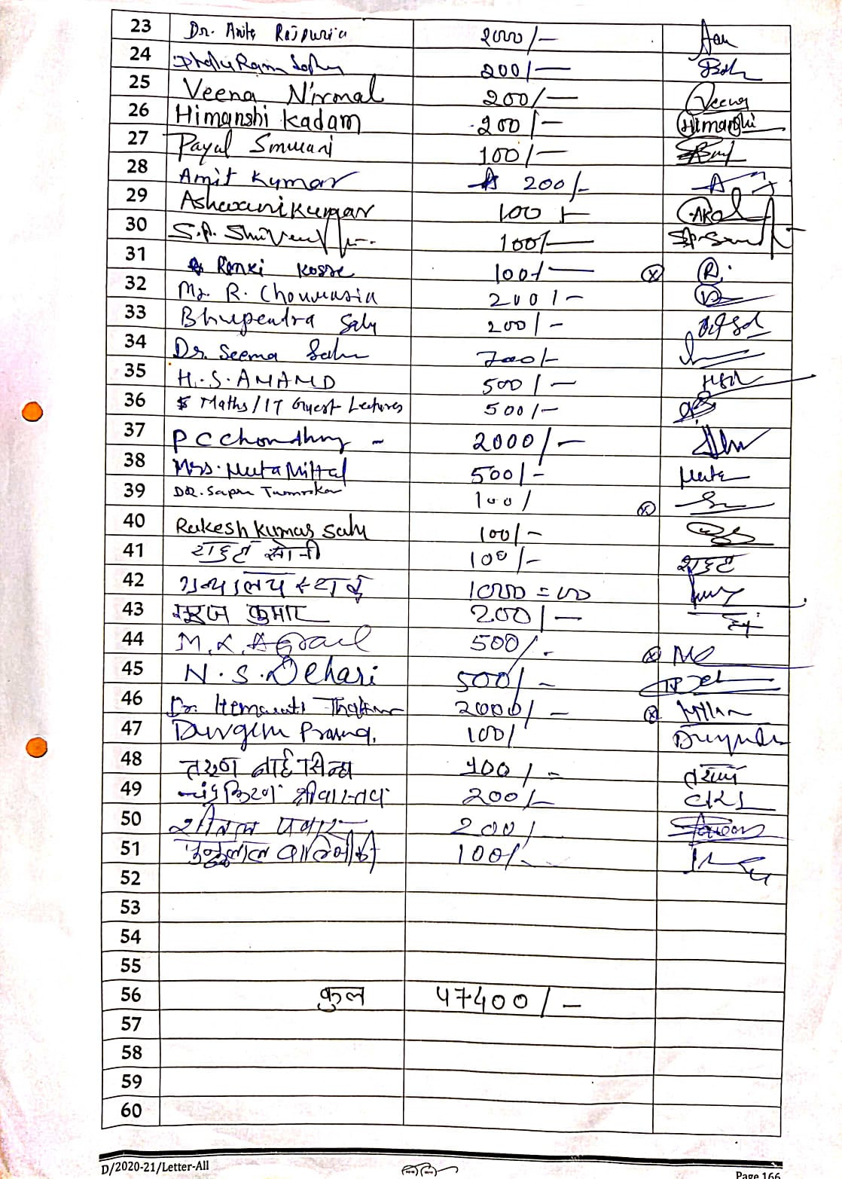
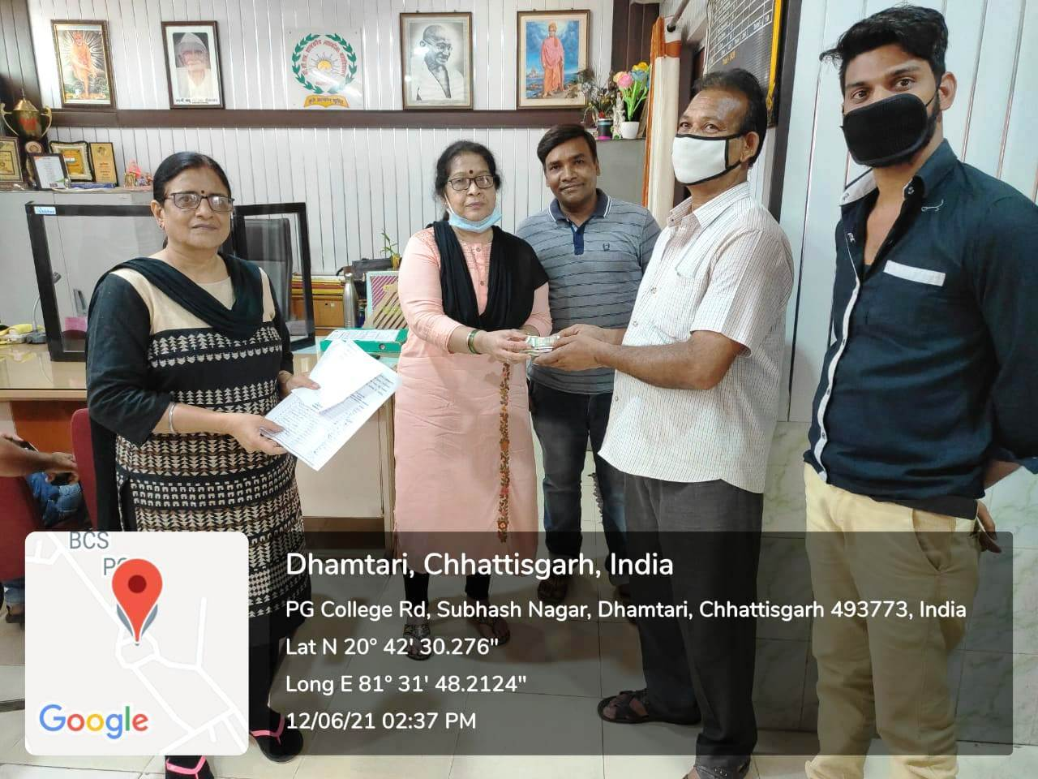

Financial Assistance to Outsiders
