
Board | DSERT
Grade | 7
Topic | Rational Numbers
Name of the volunteer | Sowmya
Learning Objective | - Natural Numbers, Whole Numbers, Integers, Rational Numbers.  - The method of plotting rational numbers on the number line.  - The different rational numbers lying between the given two rational numbers.  - Perform various mathematical operations on rational numbers and develop critical thinking and collaboration in the process
Learning outcomes | Students should be able to:  - Recapitulate of Fractions and know the history of origin of rational numbers and importance of rational numbers.  - Know types of rational numbers and their comparison with other forms of numbers like  whole numbers, integers, fractions and decimals.  - Represent rational number on a number  line. Comparing and ordering of rational numbers without number line and write rational numbers in standard form.  - Compare two rational numbers. Understand that there are infinite numbers of rational numbers between two rational numbers and find out rational numbers between given pair of rational number.  - Perform addition, subtraction, multiplication, division of rational numbers.  - Solve simple word problem on addition,  subtraction, multiplication and division of rational numbers.
Total classes recommended | 4
The main concept of the lesson | Comparing Rational Numbers, Representing rational numbers on number line, Find out Rational Numbers between given pair of rational numbers.  Addition, subtraction, multiplication and division of rational numbers.
Prior Knowledge | Knowledge of whole numbers, natural numbers, integers and fractions.
Key terms to be introduced | Representing rational numbers on number line.  Addition, subtraction, multiplication and division of rational numbers.
Initial Discussion | Facilitator will ask few questions to introduce the topic  - What is a whole number?  - What is an integer?  - What are fractions?  - What is rational number?  - What is the Difference between fraction and rational number?  - How many rational numbers are there in between 2 integers or two rational numbers?
Real world Example | - Rational Numbers:  Express the distance in rational numbers how much above the sea level whale has jumped in the first image and how much below the sea level whale is swimming in the second image.  Example: Whale would have jumped 12 1/5 meters above sea level which becomes positive fraction and whale would be swimming 17 ¼ meters which would be negative fraction with respect to the sea level.  Explain about Rational Numbers.    2) Operations on Rational Numbers: Explain simple day to day examples of adding and subtracting rational numbers. 1 such example shown below.  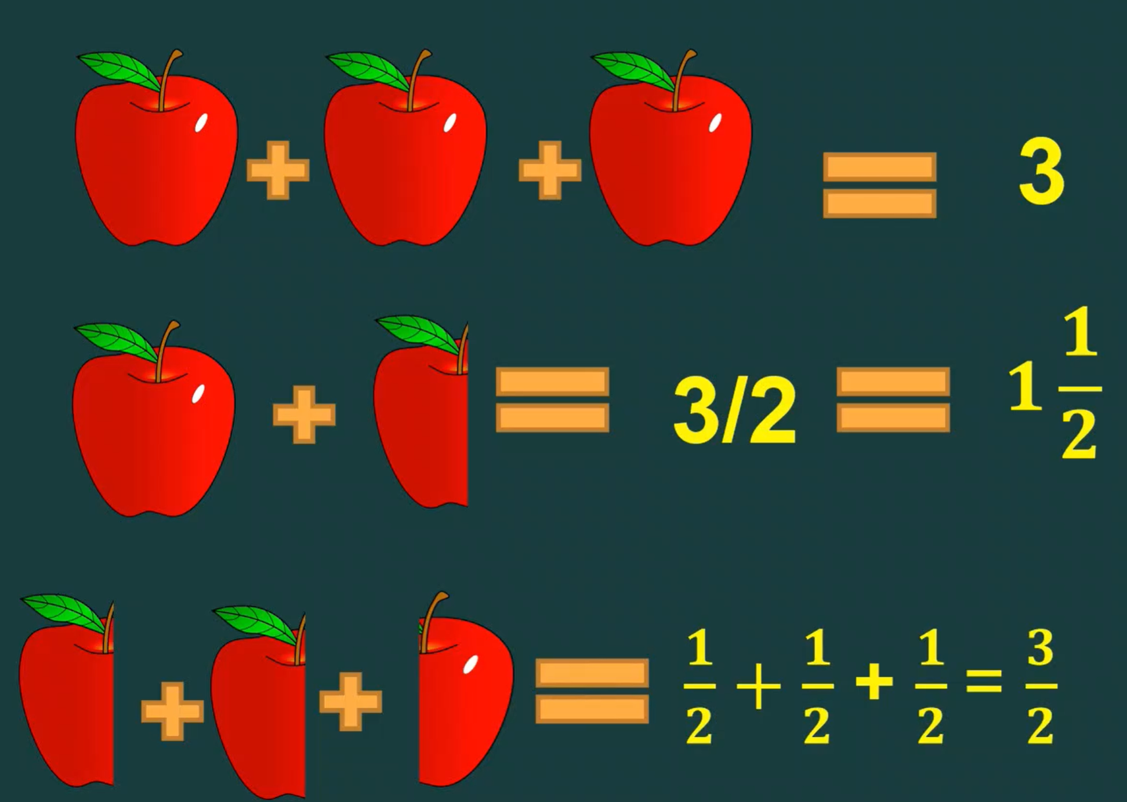
Recall | Review the definitions of all forms of numbers in the number system like natural numbers, whole numbers, integers, fractions and rational numbers.  Ask a few students at random to share the representation of positive and negative rational numbers on a number line along with their reasons behind the placement of both the numbers.  Solve problems and word problems on operations on rational numbers.
Concepts to be taught | ∙ Recapitulate concept of fractions.  ∙ Introduction to rational numbers.  ∙ Understand how rational numbers came into being in study of number system.  . Compare Rational Numbers with other forms of numbers like whole numbers, integers, fractions, decimals.  ∙ Represent rational numbers on a number line.  ∙ Compare and order rational numbers with number line.  ∙ Write rational numbers in standard form.  . Operations on Rational Numbers, addition, subtraction, multiplication and division.
To solve | - Text Exercise  - Worksheets  - Assessments
Project | 1) Students to prepare educational chart on classification of numbers with examples as shown below:  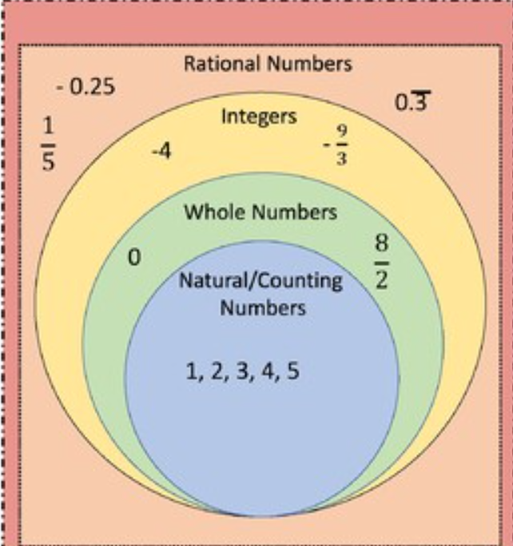  - Provide two rational numbers and ask students to answer below questions with reasoning wherever applicable:  - What will be the sum of these two rational numbers?  - What will be the difference of these two rational numbers?  - Is sum or difference of two rational numbers is also a rational number?  - How will they add/subtract two rational numbers with different denominators?
For Further Reference | https://diksha.gov.in/play/content/do_31279372347208499217884

