
Board | UBSE
Grade | 5
Topic | Mangoes
Name of the volunteer | Kavitha Joan
Learning Objective | This lesson will discuss:  1.Spoilage and wastage of food  2. How to preserve food  3. Preservatives and their role in preserving foods.  4. Technique and skill involved in preservation and cooking.  5. The function and role of FSSAI.
Learning outcomes | Students will be able to:  - Observe and record causes of food spoilage  - Identify & Classify food items that spoil quickly/ stay for a long time.  - Identify steps to prevent food spoilage  - Examine ways to preserve food.  - Analyse and report the various food products found in stores .  - Study the ‘use by and best before’ dates .  - Discover preservation techniques used in making the various food products in food stores.  - List the function and role of FSSAI?
Total classes recommended | 3 hours
The main concept of the lesson | This lesson discusses the spoilage and wastage of food; Methods of preservation of food; the role of FSSAI
Prior Knowledge | It is imperative that students are aware of spoilage of food. Have a little knowledge about how day to day food is preserved if it remains so that it can be used for the next day as well.
Key terms to be introduced | Bread, Mould, Acidity, Moisture, Manufacturing Date, Expiry Date, consumers, food labelling
Initial Discussion | To begin the class ask guiding questions to the students:  1.List out 10 food items in your house that get spoilt in short / long period  2.Name 5 food items made from mangoes that can be preserved for a longer time.  (These are suggested questions. Add more questions like these to activate prior knowledge of students.)
Real world Example | Mango pickle, Jams, Squashes and juices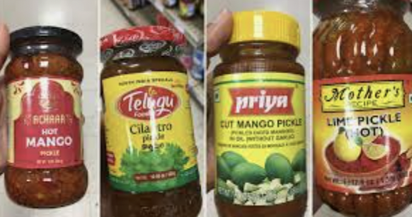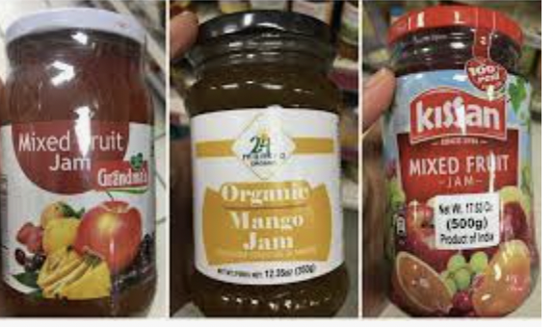
Recall | Create a pop quiz for students and have them recall methods of preservation of food.
Concepts to be taught | 1.Food items that can get spoiled in a short/long period.  2.causes of spoilage of food.  3. preserved food being sold in the market.  4.ways in which food is preserved using natural preservatives like salt, oil, jaggery  5.Importance of FSSAI mark on food products.
To solve | Solve the exercise given in the chapter
Project | Have students create an educational resource, a Book Report . The following can go into the report.  - Have students do this activity and input changes in the bread or Roti . Use the table for reference.  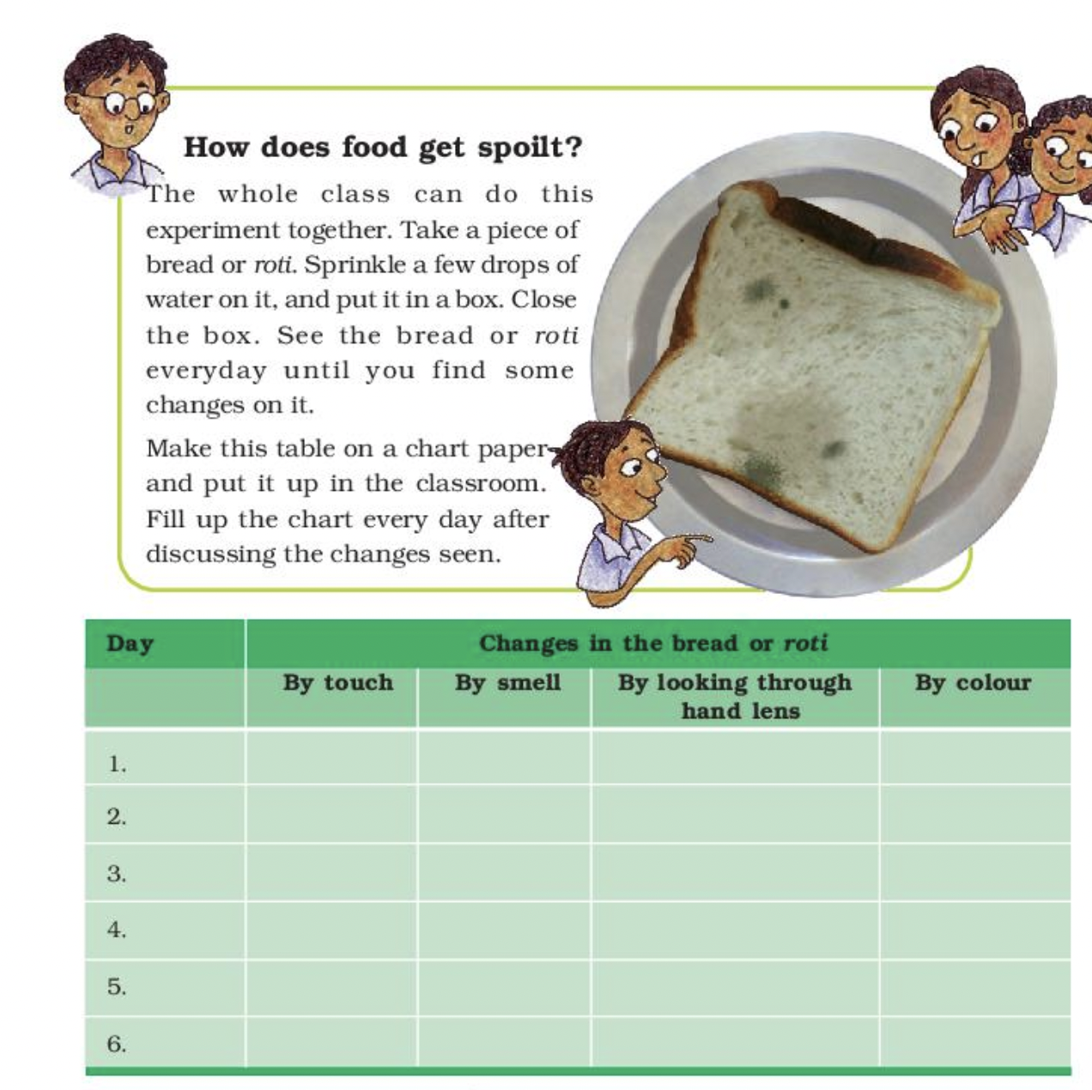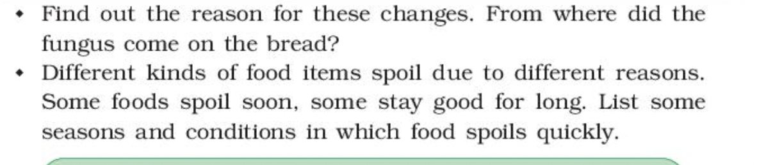  2. Have students answer these questions and have them write steps for the recipe.  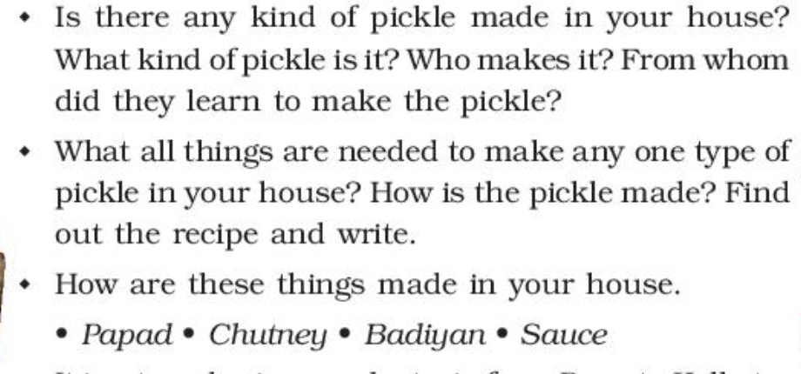
For further reference | https://kvigprimary.files.wordpress.com/2020/06/lesson-plan-mangoes-round-the-year-.pdf

