Mushroom Cultivation Workshop
Date:22-12-2024
Resource person: Kagitala.Lavanya proprietor of Alpha Mushrooms
No.of.students participated:31
Department of Botany conducted workshop and given hands on training on Milky Mushroom Cultivation for the IIIBZC Students. And also explained Commercial cultivation technology of Button, Oyster, Milky, Shiitake, Nutritive and medicinal properties, post-harvest packaging and management, Marketing, Machinery, and equipment for mushroom farm, farm layout, Disease and pest management, Sanitation & food safety in the mushroom farm . He also explained how to identify poisonous mushrooms from edible mushrooms.
No.of.students participated:31

Composting Spawning
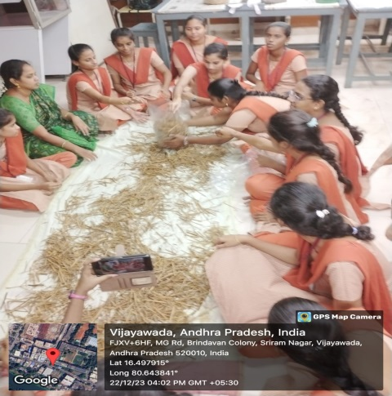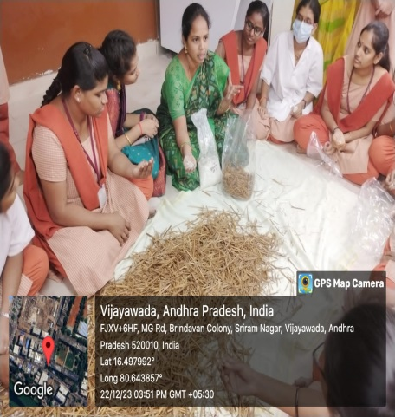
Bagging
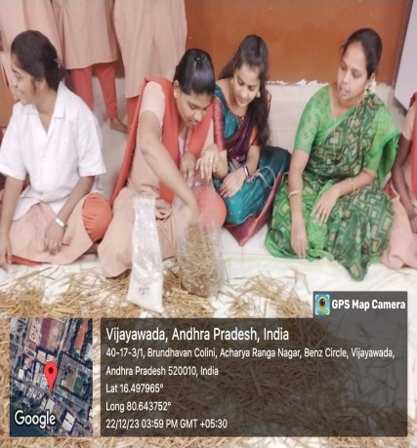
compost filling by V.Anjali III BZC
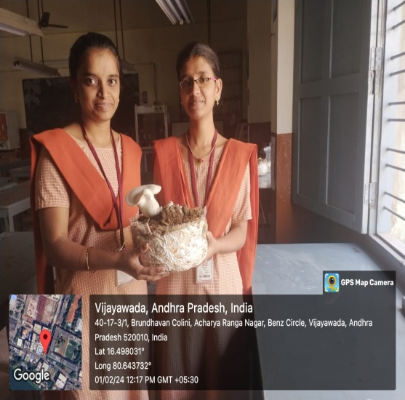 Milky mushroom formation

