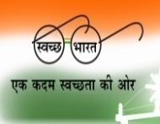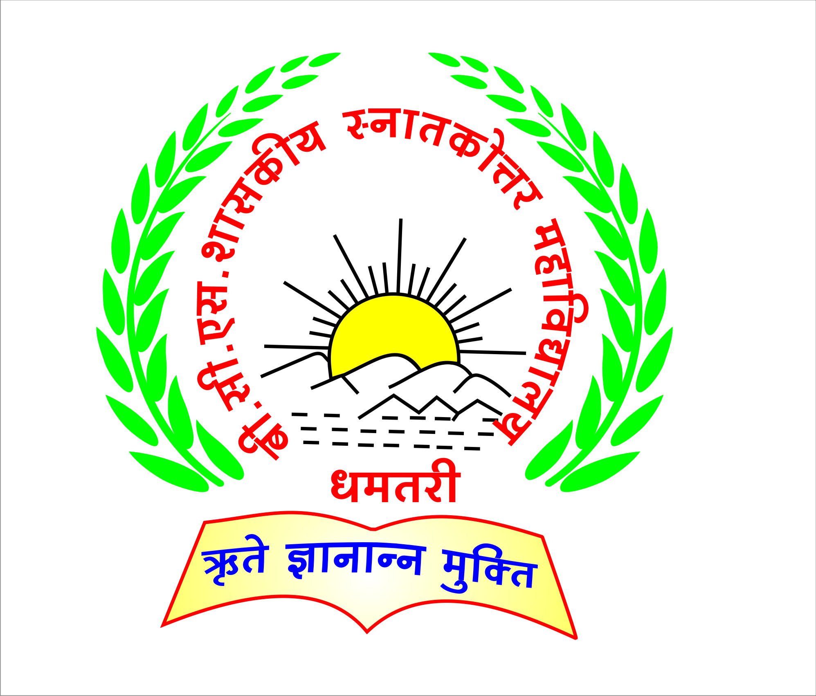

B.C.S. GOVT. P.G. COLLEGE, DHAMTARI (C.G.)

**Email – pgcollege.dhamtari@gmail.com**

**Website –** [**www.bcspgcdmt.com**](http://www.bcspgcdmt.com)

**AISHE CODE- C-21763**

CRITERION 5 –**Student Support and Progression**

**Key Indicator – 5.3 Student Participation and Activities**

**5.3.1 Number of awards/medals for outstanding performance in sports/cultural activities at university/state/national / international level.**

|  |  |  |
| --- | --- | --- |
| S.No. | Document Name | Link |
| 1 | **International Yoga Award** | <https://s3.ap-south-1.amazonaws.com/mts-buckets/bcspgcdmt/61f4e07e589d3.pdf> |
| 2 | **State Level Awards** | <https://s3.ap-south-1.amazonaws.com/mts-buckets/bcspgcdmt/61f4e093d7cdd.pdf> |
| 3 | **National Awards** | <https://s3.ap-south-1.amazonaws.com/mts-buckets/bcspgcdmt/61f4e09238e87.pdf> |
| 4 | **Other Certificate** | <https://s3.ap-south-1.amazonaws.com/mts-buckets/bcspgcdmt/61f4e28dda7cb.pdf> |
| 5 | **Other Awards and Certificate** | <https://s3.ap-south-1.amazonaws.com/mts-buckets/bcspgcdmt/61f4e29b087ca.pdf> |
| 6 | **NSS Award 2019-20** | <https://s3.ap-south-1.amazonaws.com/mts-buckets/bcspgcdmt/61f4e3cb28858.pdf> |