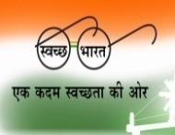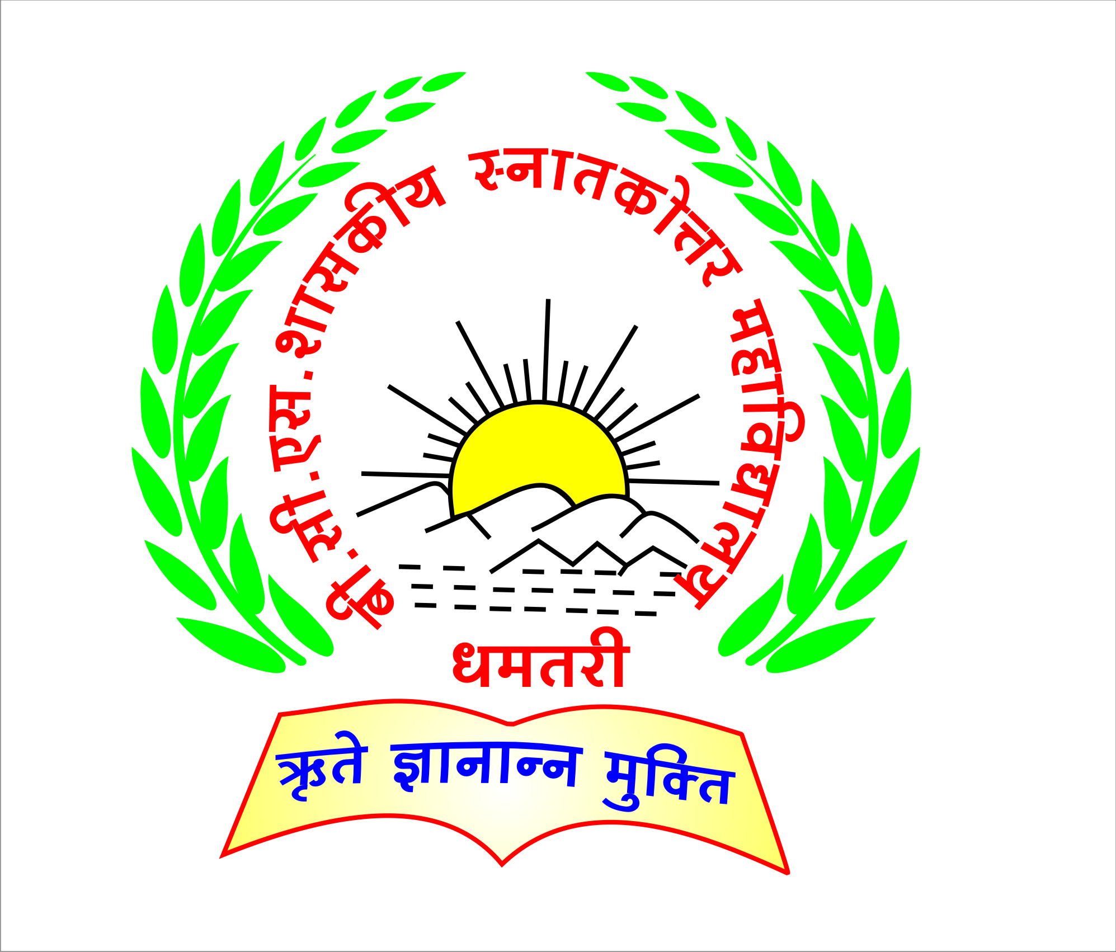

B.C.S. GOVT. P.G. COLLEGE, DHAMTARI (C.G.)

**Email – pgcollege.dhamtari@gmail.com**

**Website –** [**www.bcspgcdmt.com**](http://www.bcspgcdmt.com)

**AISHE CODE- C-21763**

CRITERION 5 –**Student Support and Progression**

**Key Indicator – 5.3 Student Participation and Activities**

**5.3.3 Average number of sports and cultural events/competitions in which students of the Institution participated during last five years.**

|  |  |  |
| --- | --- | --- |
| S.No. | Document Name | Link |
| 1 | **Yuva Utsav Report** | <https://s3.ap-south-1.amazonaws.com/mts-buckets/bcspgcdmt/61f4e96550ad4.pdf> |
| 2 | **Sports Department Report** | <https://s3.ap-south-1.amazonaws.com/mts-buckets/bcspgcdmt/61f4e9cca66d9.pdf> |
| 3 | **Annual Function Circular** | <https://s3.ap-south-1.amazonaws.com/mts-buckets/bcspgcdmt/61f4e8363845b.pdf> |
| 4 | **Sports Activities Circular** | <https://s3.ap-south-1.amazonaws.com/mts-buckets/bcspgcdmt/61f4e8276680b.pdf> |
| 5 | **List of Student Cultural Activities 2015-16** | <https://s3.ap-south-1.amazonaws.com/mts-buckets/bcspgcdmt/61f4ea5b1ab9b.pdf> |
| 6 | **List of Student Cultural Activities 2016-17** | <https://s3.ap-south-1.amazonaws.com/mts-buckets/bcspgcdmt/61f4edae17c32.pdf> |
| 7 | **List of Student Cultural Activities 2017-18** | <https://s3.ap-south-1.amazonaws.com/mts-buckets/bcspgcdmt/61f4ea59e397a.pdf> |
| 8 | **List of Student Cultural Activities 2018-19** | <https://s3.ap-south-1.amazonaws.com/mts-buckets/bcspgcdmt/61f4ea5a9da02.pdf> |
| 9 | **List of Student Cultural Activities 2019-20** | <https://s3.ap-south-1.amazonaws.com/mts-buckets/bcspgcdmt/61f4ea5ae8686.pdf> |
| 11 | **List of Student Sports Activities 2015-16** | <https://s3.ap-south-1.amazonaws.com/mts-buckets/bcspgcdmt/61f4ec1a757df.pdf> |
| 12 | **List of Student Sports Activities 2016-17** | <https://s3.ap-south-1.amazonaws.com/mts-buckets/bcspgcdmt/61f4ec1a9f9c6.pdf> |
| 13 | **List of Student Sports Activities 2017-18** | <https://s3.ap-south-1.amazonaws.com/mts-buckets/bcspgcdmt/61f4ec1a19720.pdf> |
| 14 | **List of Student Sports Activities 2018-19** | <https://s3.ap-south-1.amazonaws.com/mts-buckets/bcspgcdmt/61f4edea6e0c7.pdf> |
| 15 | **List of Student Sports Activities 2019-20** | <https://s3.ap-south-1.amazonaws.com/mts-buckets/bcspgcdmt/61f4ec1ada897.pdf> |