**BEST PRACTICE – 2021-22**

1. **Title of Practice – Empowering Women Focusing on Women E-Rickshaw Drivers.**

**Objectives of the Practice**

1. To encourage women to come forward for earning their livelihood by driving E- Rickshaw.
2. This will strengthen their financial condition.
3. To inculcate self-confidence in women for this types of public service.
4. Use of E- Rickshaw will boost reducing carbon content.

**Context**

To honour women becoming E- Rickshaw driver which will build up confidence for coming out of own premises for driving E- Rickshaw on the roads of city.

* To motivate unemployed women in society to come forward for such work.

**The Practice**

On the occasion of international women’s day the college has organized a special programme to honour women E-Rickshaw drivers in Dhamtari city and surrounding villages. For this staff member particularly women extended their voluntary contribution for the programme.

In all 15 women E-Rickshaw drivers were honored with gifts like water bottle and scarf.

Girls volunteers of N.S.S. in our college were also honoured with water bottle and scarf.

In the end cultural programmes were also organized for the guests. N.S.S. girls volunteers also participated in this programme showing their concern for women empowerment.

**Evidence of Success**

1. Confidence and sense of grate fullness on the face of women E-Rickshaw drivers motivate us to organize such programme in future.
2. Women E-Rickshaw drivers assured us to encourage other women in their locality to come forward. Use of E-Rickshaw reduced noise pollution and environmental pollution as well.

**Problem Encountered and Resources Required**

1. Lack of resources was the reason for to honour a limited number of women E-Rickshaw Drivers.
2. Number of E-Rickshaw drivers from the rural area was very less. So we decided to encourage rural women for this through NSS volunteers of our college.

**Celebration of International Women’s Day**

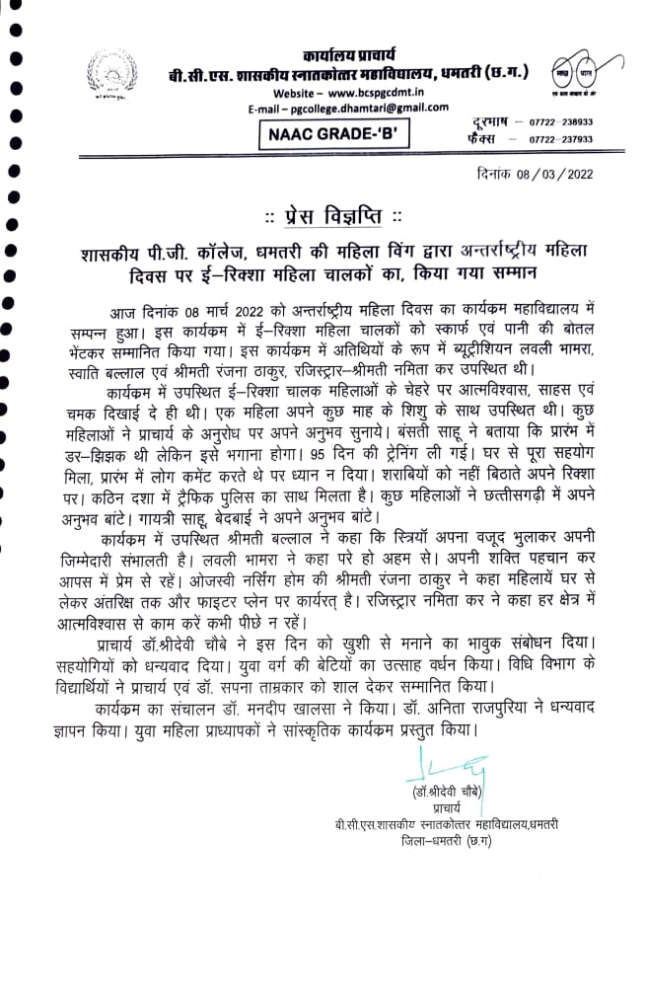

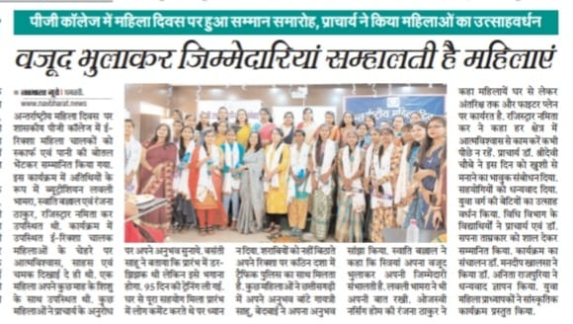

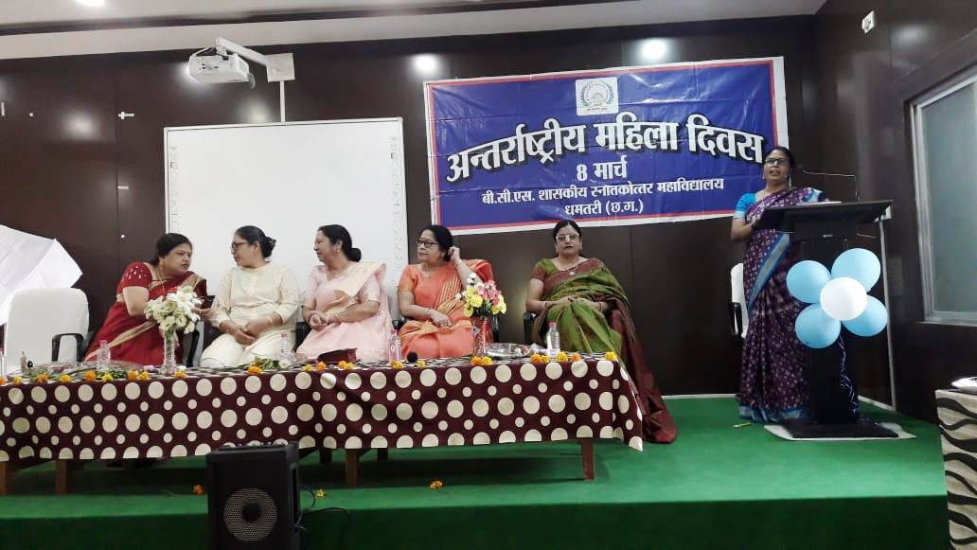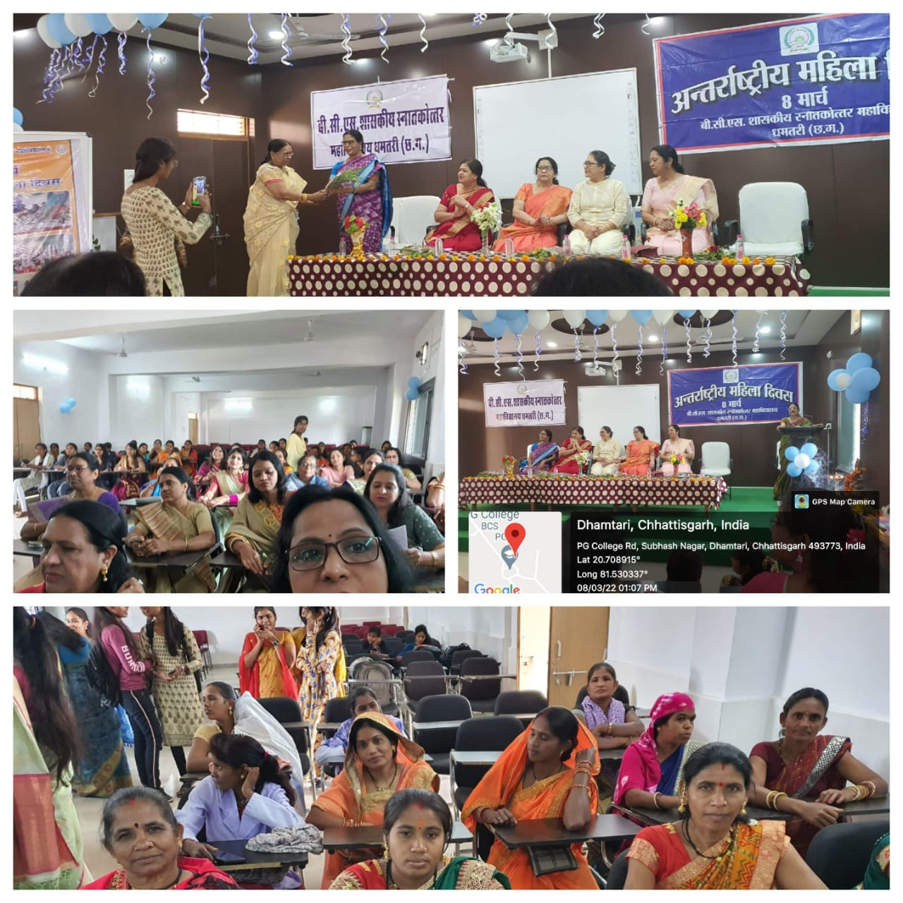

**BEST PRACTICE – 2021-22**

1. **Title of Practice – Honouring the senior citizens involved in freedom movement (Purkha ke Surta).**

On 26.10.2021 the college celebrated “Amrit Mahotsav” as 75th anniversary of our independence. We invited Shri Surjeet Navdeep, Shri Vijay Prakash Jain Son of Dr. Hazarilal Jain, driver of the vehicle of Mahatma Gandhi during his visit to Dhamtari), Shri Manharan Kandvansi, Shri Makhanlal Yadav, Shri Baisakhuram Yadav from Kandel and Smt. Leela Panchangam from Gurur.

**Objectives of the Practice**

1. To motivate students to have national Integrations.
2. Encourage students to follow the freedom fighters as role model.
3. Remembering people involved in freedom struggle in the 75th year of freedom celebrated as “Amrit Mahotsav”.
4. Inculcate feelings of patriotism through the celebration of honouring the freedom fighters and their family members.

**Context**

1. ‘Amrit Mahotsav’ celebration providing the platform to honour the people above 75 years involved in freedom movement.
2. Commemorating 75th year of independence with pride to honour people responsible for our freedom.

**The Practice**

Every year such programmes would be organized to honour people dedicating themselves for the national cause.

**Evidence of Success**

1. Sense of pride and complacence in the face of the people being honourd on the occasion.
2. Stake-holders of the college felt their responsibility and duty towards mother land.
3. Enthusiasm marked among the youth, the students, taking pledge to offer supreme sacrifice for the nation.

**Problem Encountered and Resources Required**

1. Lack of resources in compelled us to honour only five persons above 75 years involved the freedom movement.
2. Surviving people who had participated in the national movement are very less in number. Hence we have honoured their family members.

**Photographs Purkha ke Surta**

