BEST PRACTICE – 2023-24
Title of Practice – Fitness Activity “FitFusion ”.
Objectives of the Practice
To make all the students and staff members of the college, Stable. balanced, fit and strong at the physical, mental, emotional and energy level with the teaching learning process can be carried out on an excellent scale and the concept of fit India can be achieved.
Context :-
Today’s modern life style increasing hormonal imbalance, each and everyone is suffering from many physical and mental stress, these are root causes for increasing suicidal rate in all over the world. In such an era fitness activities are very relevant for good health of all of us.
The Practice
Fitness activity FitFusion program Organized by Various department under the aegis of IQAC of College.
- On 9.12.2023, Zumba dance exercise was organized in the college premises by IQAC. The trainer of Zumba dance was Mr Anubhav Dewangan and 200 members participated in it.
- On 15.12.2023, “Brain exercises” was conducted by the Psychology Department under the fit fusion program. 52 members participated in it.
- “Aerobic exercise” was conducted by the Sports Department on 16- 12- 2023.
- “Slow cycle race” was organized by Hindi department under FitFusion programme on 23.12.2023.
- On 29.12.2023, Meditation and Breathing Exercise was organized by the English Department at 12:00 noon in the Seminar Hall of the college in which a total of 20 professors and 31 students participated.
- Meditation, Yoga Practice and Dancing Yoga program was organized by the Department of Economics on 05-01-2024 under the FitFusion program. In which yoga instructors Ms. Anju Lata Sahu and Uttar Singh Gautam provided service. The program was organized in the college campus between 12:00 to 1:00, in which 26 professors and 141 students participated.
- Flexibility and Mobility Yoga was organized by the Department of Sociology on 18th January 2024.
- The Department of Political Science organized spoon race, lame race, fast walks and rope jumping games under the Fit Fusion program in the college campus on 24-01-2024. Students and teachers participated. 39 students and 32 professors participated in this program.
- The History Department organized a fun game under the Fit Tuition program on 3.2.2024, under which programs like breaking the pot, walking backwards, bursting the balloon in 1 minute etc. were organized. 140 students and 20 professors were participated in the program.
- On 20.02.2024 Department of physics organized Yoga for Today´s life style programme under fitfusion programme141 students participated
- On 3.2.2024 Challenging Surya Namaskar program organized by the Department of Geography under the FitFusion program. 90 students were participated on it.

Evidence of Success
- Sports spirit was encouraged among students and teachers, health awareness increased and health improved.
- For personality development, a person must be mentally and intellectually healthy.
- All students and teachers participated enthusiastically in the programme and they believe that such Programmes need to be continued. This is a very useful programme for physical and mental development.
Problem Encountered and Resources Required
- To conduct the FitFusion activities, trainers and sound system are required for which additional funds are required.
- To conduct this activity, a hall with basic facilities is required which is required in the college because while Conducting this programme in the college premises affects the entire academic programme of the college.

FitFusion Activities Report

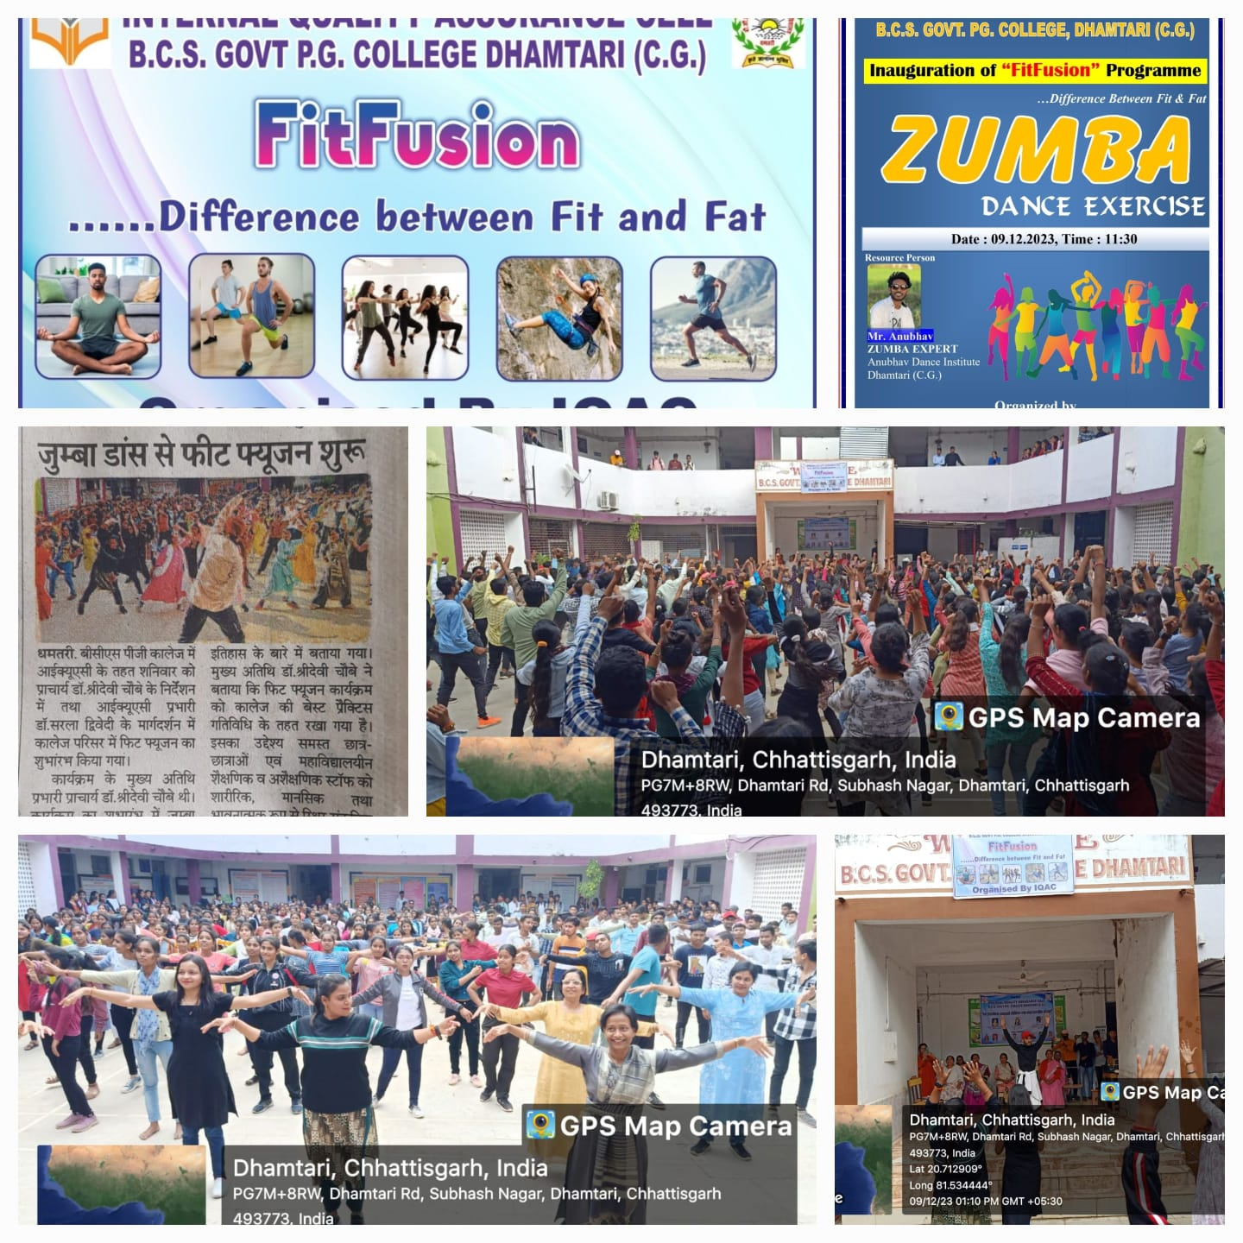
Fitfusion Activities by IQAC
09.12.2023
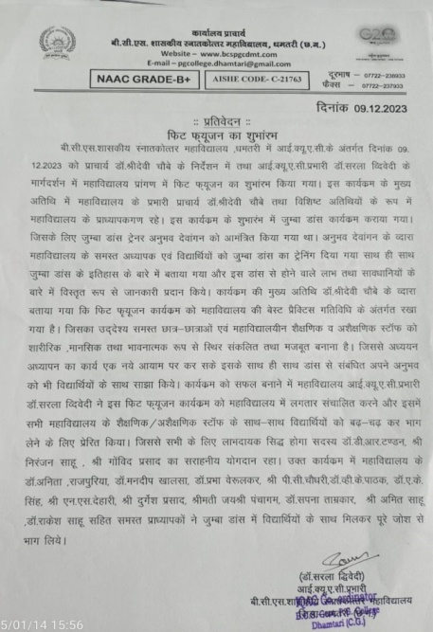
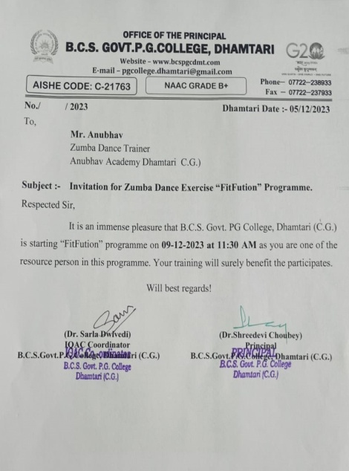

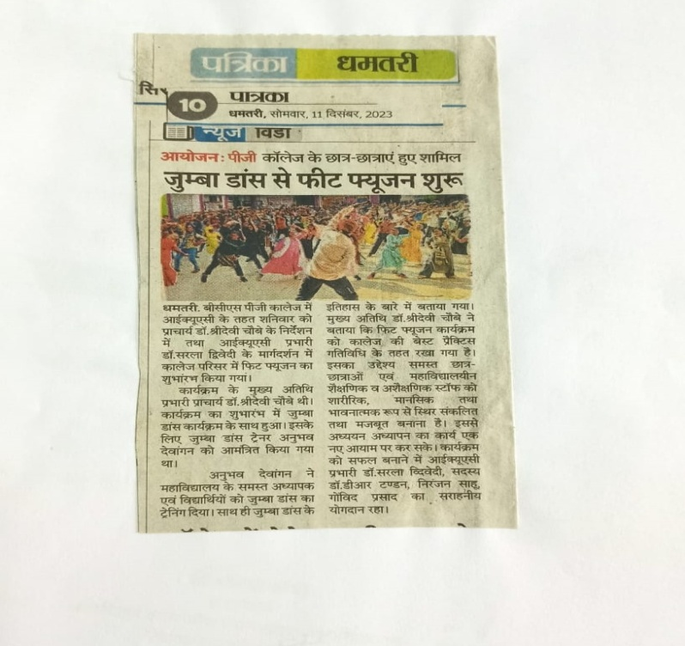

Fitfusion Activities by Psychology
15.12.2023
https://acrobat.adobe.com/id/urn:aaid:sc:AP:f046ebe1-7a29-41e5-a442-605d074e17fe

Fitfusion Activities by Sports Department
16.12.2023
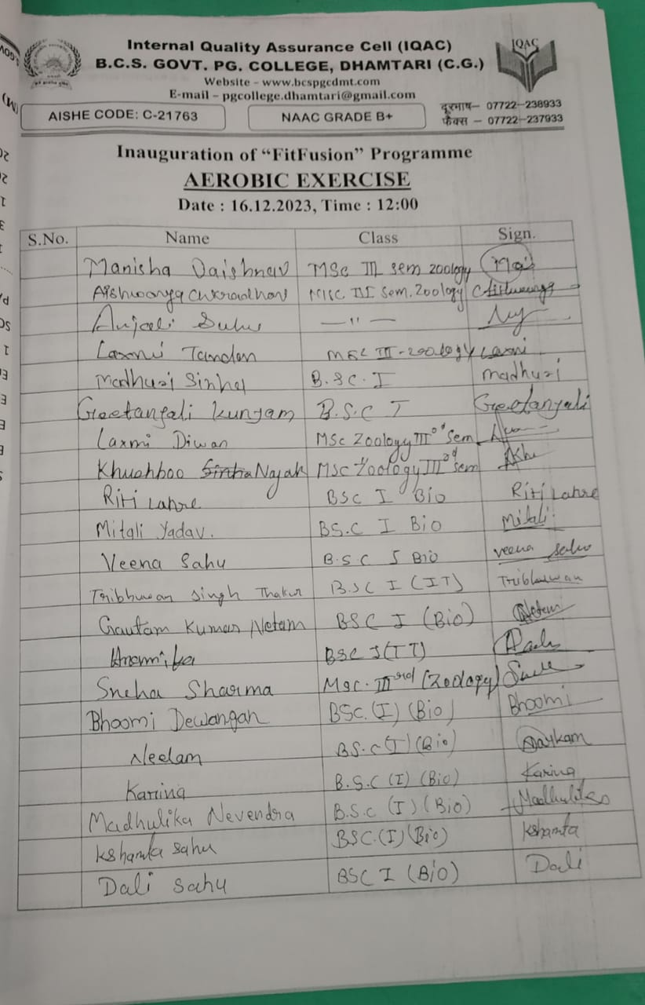
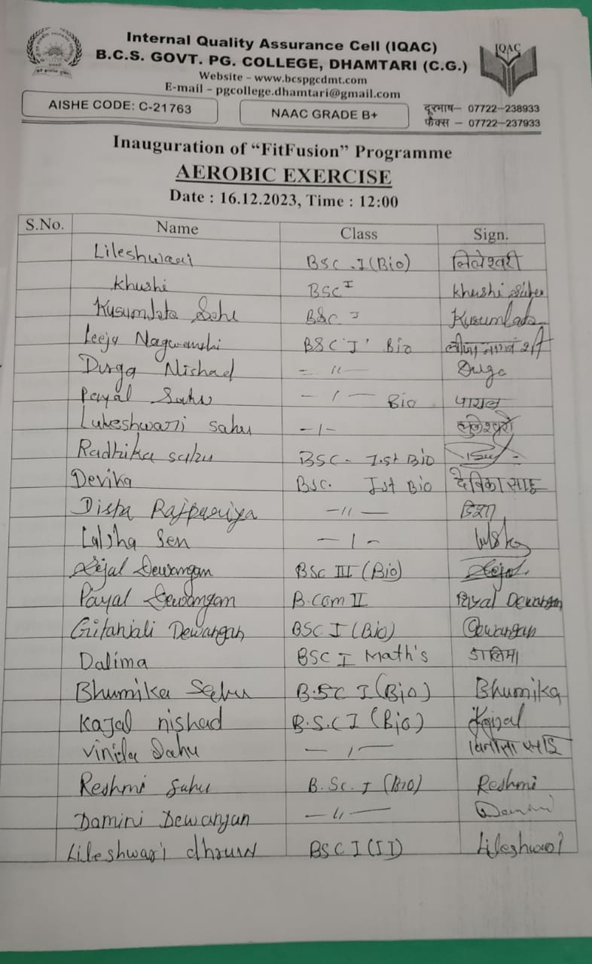

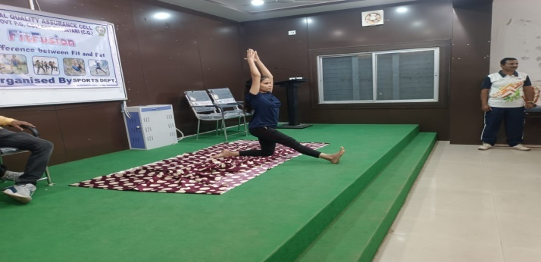

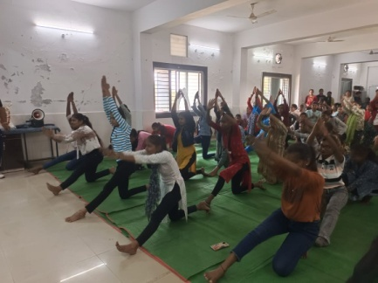
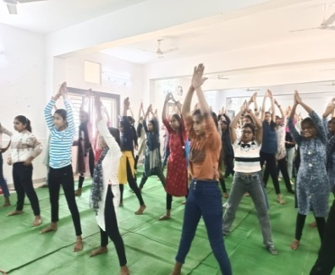

Fitfusion Activities by Economics Department
05.01.2024
Link: https://s3.ap-south-1.amazonaws.com/mts-buckets/bcspgcdmt/65a8b329a1c79.pdf

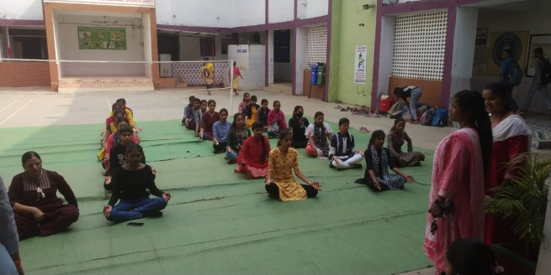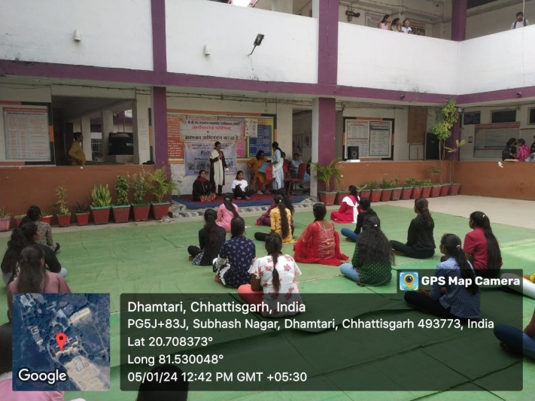
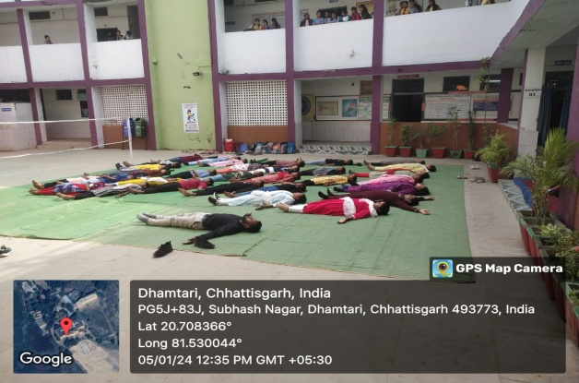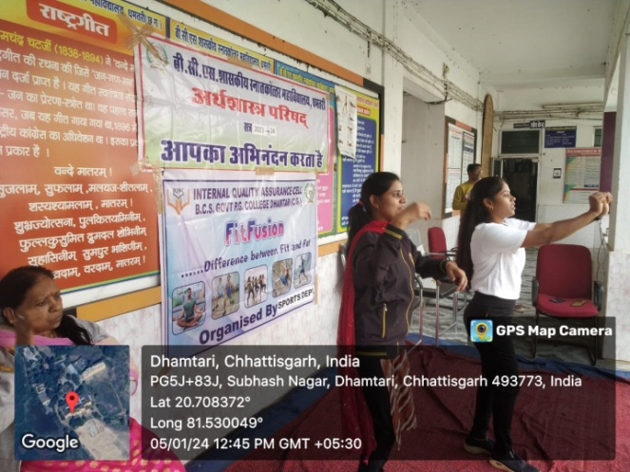

Fitfusion Activities by sociology Department
18.01.2024

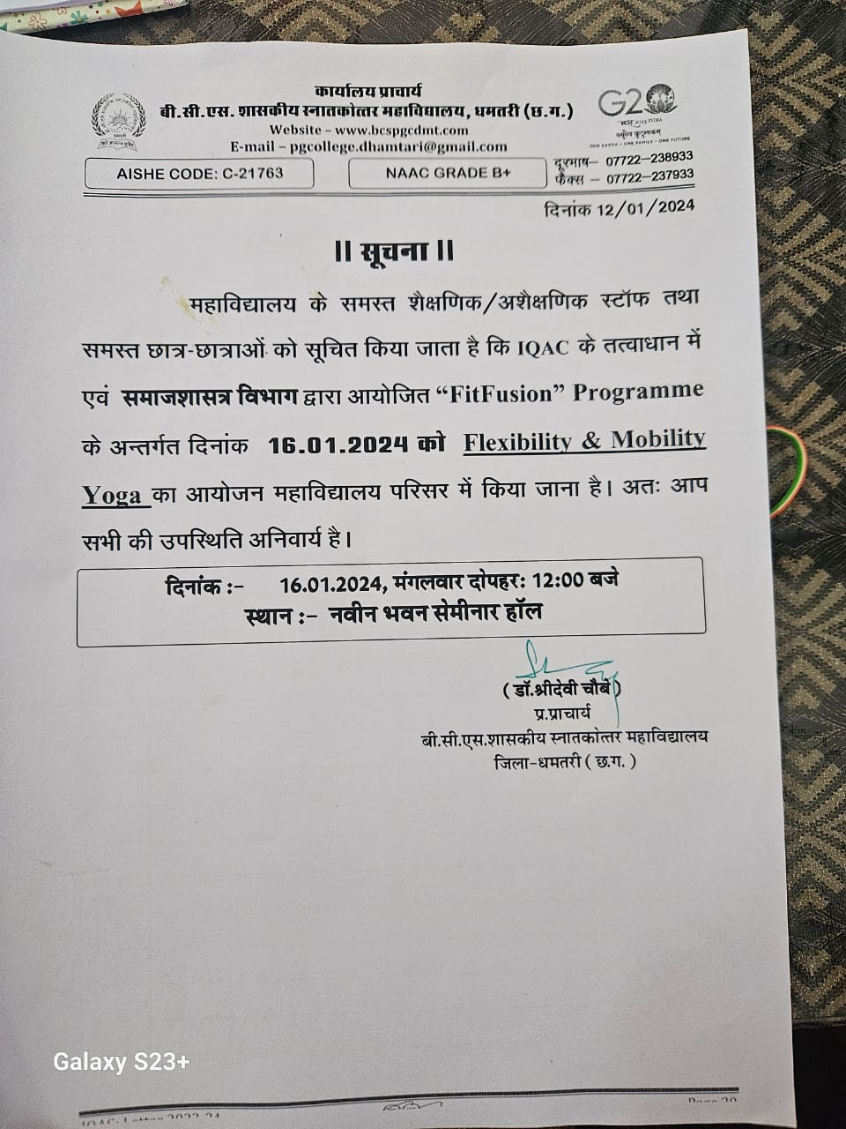

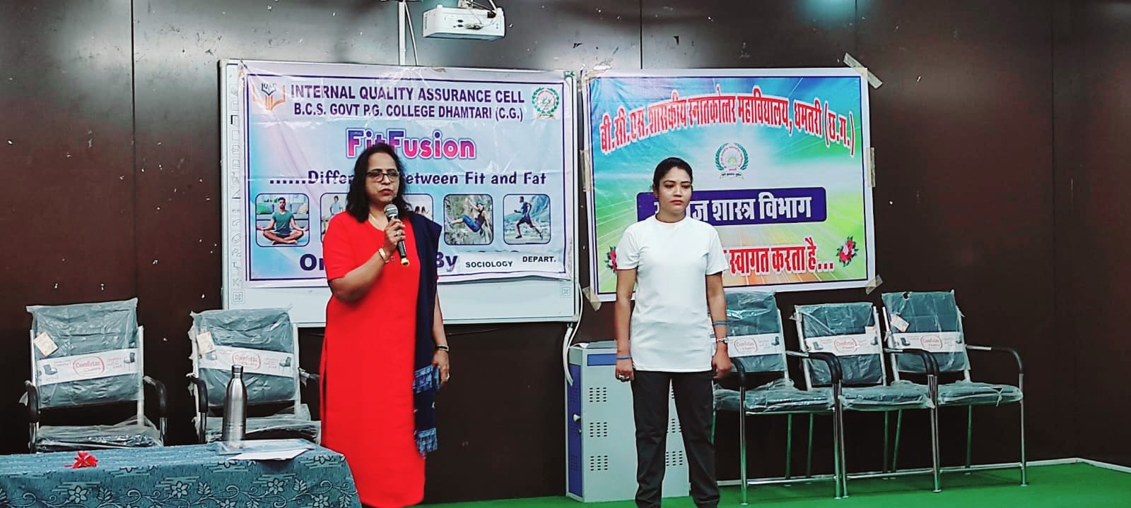

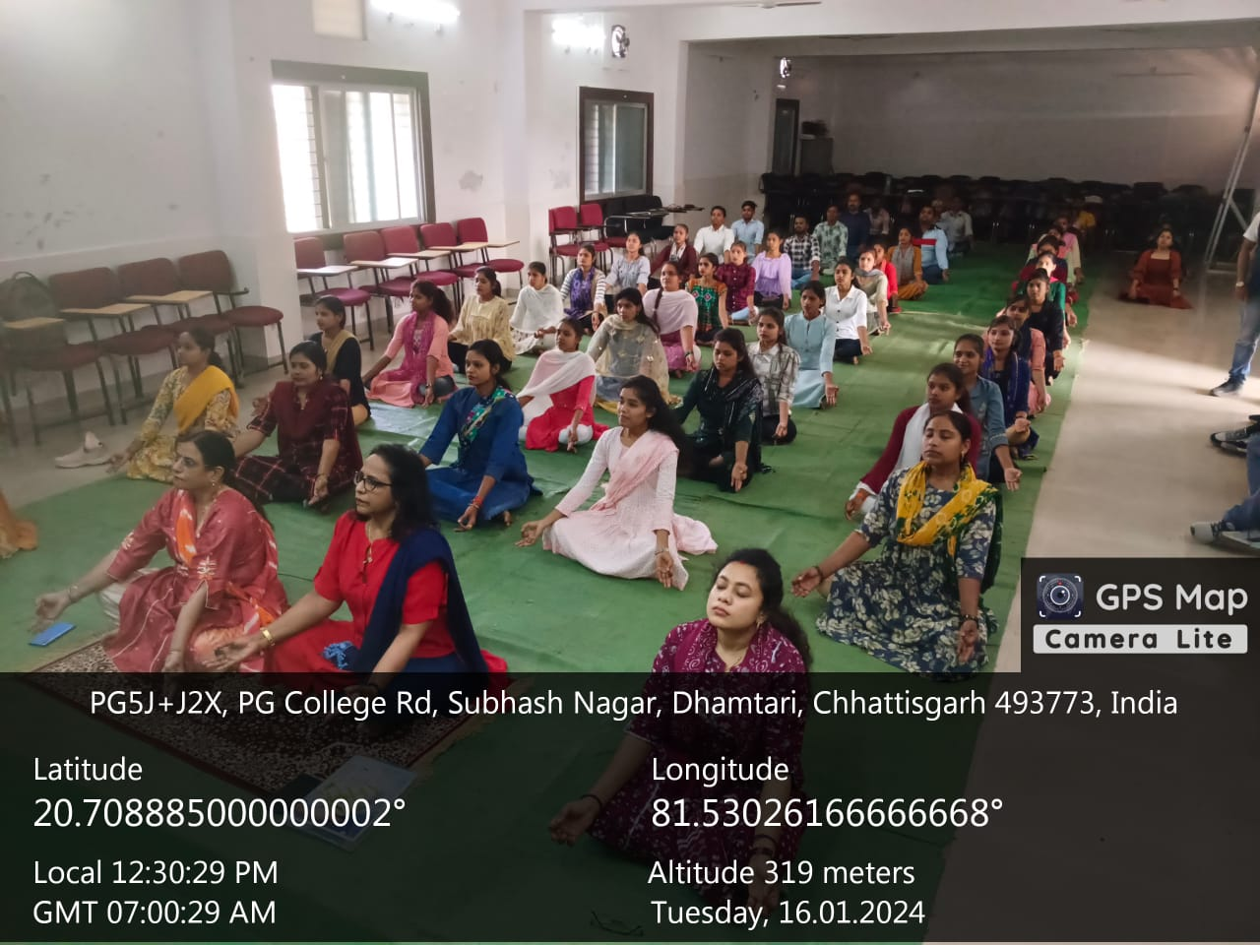

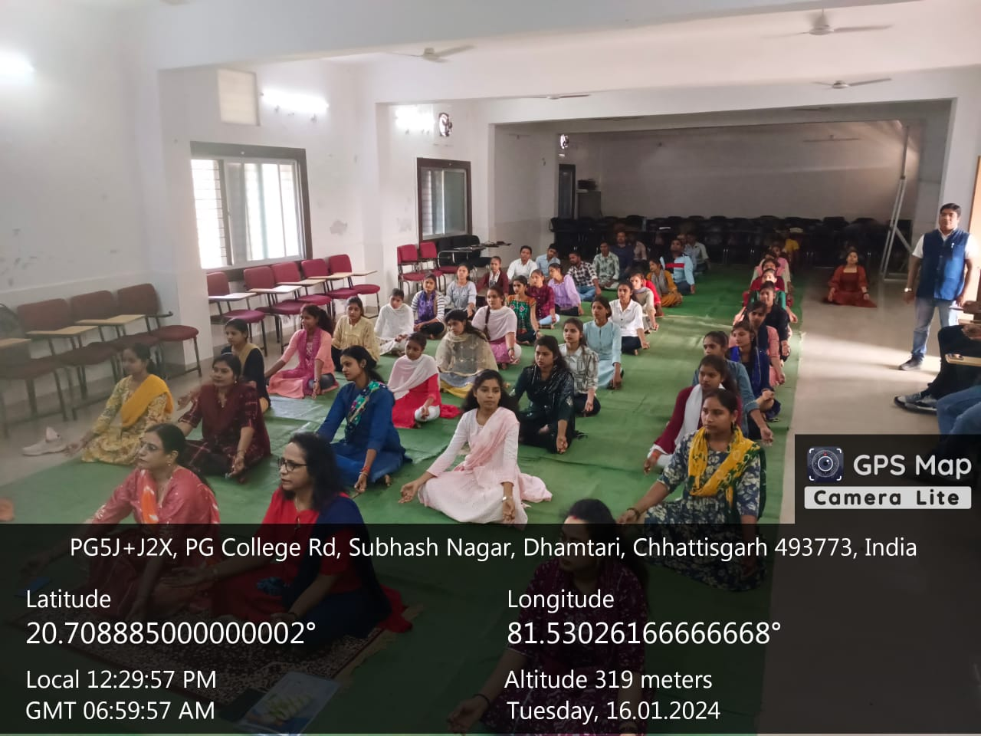

Fitfusion Activities by History Department
03.02.2024

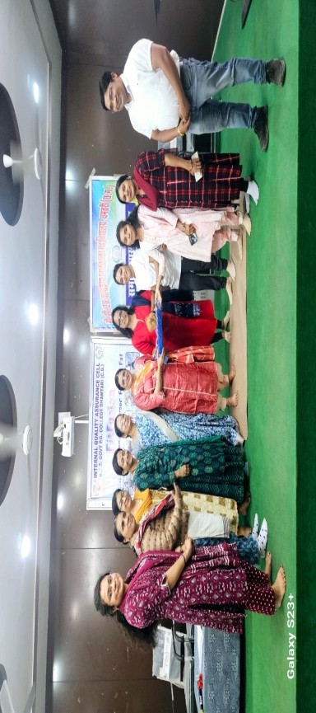

Fitfusion Activities by geography Department
03.02.2024

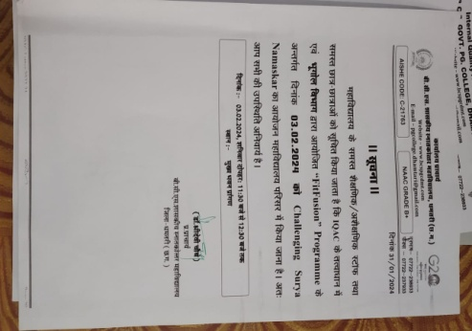
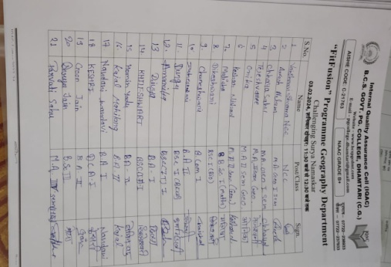

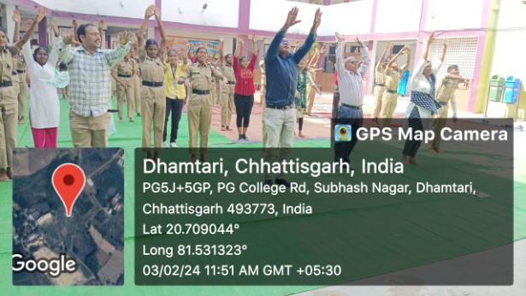

Fitfusion Activities by English Department
29.12.2023

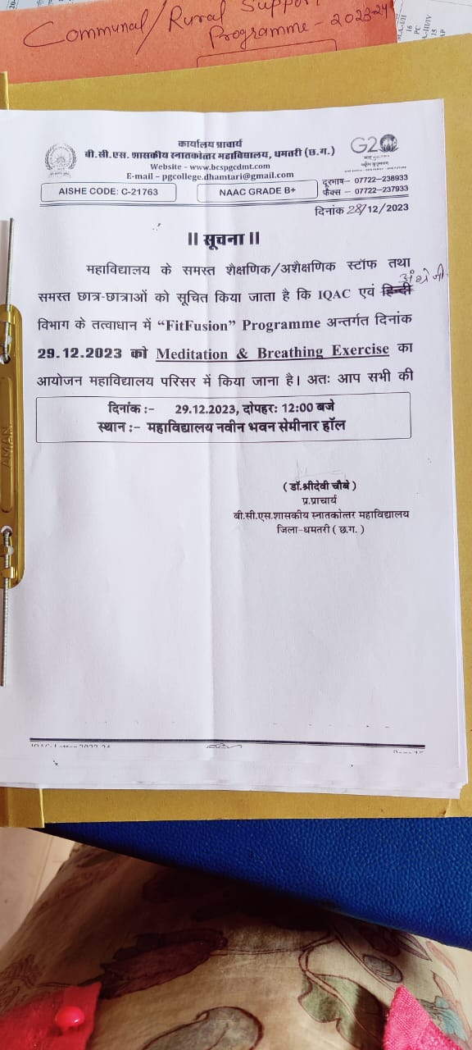

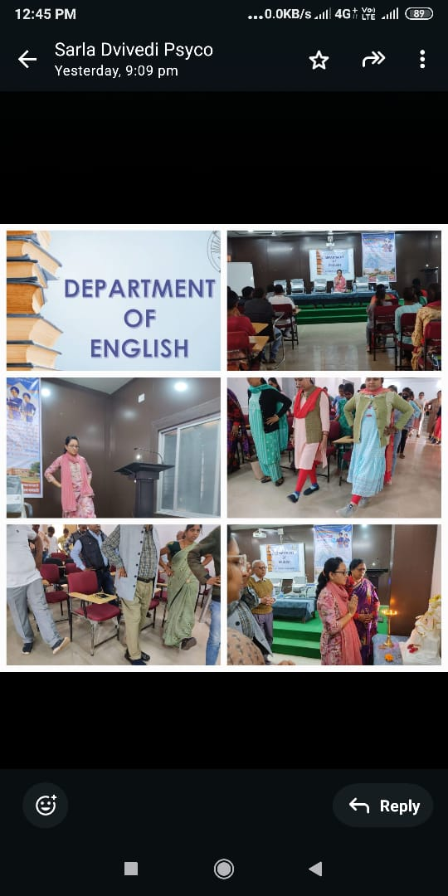

Fitfusion Activities by Physics Department
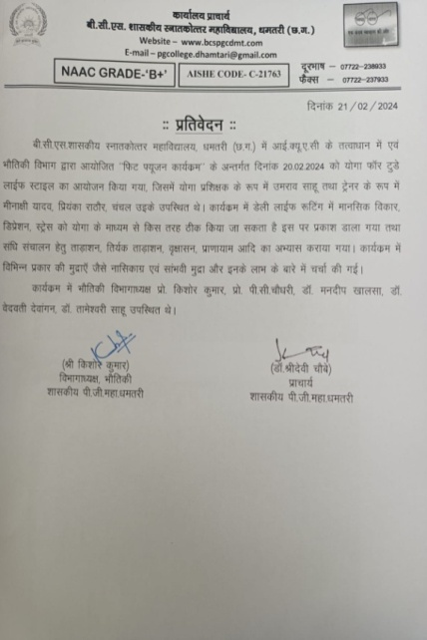
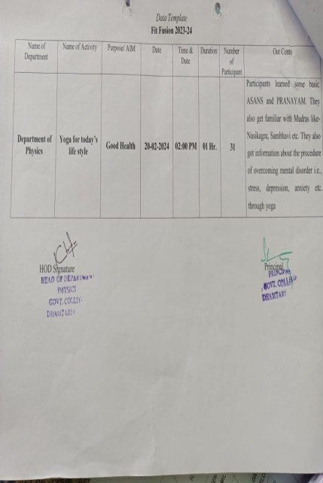
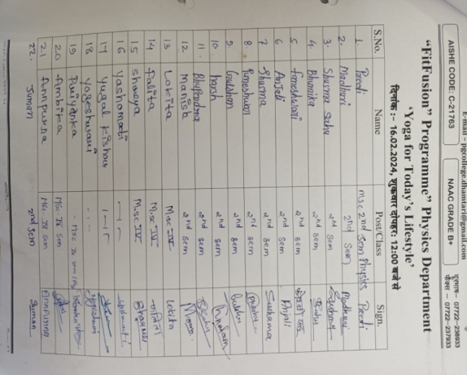
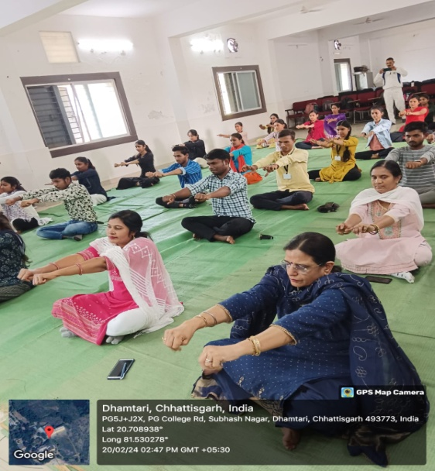
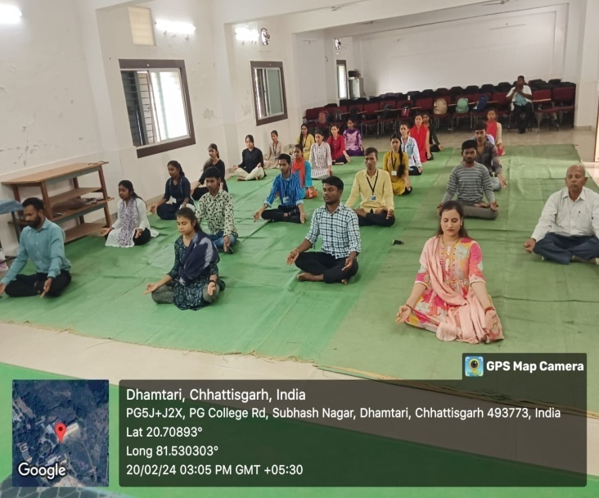
20.02.2024
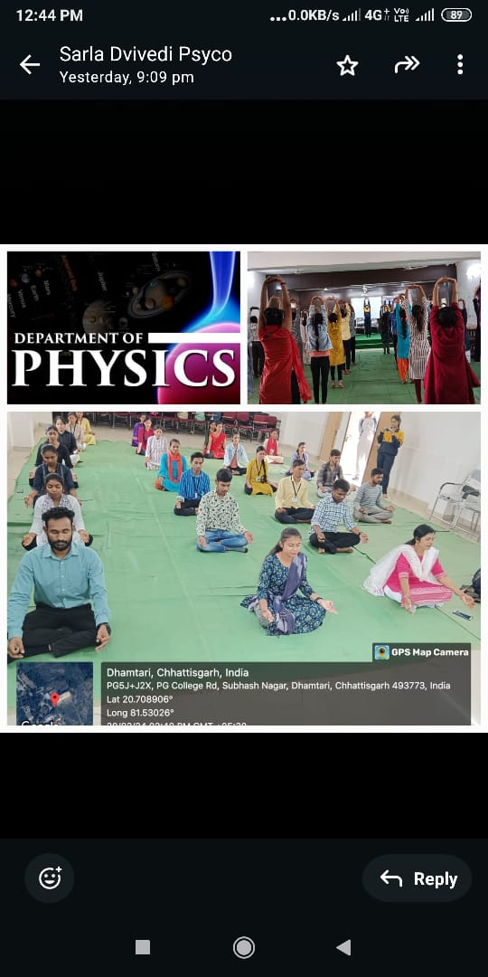

Fitfusion Activities by Hindi Department
23.12.2023
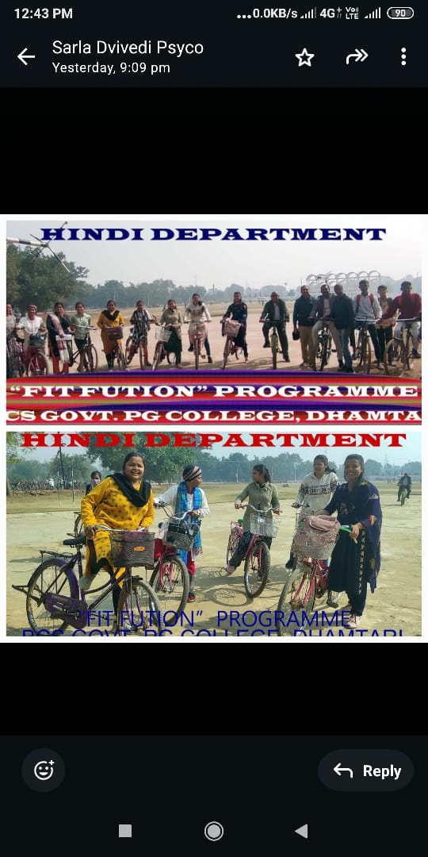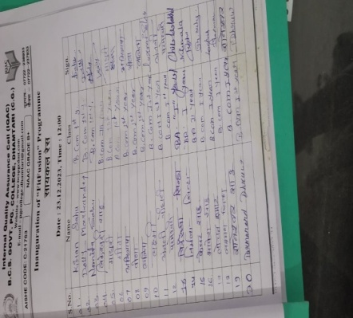

BEST PRACTICE – 2023-24
Title of Practice – Communal and Rural Support Programme
Objectives of the Practice
The Objective of “Communal and Rural support programme” is to reach the benefit of higher education to the community and rural areas the knowledge of highly qualified professor and their students has been brought to the community.
Context
It is the moral responsibility of the college to bring public awareness towards socio-economic problems. Therefore, awareness programmes were organized to go to the community and find solutions to these problems.
The Practice

- On 11-12-2023 Personality development program was organized by department of psychology at Livelihood college Dhamtari 48 members were participated in it.
- On 16-12-2023 Personality development program was organized by department of psychology at Atmanand Govt. H.S. School Dhamtari Dhamtari 90 members were participated in it.
- On 3rd January 2024, an awareness program was organized by the Hindi Department at Government Higher Secondary School, Kharega. Dhamtari.
- Personality development with some fun activities and techniques was organized by department of English at exact foundation Anand para Rudri Dhamtari on 09.02.2024. 50 members were participated in it.
- On 13.02.2024, the Department of Political Science organized an awareness program at Shiv Singh Verma, Government Higher Secondary School, Dhamtari. Under the program, the positive and negative effects of social media, fundamental rights and duties were effectively explained to the students through plays an awareness message was given. 82 members were participated in it.
The following activities were organized by the Economics department under the communal and rural support programme :
- On 09.02.2024 all the teachers and students of Economics Department organized an awareness programme in Govt. higher secondary school, Mujgahan Dhamtari, in which the topics were
- positive and negative effects of social media;
- causes and prevention of depression and stress among school students;
- Self-employment opportunities in rural areas;
- Gender equality and personality development
- Opportunities and challenges in future higher education.
- Sanitation and Environment.
Awareness information provided to the students on above topics through PPT and other teaching aid in these program 150 students benefited.
- On 15, 2, 2024, an awareness program regarding cervical cancer was organized by the Economics Council in the Post-matric tribal Girls Hostel Gokulpur Karma Mata Chowk Dhamtari, in which detailed information about cervical cancer was provided with help of PPT. 72 girl students of the hostel were participated in this program.
- On 19.2.2024, the Department of Economics organized an awareness program on cervical cancer at Shiv Singh Verma, Government Higher Secondary School, Dhamtari. In this program, detailed information was provided with the help of PPT to the girl students of the school regarding the symptoms, causes, diagnosis and treatment of cervical cancer. 57 girl students and teachers were present in the program.
Evidence of Success
In the educational institution, the staff and students came to know and became aware about a serious disease like cancer. The students of the school were also motivated to spread awareness about cancer in their neighborhood and family. In this way, the message of awareness reached their families too. They became aware of the ill effects of social media, increasing cyber crime and the students also became aware of environmental cleanliness and safety.
Problem Encountered and Resources Required
Problems arise due to lack of financial resources. Lack of modern technology reduces the effectiveness of the program. Lack of high internet connectivity creates obstacles in carrying out the program properly.

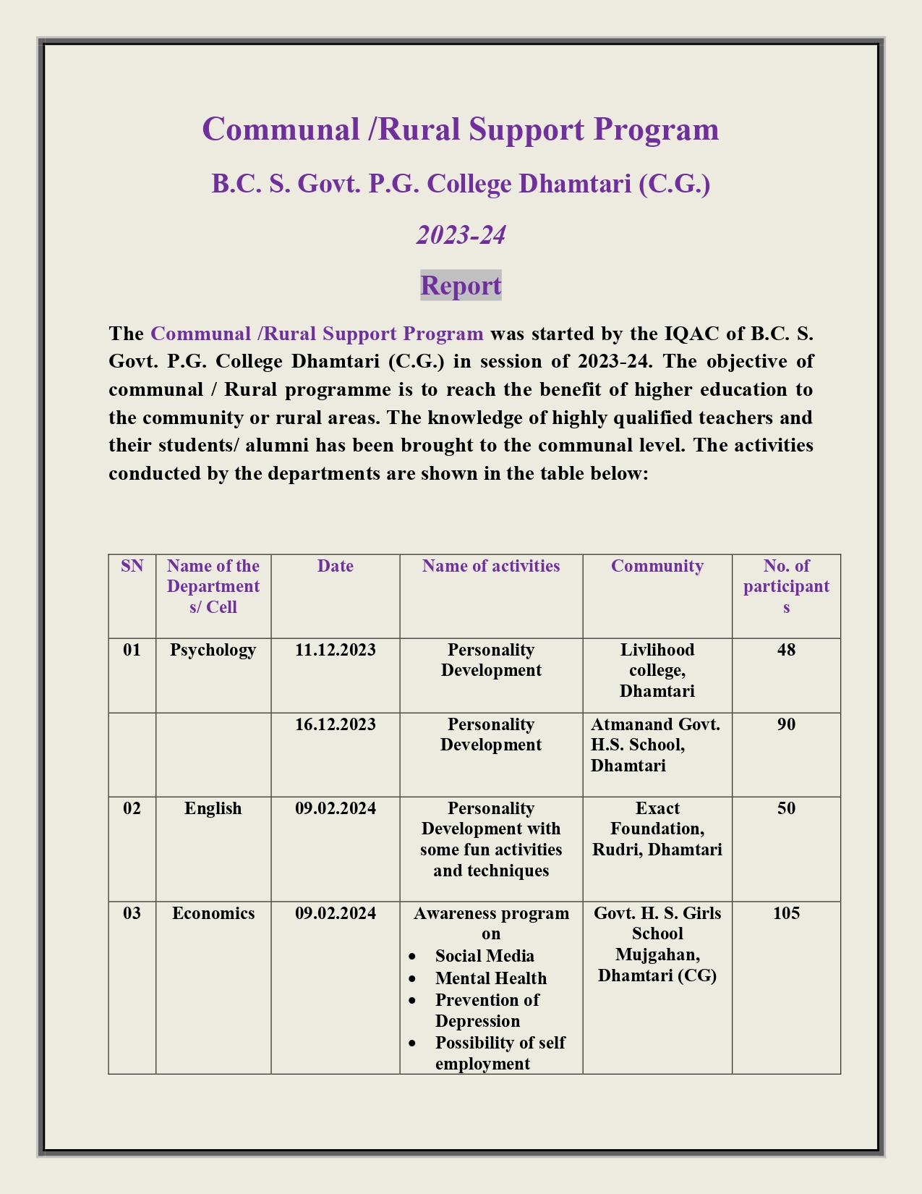

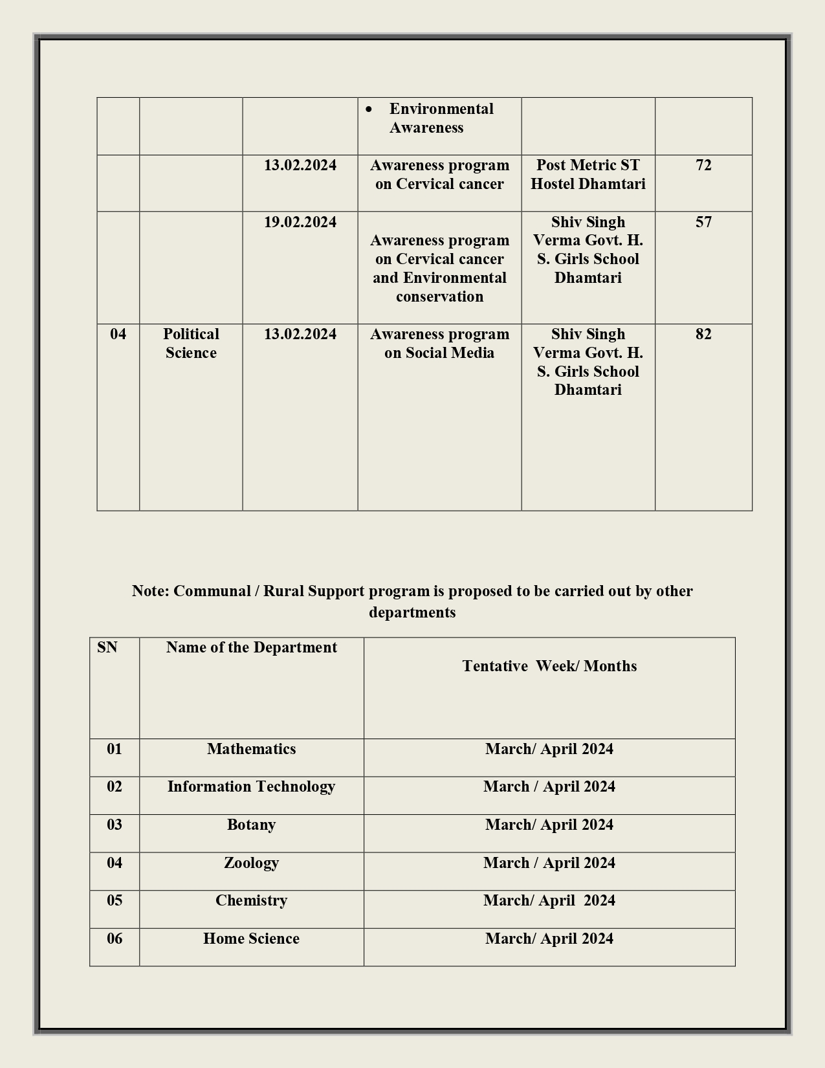

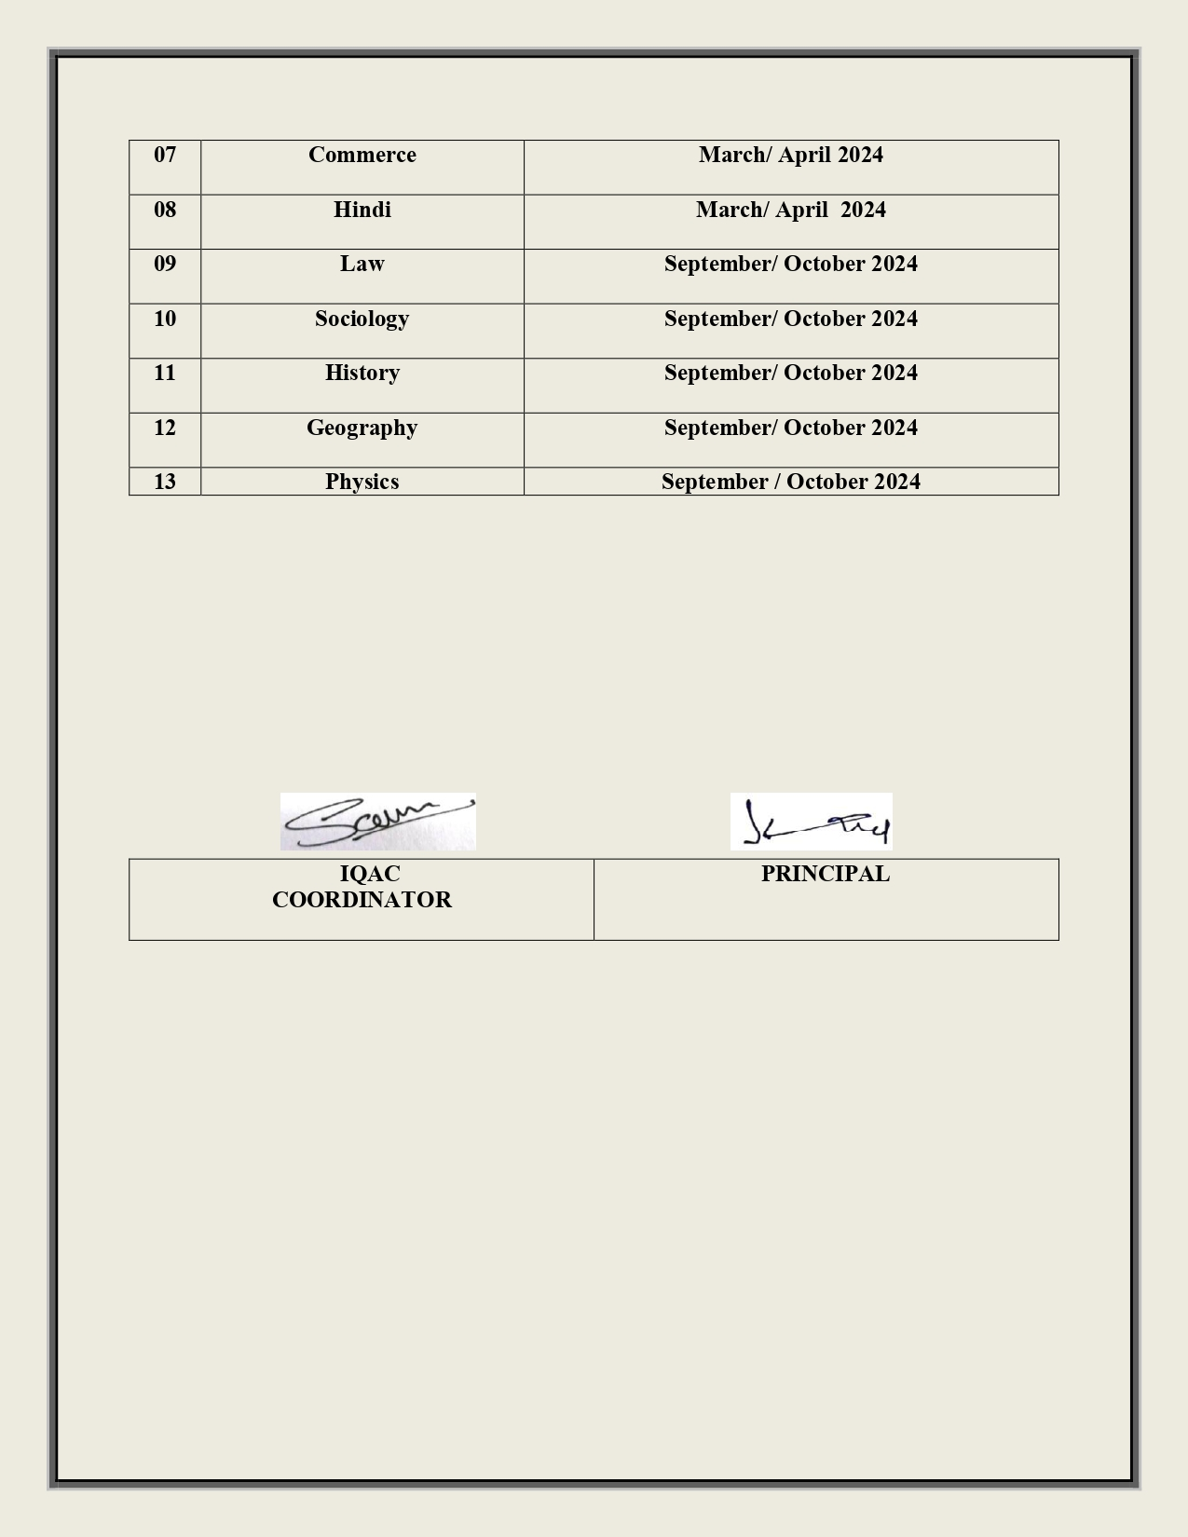

Communal and Rural Support Programme by Department of Psychology 09.02.2024
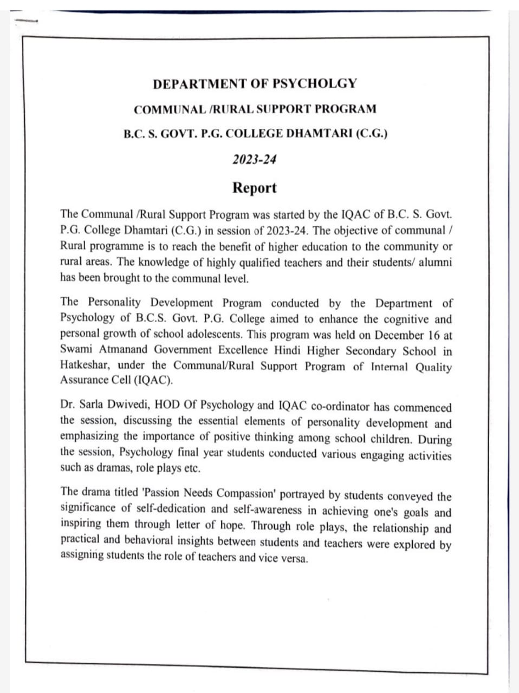
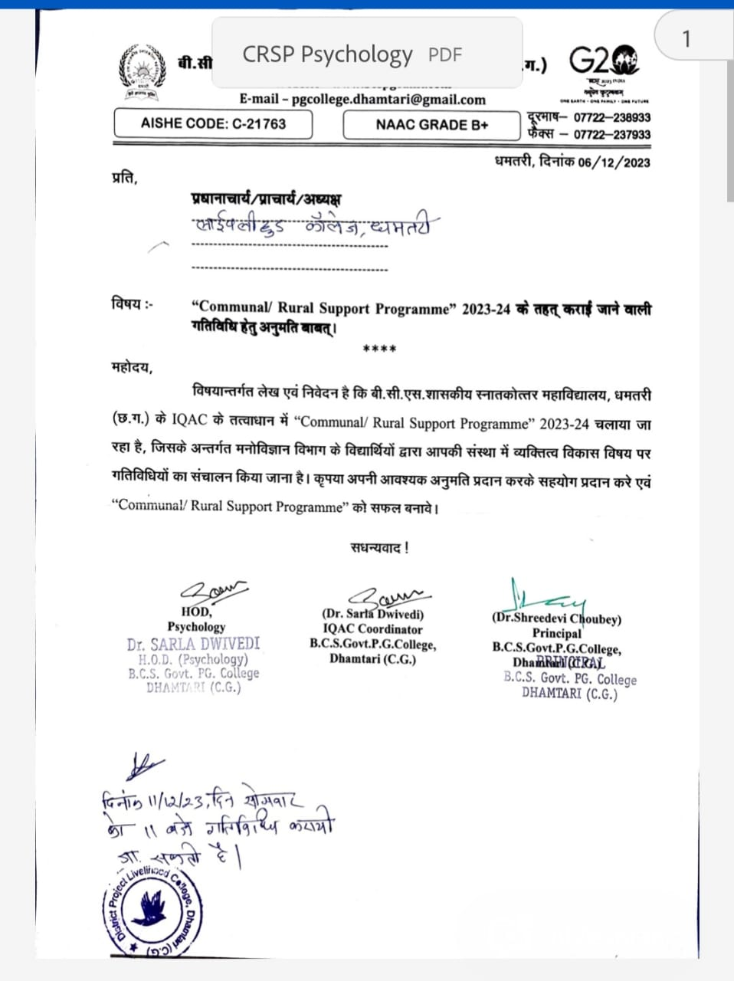

https://acrobat.adobe.com/id/urn:aaid:sc:AP:4ed5c5bf-e58b-433e-9d61-23fa8be680bf
https://acrobat.adobe.com/id/urn:aaid:sc:AP:aed4863b-e61d-44bf-94aa-b9430f3c3633
https://acrobat.adobe.com/id/urn:aaid:sc:AP:f4e59b99-1afa-4d43-a1f5-73ee6d4e5f3e

Communal and Rural Support Programme by Department of Hindi 13.02.2024
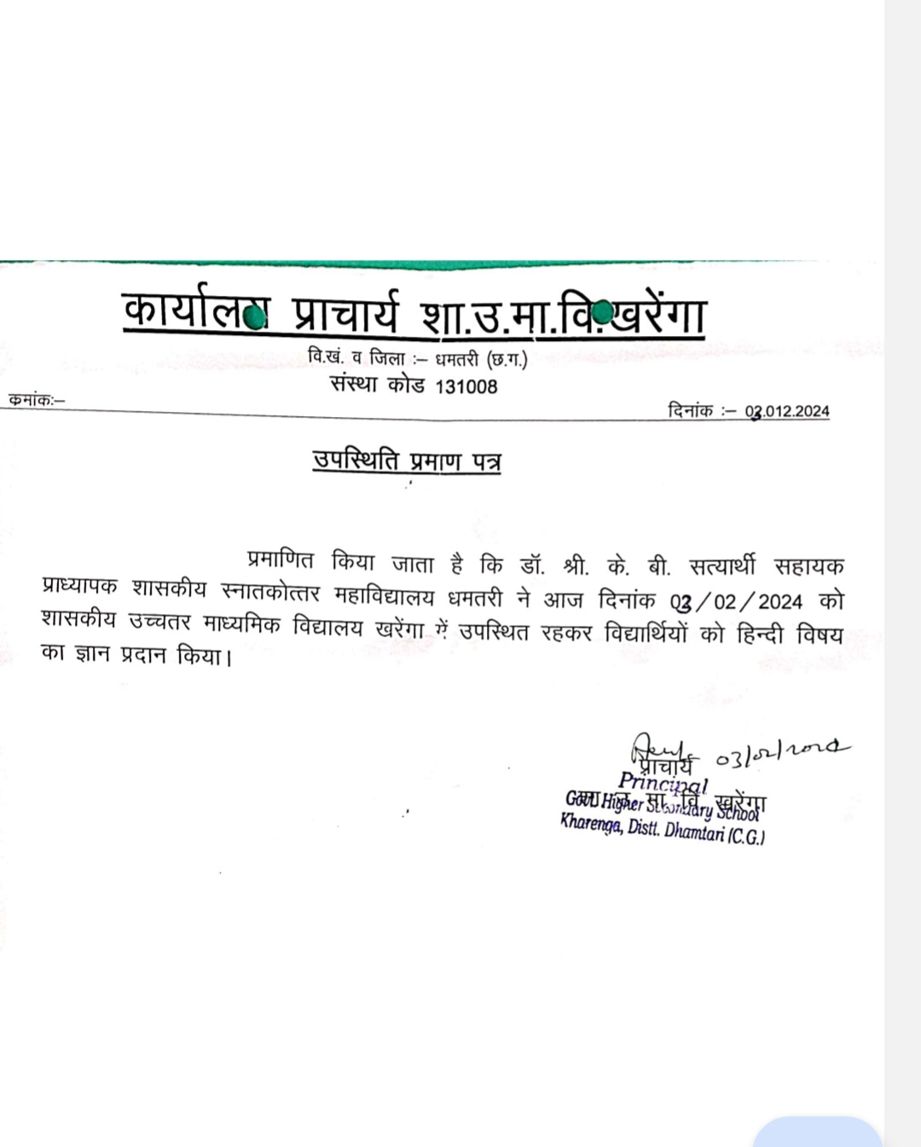

Communal and Rural Support Programme by Department of English 09.02.2024
https://s3.ap-south-1.amazonaws.com/mts-buckets/bcspgcdmt/65cc90e7a09f1.pdf
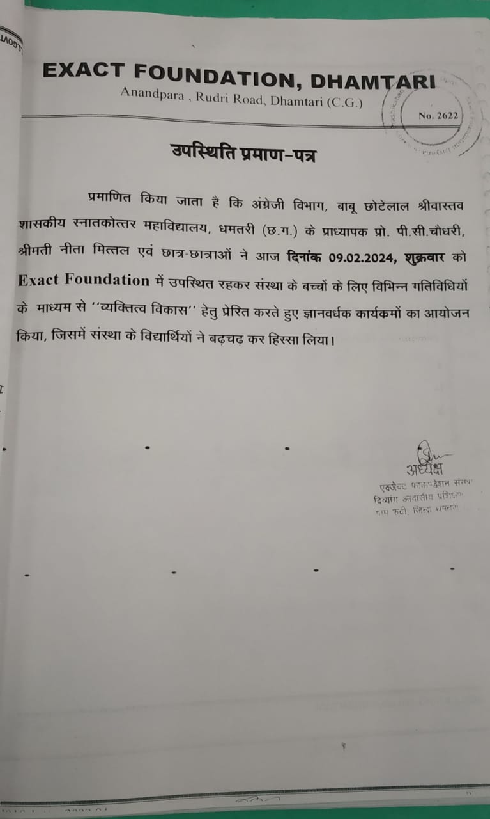
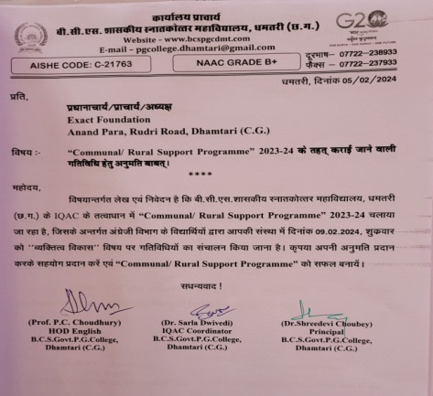

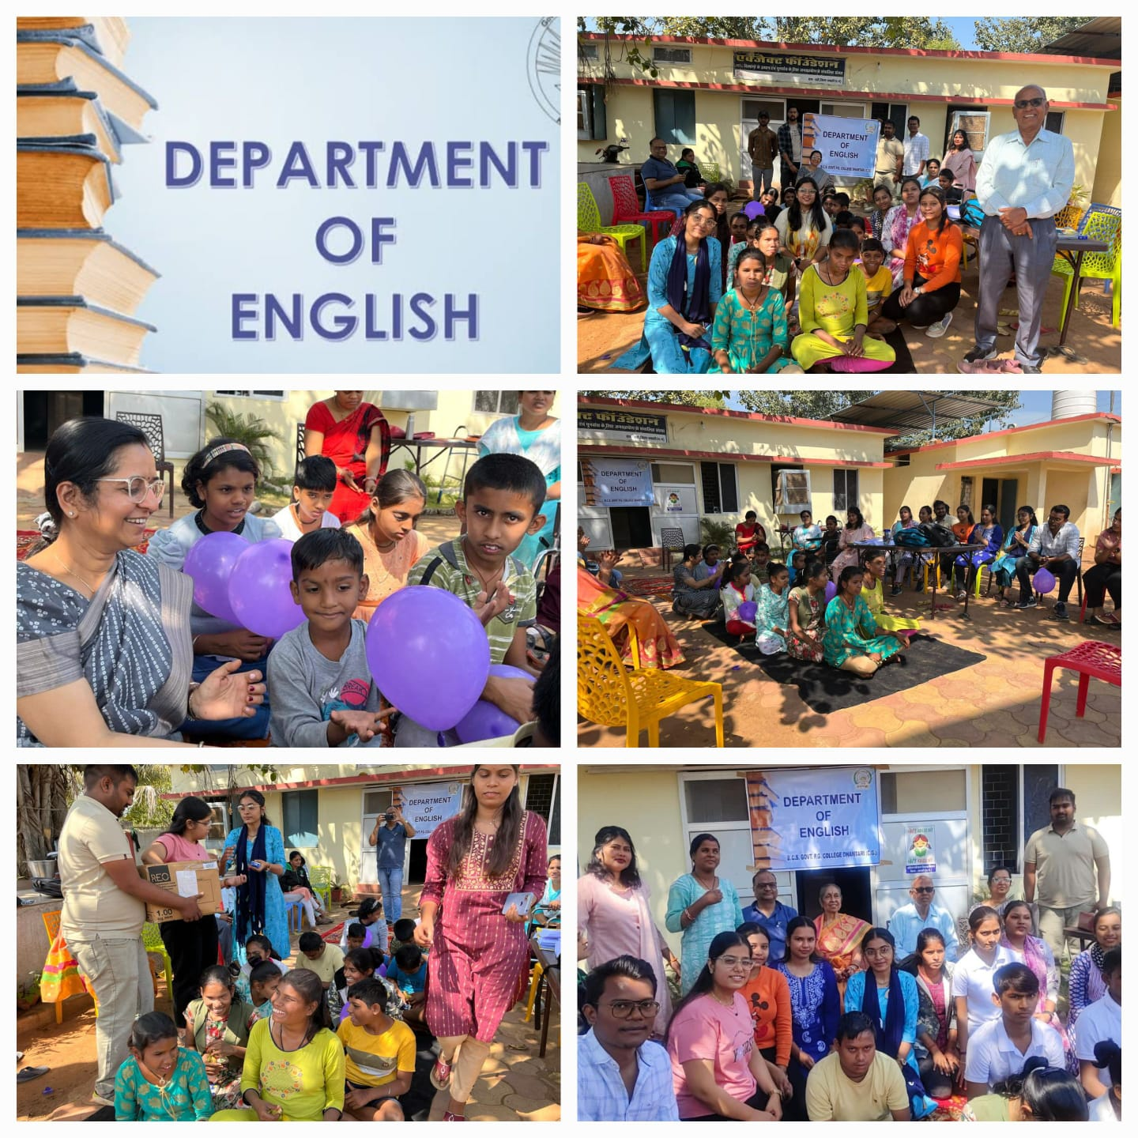
Communal and Rural Support Programme by Department of political science 13.02.2024

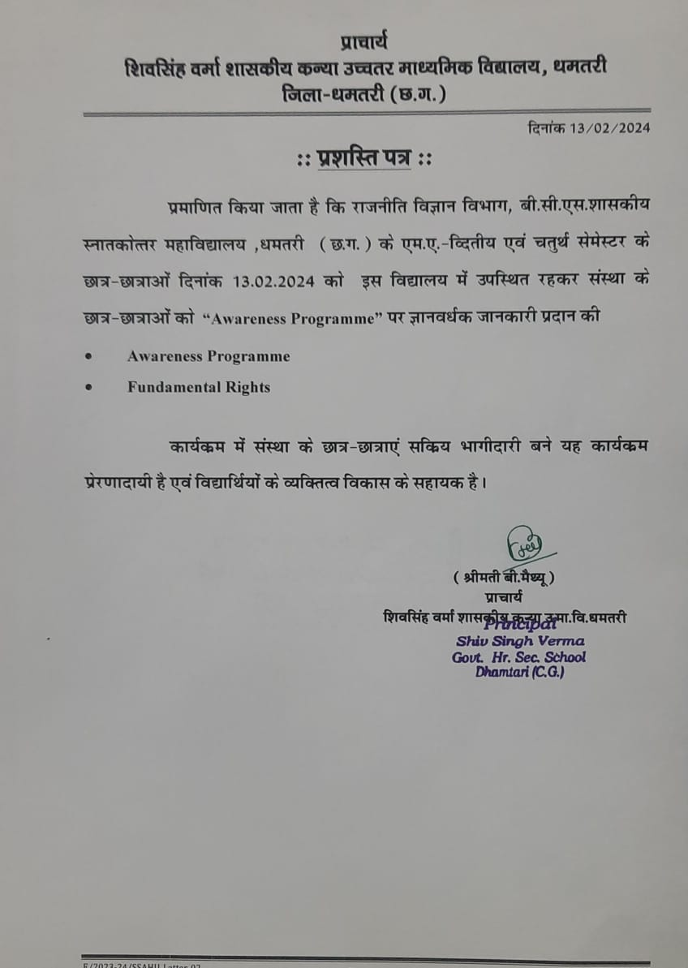

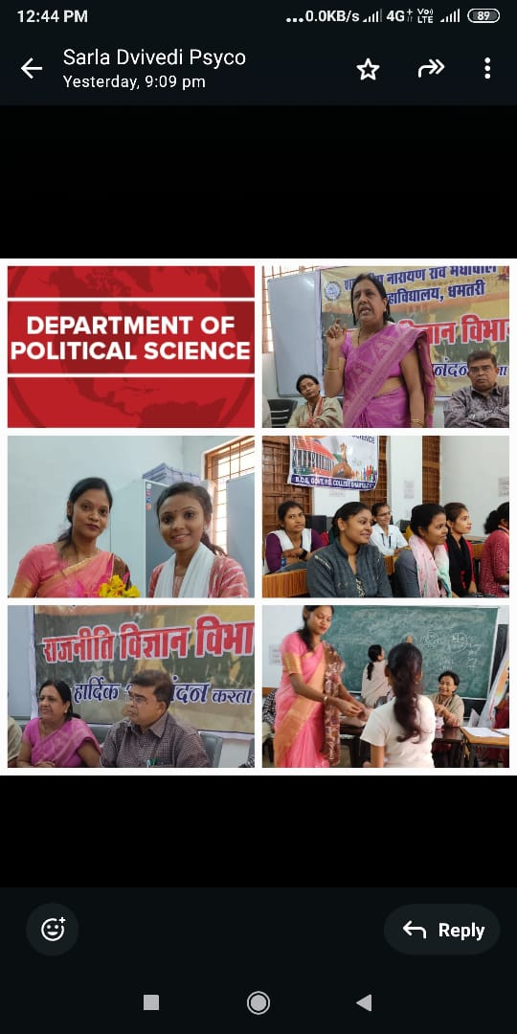
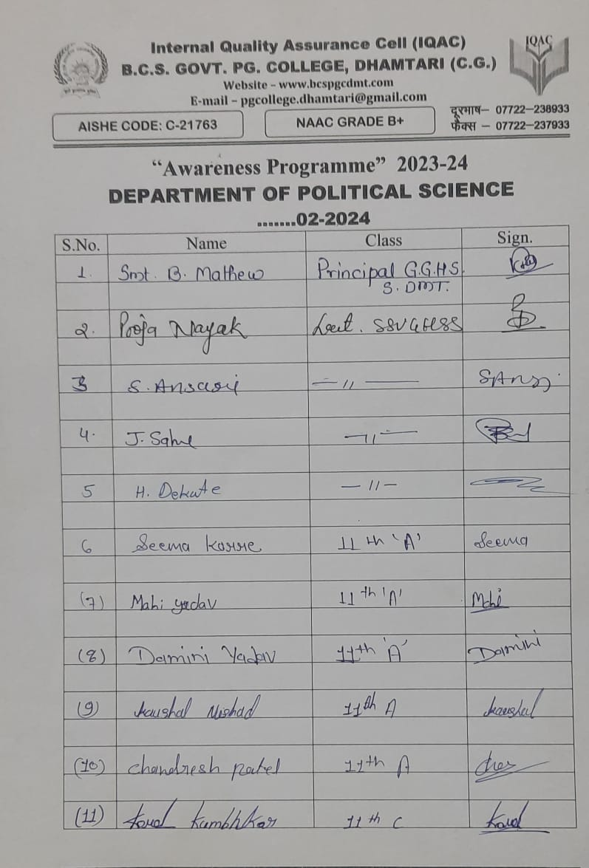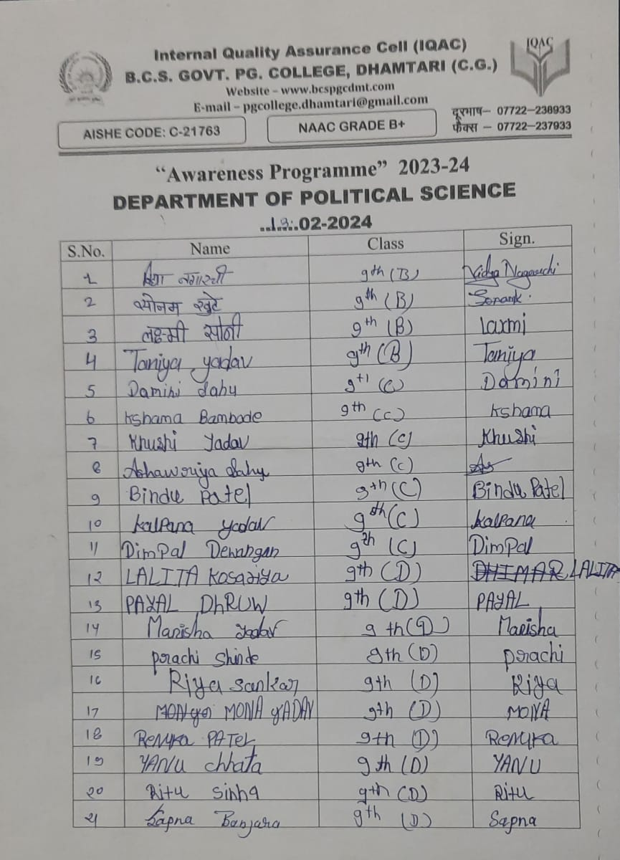

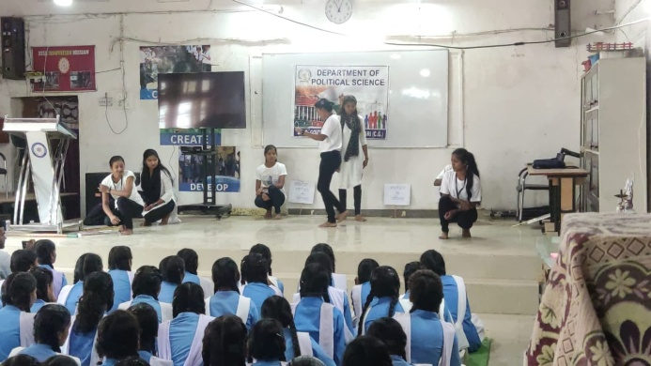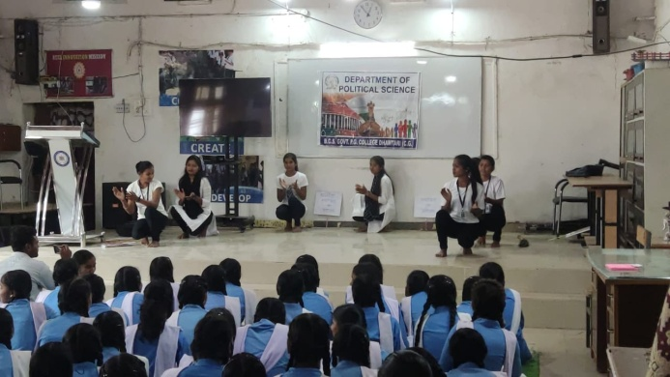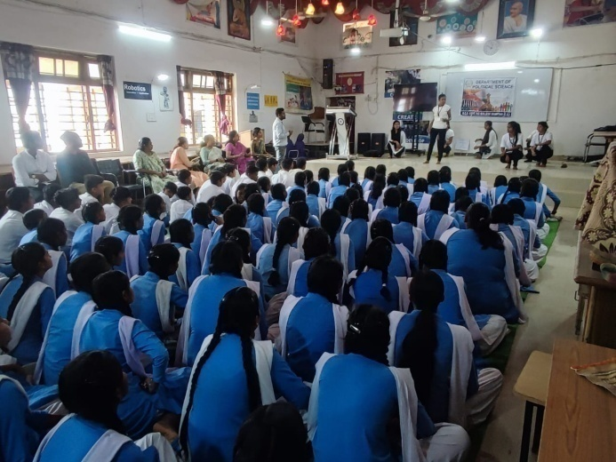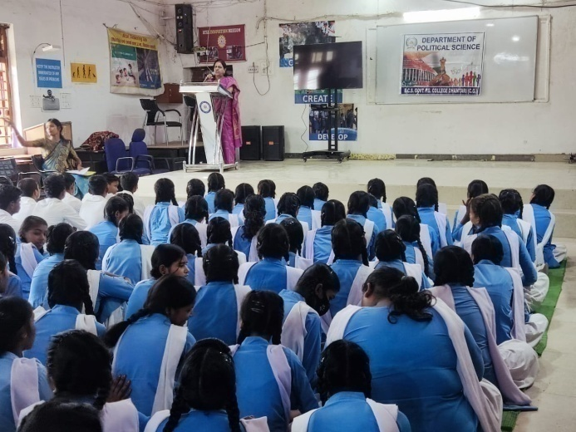

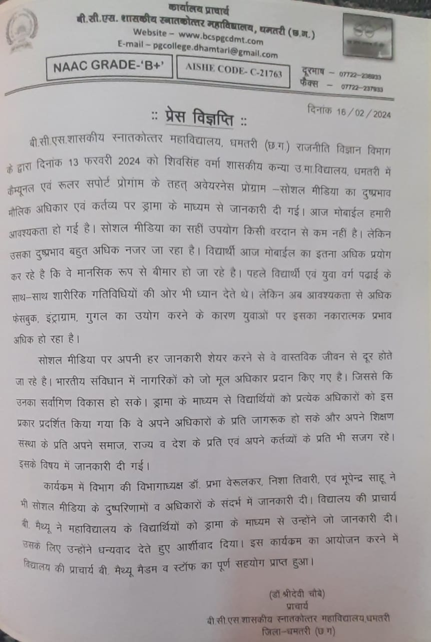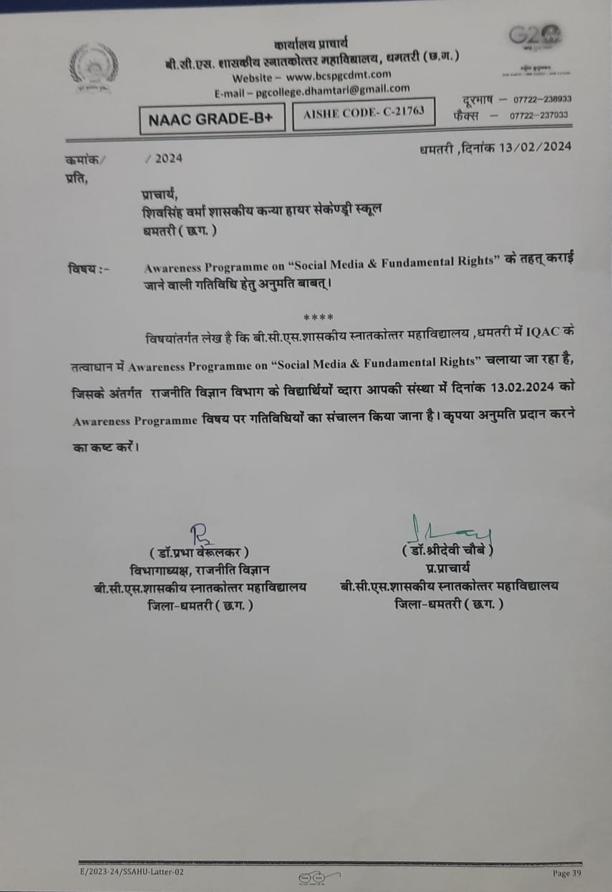

Communal and Rural Support Programme by Economics department

Link : - https://s3.ap-south-1.amazonaws.com/mts-buckets/bcspgcdmt/6786218b847ed.pdf

- fnukad 09-02-2024 fnu ‘kqdzokj dks vFkZ’kkL= ifj”kn ds leLr izk/;kid ,oa Nk=&Nk=kvksa us ‘kkLkdh; mPprj ek/;fed fo|ky; eqtxgu esa mifLFkr gksdj lks’ky ehfM;k ] ekufld LokLF;] volkn ls cpko Lojkstxkj dh laHkkouk ,oa Ik;kZoj.k laj{k.k ds lEca/k esa tkx:drk dk;Zdze dk vk;kstu fd;kA

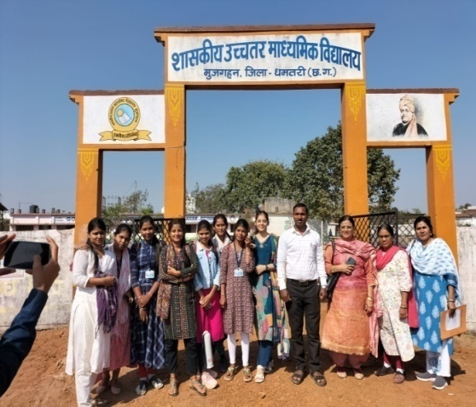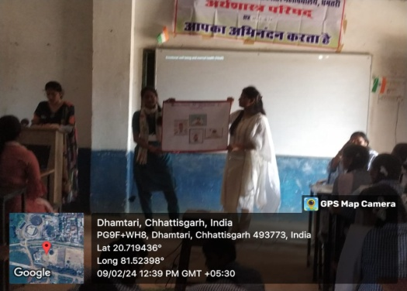
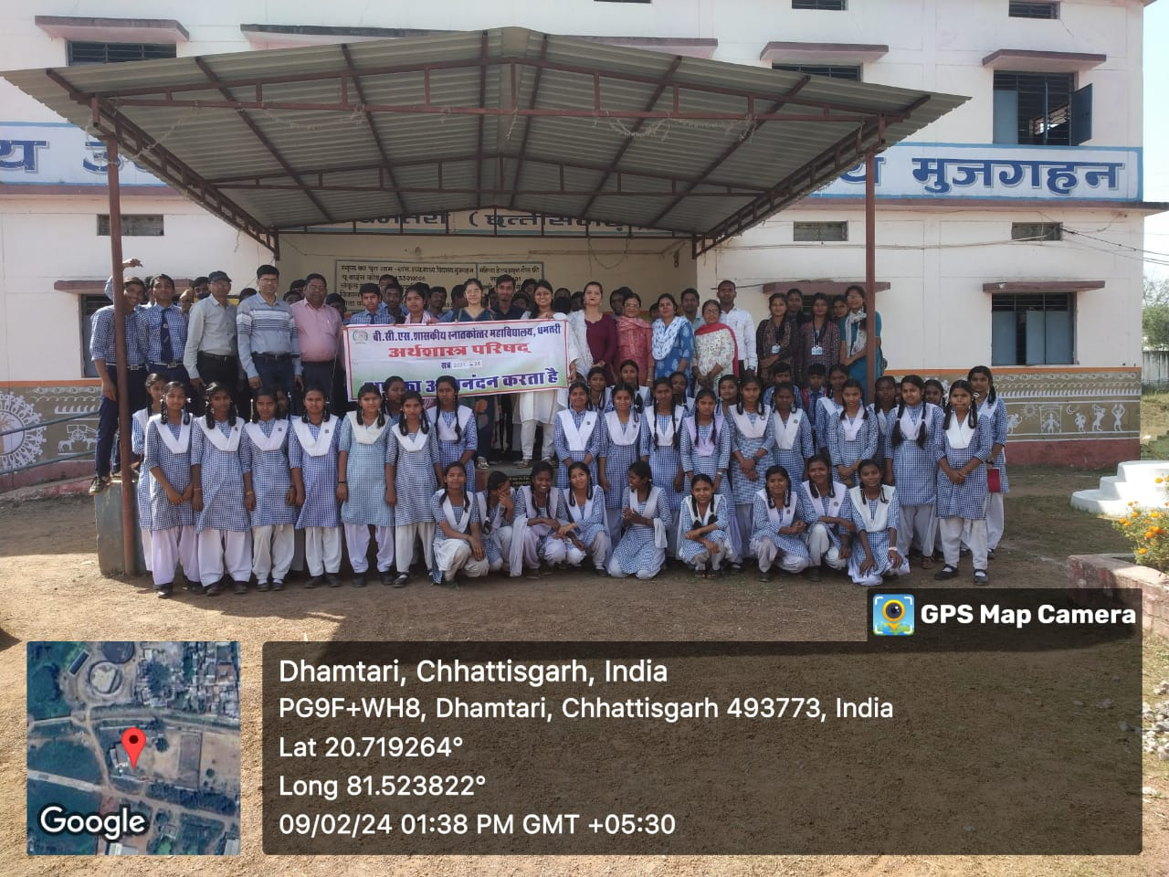
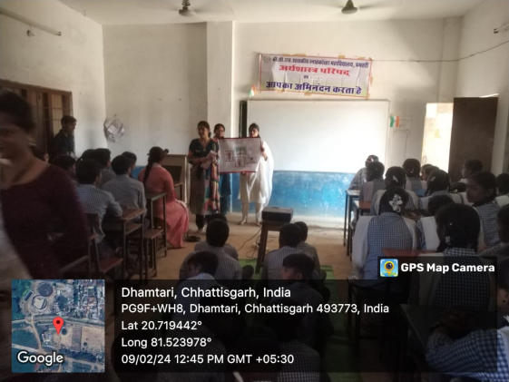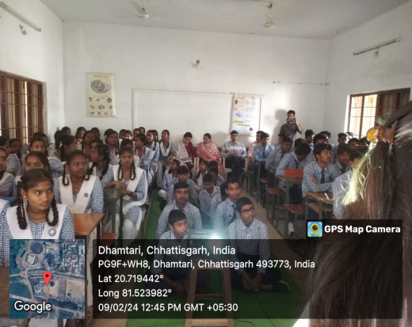

- fnukad 13-02-2024 fnu eaxyokj dks vFkZ’kkL= ifj”kn dh Nk=k,a dq- fiadh uojax ,oa dq- oanuk /kzqo ,e-,- prqFkZ lsesLVj us iksLV esfVªd vkfnoklh dU;k Nk=kokl xksdqyiqj dekZ ekrk pkSd /kerjh esa mifLFkr gksdj lokZbdy dSalj ds lEca/k esa LokLF; tkx:drk dk;Zdze dk vk;kstu fd;k A

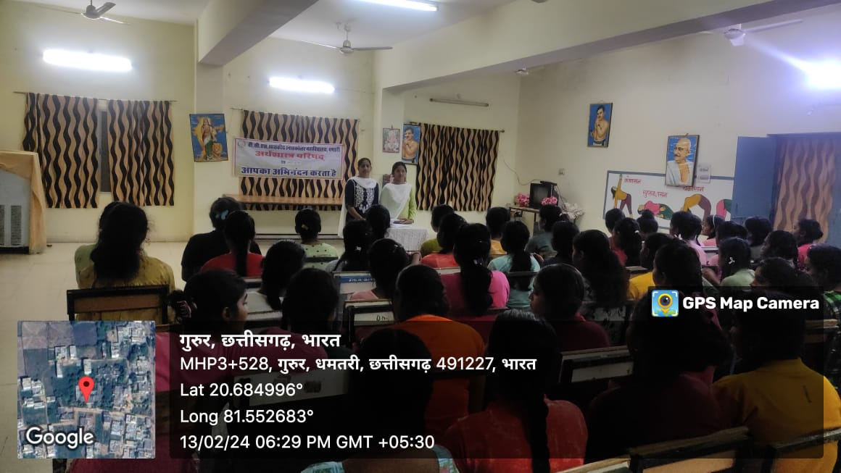

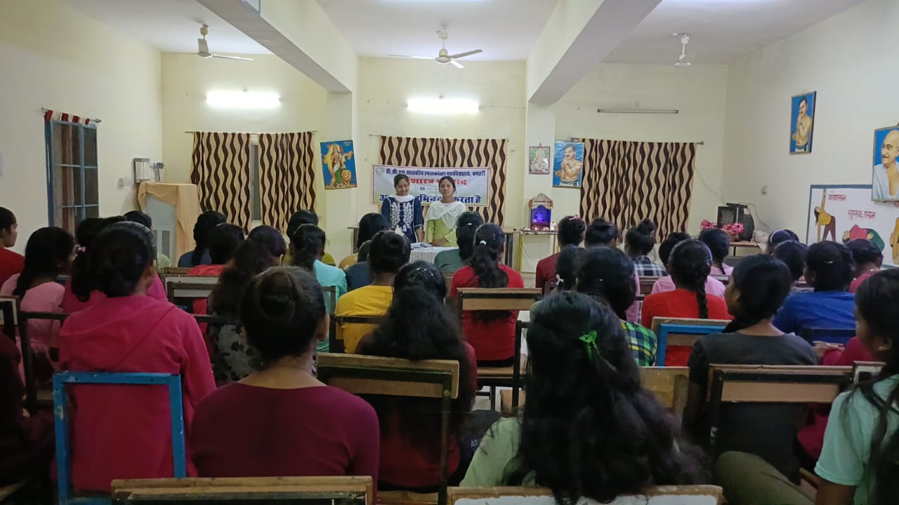

fnukad 19-02-2024 fnu lkseokj dks vFkZ’kkL= ifj”kn dh Nk=k,a dq- Hkkuqnsokxau ] dq- ljyk ]dq- ek/kqjh iVsy ,oa r`Irh iVsy us f’ko flag oekZ ‘kkldh; mPprj ek/;fed fo|ky; /kerjh esa mifLFkr gksdj lokZbdy dSalj ,oa Ik;kZoj.k laj{k.k ds lEca/k esa LokLF; tkx:drk dk;Zdze dk vk;kstu fd;k A

